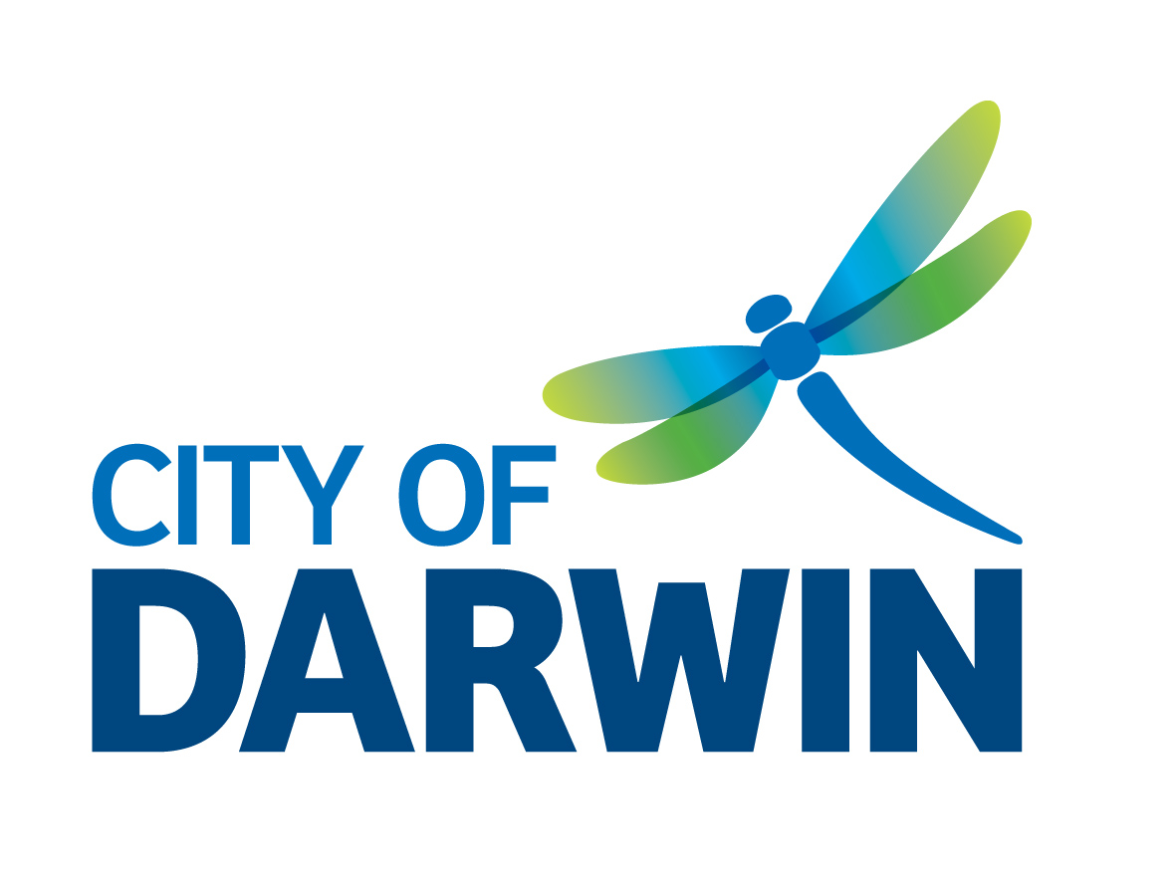
Nightcliff Community Centre Office Tenancy

Expression of Interest Form

Please complete the following information:

SECTION 1 ABOUT YOU

Name and Title:
On behalf of (full name of organisation / individual):
Postal Address:
ABN, BN, ACN:
Contact Telephone: | B: | AH: | M:
Facsimile:
Email:
Business / Trading Name:

SECTION 2 ABOUT YOUR ORGANISATION

- Description of the organisation and the services delivered in the Darwin community (max 200 words).

- Organisation’s current location and lease agreement (max 100 words).

- Evidence of Not-for-Profit status (max 100 words).

- Proposed use of the space (max 100 words).

- Office space required (max 100 words).

- Any proposed modifications to the office space? (max 100 words).

- Business and strategic plans (max 100 words).

- Copy of most recent annual report.
Attached | Yes | No

- Certificate of Public Liability Insurance.
Attached | Yes | No

SECTION 3 ASSESSMENT CRITERIA

- Location Rationale: Why does this particular location benefit your organisation and the community? (max 200 words).

- Facility Use: The proposed use of and the activities that will be undertaken in the leased area? (max 200 words).

- Community Benefits: The organisation can demonstrate experience in delivering services which address a local community need or build capacity of the Darwin community? (max 200 words).

- The organisation has proven experience in community engagement? (max 200 words).

- Demonstrated experience in developing partnerships with other community groups/stakeholders and willingness to work collaboratively with Council and other community groups (max 200 words).

- Financial management of the organisation (max 200 words).

SECTION 4 DECLARATION

I have been authorised by |  |  | (name of organisation)
to make this application.
State Full Name:
Position in Organisation:
Signature:
Date:

COMPLETED APPLICATIONS MUST BE SUBMITTED BY EMAIL:
Family and Children’s Services Coordinator
City of Darwin
darwin@darwin.nt.gov.au

