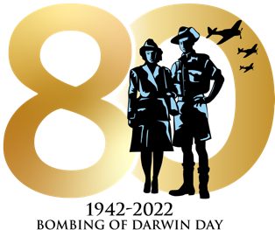

Order of Service

Music and Vocals
Band of the 1st Brigade, Darwin Chorale

9.30am Overview
Mr Scott Waters, CEO City of Darwin

Welcome to Country
Aunty Bilawara Lee, senior elder of Larrakia nation

The 19th Day of February
Rupert McCall

Music and Vocals
Band of the 1st Brigade, Darwin Chorale

Catafalque Party takes post
Australian Defence Force personnel enter parade area

9.58am Sound of air raid sirens, re-enactment of events on 19 February 1942
The air raid sirens first sounded at 9.58am on 19 February 1942
Royal Australian Air Force Flypast, 1Avn Flypast

Commemorative address

His Excellency, the Governor General of the Commonwealth of Australia, General the Honourable David Hurley

Her Honour the Honourable, Vicki O’Halloran, Administrator of the Northern Territory

The Honourable Scott Morrison, Prime Minister of Australia

The Honourable Michael Gunner, Chief Minister of the Northern Territory

The Honourable Anthony Albanese the Federal Leader of the Opposition

The Right Worshipful the Lord Mayor of Darwin, the Honourable Kon Vatskalis

Prayer for Australian Defence Force
Chaplain

Wreath Laying

Ode of Remembrance

They shall not grow old,
As we that are left grow old;
Age shall not weary them,
Nor the years condemn.
At the going down of the sun
And in the morning,
We will remember them.

Response

We will remember them
Lest we forget

Last Post

Minute’s silence

Rouse

8/12 Regiment
Simultaneous firing of one round by four M2A2 (105mm) Howitzer guns

National Anthem
Band of the 1st Brigade, Darwin Chorale

Benediction by Chaplain

Catafalque Party and Flag Party dismount
Australian Defence Force personnel depart parade area

Service concludes

