Host Owned Parklet Guidelines

1. Introduction

Parklets are repurposed car parking bays designed to create new spaces for activation of City of Darwin’s streetscape.

Parklets provide the opportunity to support local business while positively contributing to the broader community through, the provision of seating and greenery, and fostering the potential for neighbourhood interaction. The intent is for greater community activation and public amenity of car parking bays.

You can apply for a Parklet as an extension of public open space adjacent to your business or as an extension of outdoor dining. The Parklet may be for the exclusive use of patrons of the host venue/business during their *regular* trading hours. Outside of those periods the Parklet is to be available for use by the public.

1. Eligibility

Any business, property owner, not-for-profit or community organisation can apply to host a Parklet if they meet the following location criteria.

# Location Criteria

A Parklet can only be located in a designated parking bay(s) which is:

* located on a City of Darwin owned road that has a speed limit of 40km/h or less with street lighting,
* located in a business centre with medium to high levels of pedestrian activity and;
* located directly adjacent to/in front of the business or venue hosting the Parklet, or within a reasonable distance

A Parklet can NOT be located in a parking bay which:

* is within 10m of an intersection
* is within 20m of a signalled intersection on the approach side. These dimensions are from the kerb line
* is located within a loading zone, clearway, disabled parking bay, motorcycle parking, bus or taxi zones. (Council may consider a variation to this requirement where the applicant demonstrates that suitable alternative arrangements can be made to compensate for the loss in space.)
* contains utility access panels, fire hydrants or storm drains within the bay
* will impede or negatively impact upon pedestrian or vehicular movement or sightlines at road junctions and vehicle access crossovers or;
* will impede emergency vehicle movements. A Parklet must be located on a straight section of road.

Upon review, and on a case-by-case assessment, a Parklet may be located in a parking bay which:

* is in front of a ticket machine, street sign, existing street furniture or tree
* is near a driveway

1. Responsibilities

* Public Liability Insurance to a value in accordance with City of Darwin requirements that lists City of Darwin as an interested party within the policy
* Outside of the Hosts’ regular trading hours the Parklet is to be available for use by the public.
* Parklets shall not conflict with, or inconvenience, other adjacent businesses, or negatively impact upon the amenity of occupiers of said businesses. The area must not extend beyond the limits of the shopfront without the written permission of neighbouring businesses.
* Outdoor dining on the footpath is not Licence to Occupyted adjacent a Parklet. Furniture that can be removed should be provided entirely within the Parklet keeping the entire adjacent footpath clear of all furniture.
* Maintenance and upkeep. The Parklet shall be kept clean of litter, grime and graffiti. The surfaces and area underneath the platform should be cleaned.
* The applicant must keep any plants in good health, including watering, weeding, and trimming when necessary.
* City of Darwin reserves the right to remove Parklets, at the owner's cost, if in the opinion of the Chief Executive Officer, the Parklet is not regularly managed in accordance with these guidelines. The city will inform the owner before removal.
* Umbrellas cannot overhang into the travel land of the road or adjacent parking bays when fully opened. They must have a minimum canopy head clearance of 2.2m from the level of the footpath. It is the responsibility of the applicant to ensure that any umbrellas included in an application are adequately secured to ensure they do not become a safety hazard and comply with high/very high wind zone loading, and do not contain any advertising.
* All removable items are to be removed and securely stored in the business/venue outside of regular business hours, e.g. chairs, stools, umbrellas etc.
* There is to be no advertising fixed to, inside, or on the Parklet or any of the removable items. Exceptions may be made for menu boards on a case by case assessment.
* The occurrence of smoking must comply with the Tobacco Act.
* If there is a change in ownership of the business, or change of tenant of the venue the exiting host will be responsible for any legal fees associated with the change over.
* Every 12 months the host will be required to submit: consent of land and business owner whose property fronts the proposed Parklet and continued support of business and property owners immediately adjacent
* Unless otherwise specified, at the end of a Parklet’s approval period the Parklet must be removed and the road reserve reinstated to the same condition as existed prior to the Parklet’s installation.
* All costs associated with the construction, maintenance and removal of a Parklet must be borne by the Host.

1. Licensed Outdoor Dining

* Licensed outdoor dining requires approval from Licensing NT prior to the serving of alcohol on City of Darwin road reserves. Applications to the Liquor Commission cannot be made without Council’s written authorisation as landowner.
* Outdoor dining areas contained on Council land must comply with the requirements of the *Northern Territory Tobacco Control Act* and Regulations.

1. Design

The design of the proposed Parklet should be interesting and creative, demonstrates an improvement in the quality of public space, is compatible with the established streetscape character, encourages interaction, provides adequate disability and universal access and maintains or improves public safety in the street. City of Darwin are seeking more than just a standard design to place tables and chairs in. The intent is for greater community activation.

The proposed Parklet will need to meet the following criteria.

General:

* Comply with Building Code of Australia (BCA) and all relevant Australian Standards
* The final design will require:
  + a Section 40 – Certificate of Compliance – Structural Design OR the applicant must be able to demonstrate that they will be able to secure and/or remove the Parklet safely in the event of a cyclone
  + approval by a Traffic Engineer or Road Safety Auditor, including an assessment of the Parklet’s impact on road safety, including lighting etc.
* Fit into a standard or multiple standard:
  + parallel parking bay(s) of 6400mm x 2500mm or;
  + perpendicular parking bay(s) of 5400mm x 2500mm or;
  + an angled parking bay(s) of 5400m x 2500mm

Easy Removal:

* Be freestanding and not interfere with the functioning, or result in the damage or permanent removal, of existing infrastructure such as hardstand infrastructure (kerbing, paving, crossovers or road drainage), verge trees, lighting, underground services or other services.
* Can be removed readily in the case of maintenance and emergency within a 24-hour period with the road reserve being reinstated, to the same condition as it was previously to the parklet installation.

Safety:

* Non-reflective and non-slip ground/floor surfaces.
* A minimum buffer zone of 30cm between the edge of the parklet and the through traffic lane in accordance with Austroads Guide to Road Design Part 3. Further to this a one (1) meter buffer zone should also be applied and/or extended where vehicles are required to manoeuvre into and out of adjacent parking bays. See diagrams below:

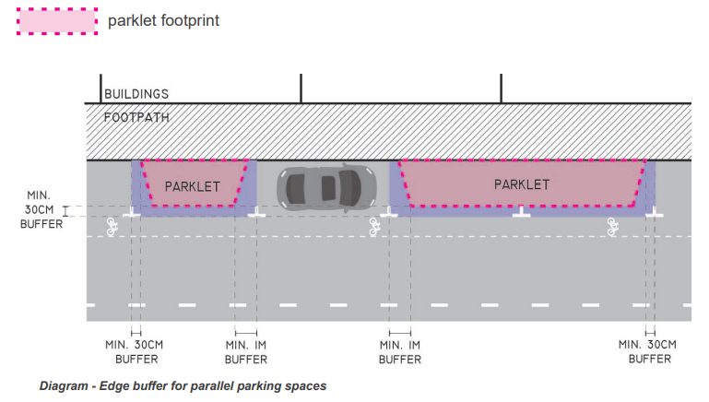

* Pedestrian and vehicle separation via a visible and continuous physical barrier around the outside edges of the parklet. The design should ensure both the inside and outside edges are attractive from all viewing angles.
* Reflective tape is required along the approach side of the planter box – top.
* The parklet layout should include a solid edge which could be constructed of planter boxes as a passive barrier for hostile vehicle mitigation.
* The barrier should not exceed 1.1m in height and any trees or planting must allow for sufficient visibility with tree trunks less than 20cm in diameter.

Cross Fall

* The cross fall on the parklet maintains a fall of 1:40 or 2.5% as prescribed in AS 1428.1:2021. Cl 7.1,
* The decking is to be installed as per AS 1428.1: 2021 Cl 4.2 abutment of surfaces with a tolerance of 3.6mm gap between boards.

Footpath and Accessibility:

* Edge to footpath open and welcoming, minimise elements which might discourage people from entering.
* Ensure access points are flush and level with the footpath/pavement for wheelchairs, mobility devices, people with prams and the like.
* There must be at least one point of entrance which is in an unobstructed area and is a minimum width of 900mm
* Where a step ramp is installed, the gradient should not exceed 1:10 as required in AS1428.1:CI7.6.1 and CI7.6.2.
* In mitigating the creation of a trip hazard a 30% luminous contrast between the pavement and the ramp should be provided.

Planting and Landscaping:

* Planting elements to be integrated into the design of the parklet while keeping in mind sightlines both for vehicles and to neighbouring businesses.

Drainage:

* The parklet should not obstruct existing drainage.
* The parklet is to be positioned 100mm away from the kerb to create a flow path for stormwater and minimise impeding or diverting the natural stormwater or overland flow of the site.

Materials:

* Fit for purpose and suitable for public and commercial use.
* Durable, long-lasting and weather resistant.
* Suitable and complimentary to the Darwin streetscape and character.
* Darwin sourced materials preferred, followed by Northern Territory and then Australia.
* Sustainably harvested, re-used and recycled materials where possible.

1. Application for Licence to Occupy

Any approval granted for a Parklet installation will initially be within the 12-month trial period. Notification of an approval will include a statement that the Council retains absolute discretion in determining whether to approve any subsequent application to renew the approval, and if an approval is renewed it may be for a shorter period than the original approval.

1. Legislative References

**Please note**: that as landowner, City of Darwin may approve or refuse any parklet application whether or not the application complies with the guidelines. City of Darwin also reserves the right to add any conditions it considers relevant to individual Parklet Licence to Occupy.

1. Fees and Charges

City of Darwin has the right to charge a fee associated with the loss of the parking bay and for outdoor dining.

Council sets the fees and charges on 1 July of each year and as such, all outdoor dining licences expire on 30 June. The current fees and charges are published on City of Darwin’s website.

In addition to these fees, the applicant may be responsible for the once-off cost of the preparation of the licence and agreement conditions.

1. Policies / Related Documents

* City of Darwin Policy No 011 – Outdoor Dining
* Outdoor Dining Application and Guidelines
* City of Darwin Fees & Charges
* *Local Government Act 2019*