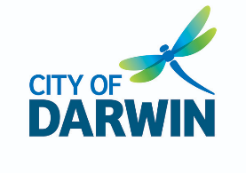



Parap Pools

Accessibility Guide

Updated July 2024

# Acknowledgment of Traditional Owners

City of Darwin acknowledges the Larrakia people as the Traditional Owners of the land and waterways now known as Darwin. Council pays respect to Elders past, present and emerging, and values the ongoing contribution to enrich and appreciate the cultural heritage of Darwin. Council acknowledges and respects Australia’s First Peoples as Traditional Owners of lands and waterways across Country, and encourages reconciliation between all. City of Darwin also values the contribution made to Darwin over the years by people of diverse backgrounds and cultures.

# Contact Us

Address: 77 Ross Smith Ave Parap, Northern Territory

Phone: 08 79128370

Email: [psp.reception@ynt.org.au](mailto:psp.reception@ynt.org.au)

Website: <https://www.darwin.nt.gov.au/community/community-facilities/parap-pool>

**Contents**

Acknowledgment of Traditional Owners 2

Contact Us 2

Welcome 5

Access At A Glance 5

What to Expect 5

Opening Hours 6

Getting Here 7

Travel by bus 7

Travel by car 7

Bicycle Rack 8

Arrival 8

Entrance 8

Service Counters 9

Kiosk 9

Dietary Options 9

Cafe 9

Cafe Entrance 9

Children’s Play Area 10

Furniture 10

Clear Floor Space 10

Temperature 10

50m Pool 11

Access to the Pool 11

25m Pool 12

Access to the Pool 12

Zero-Depth Wet Play Area 13

Access to the play area 13

Furniture 14

Silver Pedestal Table 14

Tall Tables 14

Bench with Armrests 14

Bench without Armrests 15

Silver and Blue Picnic Benches 15

Black and Silver Picnic Benches 15

Pool Equipment 16

Aquatic Wheelchairs 16

Toilet Facilities 16

RHS Accessible Toilet and Change Room 17

LHS Accessible Toilet and Change Room 18

Toilets and Changing Rooms 20

Other Features 22

Outdoor Shower 22

Viewing Areas 22

Lockers 22

Water Fountain 22

Safety 22

Wi-Fi 22

Communication 23

External Wayfinding 23

Internal Wayfinding 23

Information 23

Lighting 23

Sounds 23

Quieter and Peak Periods 23

Quieter Periods 23

Peak Periods 23

Programs and Events 24

Aquatic Programs 24

Events 24

# 

# 

# 

# 

# 

# 

# 

# Welcome

Parap Pool is for recreational and leisure use for all members of the community and swimmers of all abilities. The facility is World Aquatics compliant, putting Darwin on the national map for swimming competitions, training and events. Parap Pool offers a range of programs and activities for all ages, including learn-to-swim and swim club training.

# Access At A Glance

|  |  |
| --- | --- |
| * Accessible Toilet and Change Rooms | * Aquatic Wheelchair |
| * Accessible Parking | * Drinking Fountain |
| * 50m Pool | * Ramp Access to Pool |
| * 25m Pool | * Baby Changing Table |
| * Changing Rooms | * Wifi |
| * Step Free Access | * Bicycle Rack |
| * Charging Point | * Showers |
| * Toddlers Pool |  |

# What to Expect

* 50m pool with partial shade
* 25m pool that is fully shaded
* Both pools have ramp access and an aquatic wheelchair
* Shaded, zero-depth wet play area
* Male and Female toilets and changing rooms
* Two Unisex Accessible Toilets and change rooms
* Free Wi-Fi
* Kiosk
* Discounted entry prices for holders of government-issued Pension Cards and Companion Cards

# Opening Hours

* Monday – Friday 5:30am- 7:30pm
* Weekends and Public Holidays 8.00am- 7.30pm
* Closed Good Friday, Christmas Day and New Year's Day

# Getting Here

## Travel by bus

* The nearest stop is Op Parap Pool for Bus Route 6 with major stops of Darwin Interchange, Museum, Philip St Shops, Parap Rd, and Darwin Interchange
* The Route 6 bus is wheelchair accessible
* The route from the bus stop to the pool is approximately 100m with a step-free route available
* Refer to the [NT Bus Tracker App](https://nt.gov.au/driving/public-transport-cycling/public-buses/nt-bus-tracker-app) for the timetable

## The bus stop that is located out the front of the pools between the driveways. There is a footpath from the bus stop to the pool entrance. The large "Parap Pool" sign at the side of the road near the entrance of the pool

## The path that leads to the main entrance from the bus stop.

## Travel by car

* There is a carpark directly next to the facilities
* There are two accessible parking bays approximately 15m from the entrance of Parap Pool
* A continuous accessible path of travel leads from the carpark to the entry
* Undercover parking is not available

## Accessible parking bays at the entrance of the pool. The Parap pool car park.

## Bicycle Rack

* 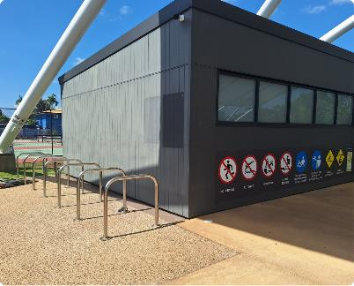Bicycle racks are located in the carpark and inside the entrance

# The entrance of the pools with a large blue installation out the front. Arrival

* The path to the entrance from the carpark and the street is concreted
* There is step-free access from the frontage to the entrance
* A pedestrian crossing allows safe access from the street to the entrance

# The wide entrance to the facilities with various signs and A-frames at the entrance.Entrance

* There is a clear and level path of travel to the entrance
* An overhanging shelter covers the service counter
* The pool features an open entrance with no gates, allowing for easy and unrestricted access at any time
* The clear entry width is greater than 2000mm

# Service Counters

* There is a service counter where you can pay for entry and make enquiries and purchases
* The counter has a height of 900mm and is sheltered
* The flooring is nonslip, level concrete
* Staff can help with enquiries, bookings, and payments, or provide directions
* There is a portable EFT machine and cash payments are accepted

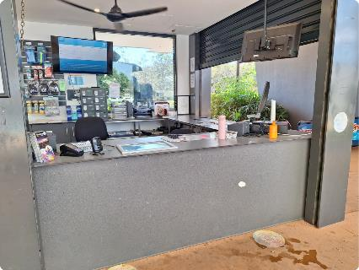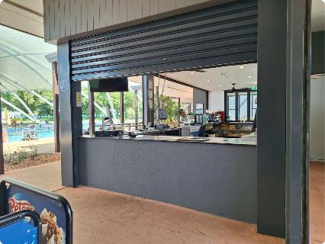

# Kiosk

* 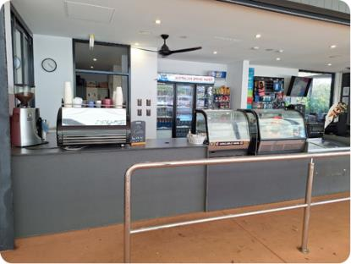The kiosk is situated at the front of the venue near the entrance with a counter height of 900mm
* There is a portable EFT machine and cash payments are accepted

## Dietary Options

* Hot and cold snacks and drinks are available
* There is a limited selection of dietary options available, such as gluten-free, dairy-free and vegan snacks

# The manual door to enter the cafe has dark grey trim and level access. A non slip mat is positioned in front of the door. Cafe

## Cafe Entrance

* There is a clear path of travel into the cafe
* The door swings out to the left with a clear width of 920mm

## The children's play areas in the cafe with shelving of various toys. Children’s Play Area

* A children's play area is in the corner with a selection of toys

## 

## Furniture

* There is a selection of tables and seating. Furniture may vary from the furniture shown in these photos.

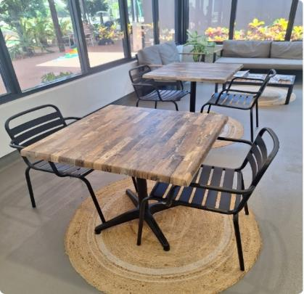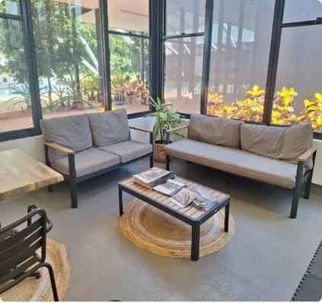

## Clear Floor Space

* Chairs and tables can be re-positioned to increase floor space

## Temperature

* This room is air conditioned and is temperature controlled

# 50m Pool

* The 50m pool has 10 lanes and partial shade
* It has a moveable boom, and start blocks at each end
* The water is temperature-controlled to 27 degrees Celsius
* The pool depth is 1.4m - 2.0m
* For availability visit [Parap Pool 50m Pool Lane Availability Calendar](https://teamup.com/ksavtpebi7c796e3v6). While we attempt to keep this up to date, the calendar may not include all one-off or casual bookings. Please contact the pool directly for further information.

## Access to the Pool

* The pool can be accessed via a ramp with rails on both sides at a height of 900mm
* The depth at the bottom of the ramp is 1.2m with one step down to a 1.4m depth on the pool floor
* There is ladder access at various points around the pool with rails on both sides
* A continuous accessible path of travel surrounds the pool

# Ramp access into the pool with rails on the left and right side.

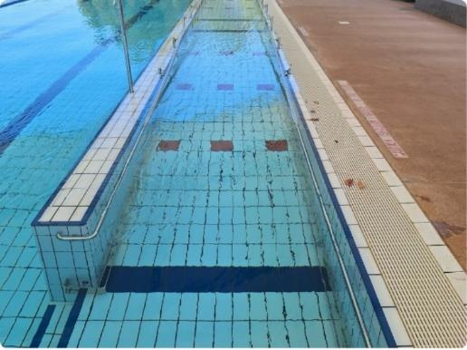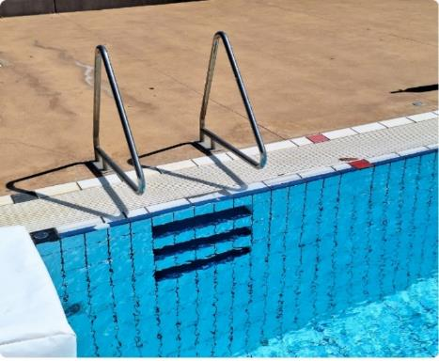

# 25m Pool

* The 25m pool has 6 lanes and is fully shaded. It has start blocks at one end
* The water is temperature controlled to 30 degrees Celsius
* The pool depth is 1.2m - 1.35m
* This pool is popular for aqua programs, hydrotherapy and third-party physiotherapy
* For availability visit [Parap Pool 25m Pool Lane Availability Calendar](https://teamup.com/ksowdk3xujj3cjnwnz). While we attempt to keep this up to date, the calendar may not include all one-off or casual bookings. Please contact the pool directly for further information.

## Access to the Pool

* The pool can be accessed via a ramp with rails on both sides at a height of 900mm
* The depth at the bottom of the ramp is 1m with one step down to a 1.2m depth on the pool floor
* Six stairs with rails on the left or right side at a height of 900mm
* Ladder access at various points around the pool with rails on both sides
* A continuous accessible path of travel surrounds the pool

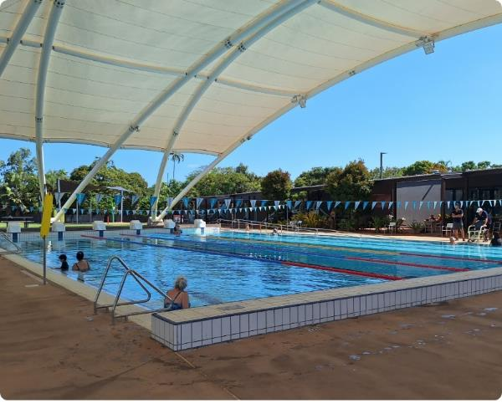

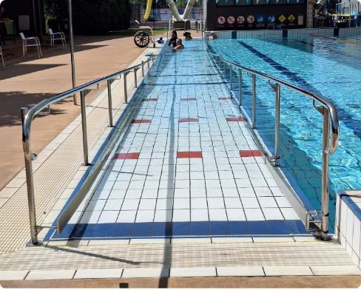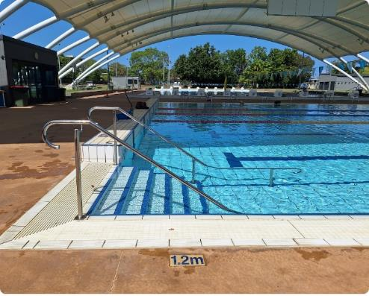

# Zero-Depth Wet Play Area

* A shade cloth covers the zero-depth wet play area
* Water is turned on by pressing a large button with a height of 870mm that can accessed using a closed fist or open palm
* There are a range of water features to play with that drop buckets of water or gently shower water
* You will hear water running and splashing

## Access to the play area

* Access to the play area is step-free with a gentle gradient
* A continuous accessible path of travel leads to the play area

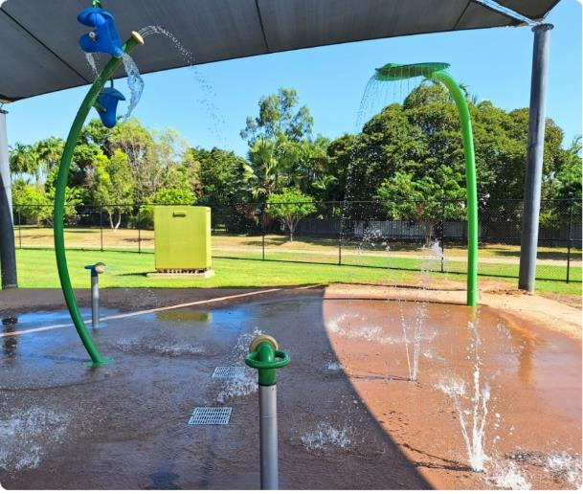

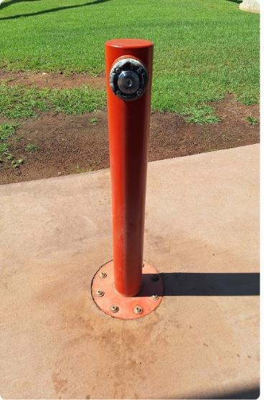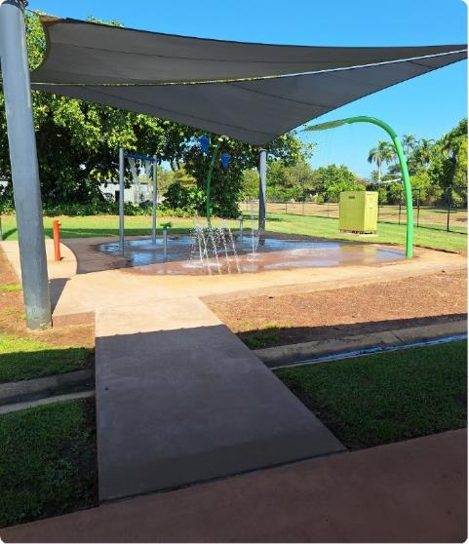

# Furniture

* There are a range of seating options with varied styles and heights
* Tables and seating as shown here may change
* A selection of seating is undercover
* The location of seating may change depending on weather or events. If you require seating in a specific location, please call the venue before your visit and staff will accommodate your needs where possible

## Silver pedestal table and chairs set outside. Silver Pedestal Table

* The table has a height of 730mm and an under-table clearance height of 720mm
* The chairs are firm with armrests and have a seat height of 420mm

## Tall tables and chairs looking over the pools. Tall Tables

* The table has a height of 1000mm and an under-table clearance height of 940mm
* The stools are firm without armrests and have a seat height of 740mm

## A black metal bench sitting in front of a grey wall. There is a towel on the seat and shoes underneath. Bench with Armrests

* These have a seat height of 420mm and have armrests on the right or left side

## 

## 

## A silver bench sitting in front of a grey wall.Bench without Armrests

* These have a seat height of 400mm
* These are lightweight and can be repositioned

## 

## A picnic table with blue legs undercover.Silver and Blue Picnic Benches

* The table has a height of 720mm and an under-table clearance height of 660mm
* The overhang has a depth of 230mm and there is 670mm width between the legs of the bench
* The seats are fixed and have a seat height of 390mm

## 

## A picnic table with black legs undercover.Black and Silver Picnic Benches

* The table has a height of 830mm and an under-table clearance height of 770mm
* The overhang has a depth of 380mm and there is restricted knee and foot clearance at the end of the table
* The seats are fixed and have a seat height of 530mm

# 

# Pool Equipment

## Aquatic Wheelchairs

* Two Aquatic wheelchairs are available for use
* The seat height of the wheelchair is 560mm, the seat width is 480mm and the seat depth is 460mm
* Bring your own portable hoist for transfers into the wheelchair
* 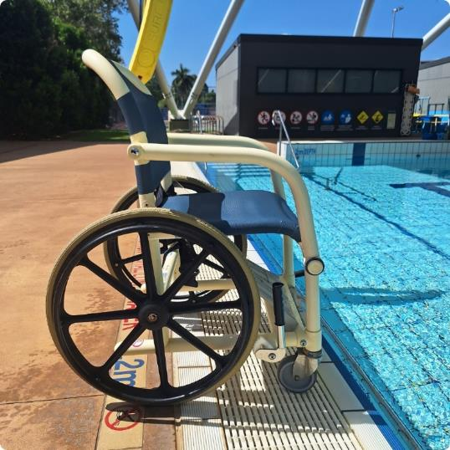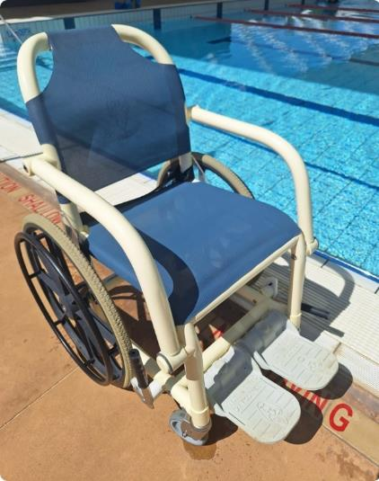We are intending to install a hoist at the 25m pool. Please contact Parap Pools for further information

# Toilet Facilities

* 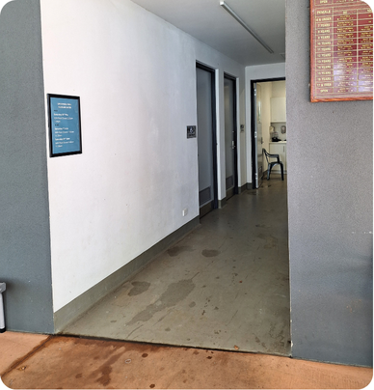There is a Right Hand Side (RHS) and Left Hand Side (LHS) Unisex Accessible Toilets, Female change rooms and toilets, Male change rooms and toilets and Ambulant toilets
* There is step-free access to all toilets and change room facilities
* Wayfinding to the toilets is clear with graphics and Braille to indicate facilities
* The standard cubicle toilets are located in the same facility as the changing rooms

# The grey door to the accessible toilet with clear signage.RHS Accessible Toilet and Change Room

* The corridor leading to the toilets is greater than 1000mm
* The manual door is in-swinging to the right and has a clear width of 860mm
* The lever-style door handle is positioned at 1000mm from the ground with a lever style lock
* The toilet height is 480mm
* Space to the left of the toilet is 290mm and space to the right of toilet is open
* Rails are set at 800mm on the left side
* An Over Toilet Aid is available for use

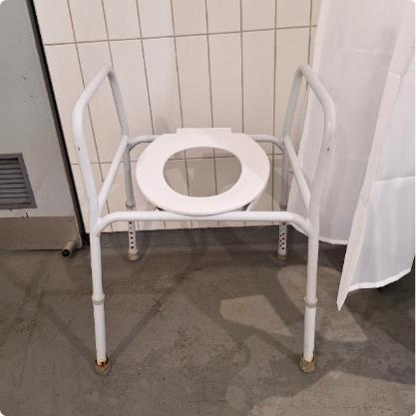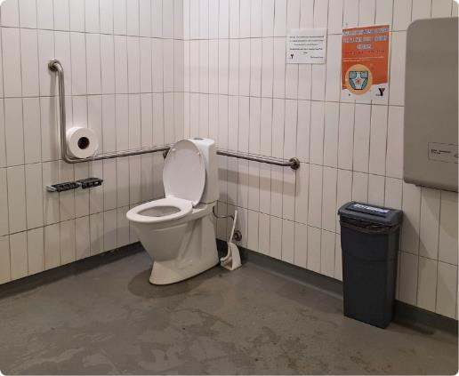

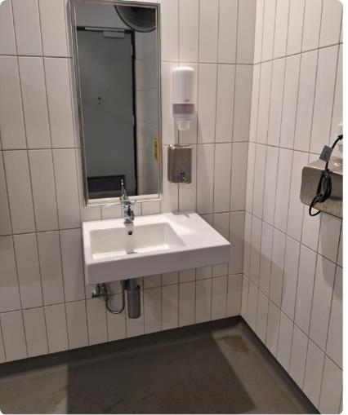

* Basin has a height of 830mm with a lever-style tap
* The hand dryer is positioned next to the basin with the lowest point at 100mm
* Baby Changing table has a height of 900mm when it is folded down
* 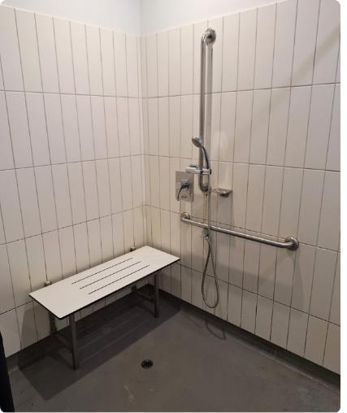The Shower has an adjustable hand-held shower hose
* The fold-down bench has a height of 480mm
* The lever style taps have a height of 1000mm and the horizontal rail has a height of 800mm
* Hooks are positioned on the wall at 1300mm high
* Lighting is automatic
* The fan has a pull cord at a height of 1730mm

# LHS Accessible Toilet and Change Room

* The corridor leading to the toilets is greater than 1000mm
* The manual door is in-swinging to the left and has a clear width of 860mm
* The lever-style door handle is positioned at 1000mm from the ground with a lever style lock

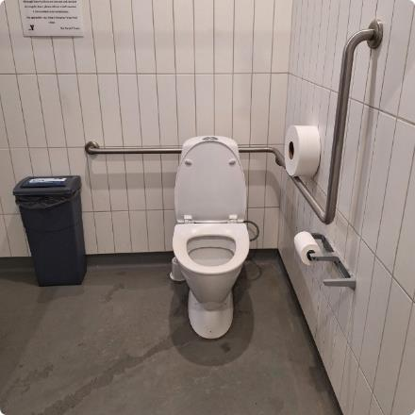

* The toilet height is 480mm
* Space to the left of the toilet is 270mm and space to the right of toilet is open
* Rails are set at 800mm on the left side
* An Over Toilet Aid is available for use

LHS Accessible toilet with basin, shower and plastic chair. 
 

* Basin has a height of 830mm with a lever-style tap
* The hand dryer is positioned next to the basin with the lowest point at 1150mm
* Baby Changing table has a height of 900mm when it is folded down
* 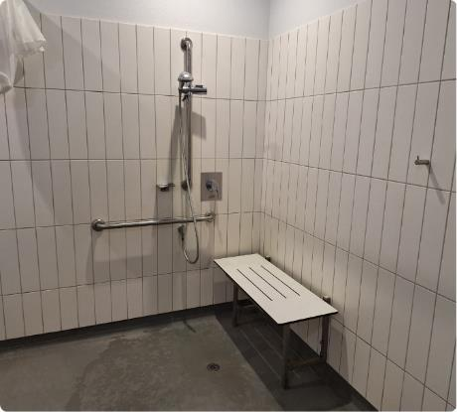The Shower has an adjustable hand-held shower hose
* The fold-down bench has a height of 480mm
* The lever style taps have a height of 1000mm and the horizontal rail has a height of 800mm
* Hooks are positioned on the wall at 1300mm high
* Lighting is automatic
* The fan has a pull cord at a height of 900mm

# Toilets and Changing Rooms

* 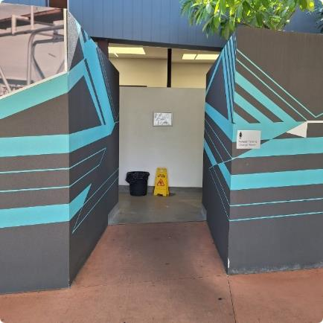The separate male and female toilets, showers, and change rooms have step-free access. There is a large circulation space
* The width of the entrance is 1520mm
* The toilets have a height of 420mm. The toilet cubicles are small with a door width of 560mm
* Ambulant toilets are located in the male and female facilities

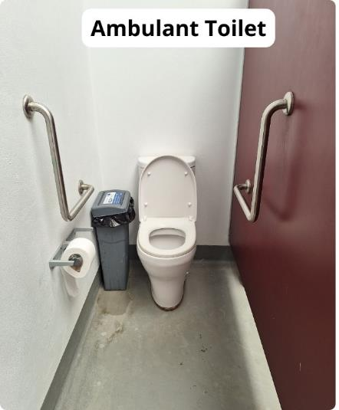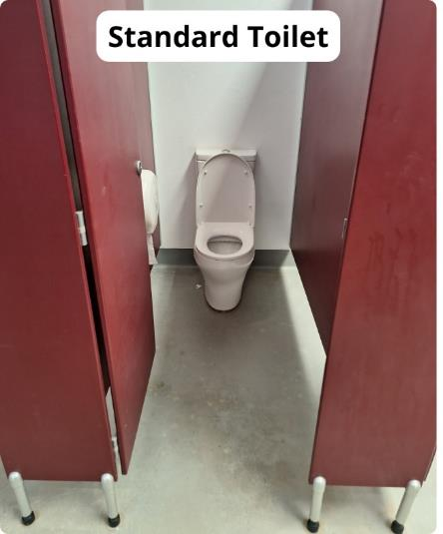

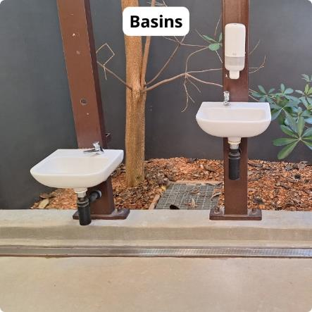

* The basins are situated at 940mm or 630mm with push taps that have timed water flow

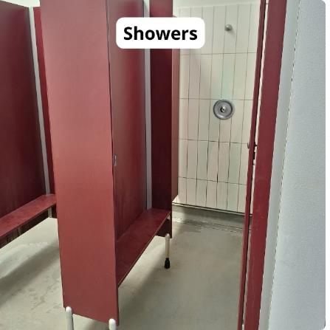

* There are a number of temperature controlled showers
* Shower door widths are 560mm
* Shower heads are fixed
* The push taps have timed water flow
* There are small benches in the shower cubicles

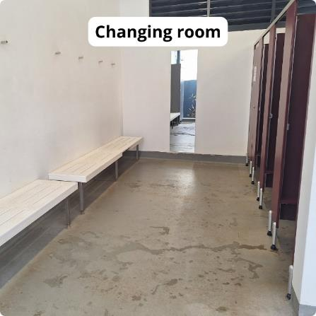

* There are two private changing cubicles in the female changing rooms with a door width of 560mm, and seating with armrests
* There is a large communal changing space with benches available with a height of 460mm and hooks at 1600mm

# Other Features

## Outdoor Shower

* An outdoor shower is available. It is operated using a push-button positioned at a height of 1120mm and has timed water flow
* The surface is firm with a concrete pad allowing a front or parallel approach

## Viewing Areas

* Viewing areas can be accessed via a ramp with the most narrow point being 580mm
* 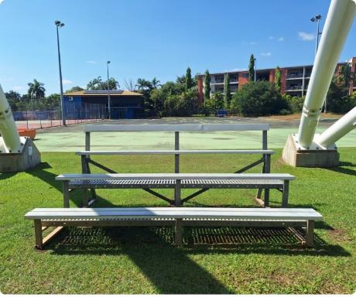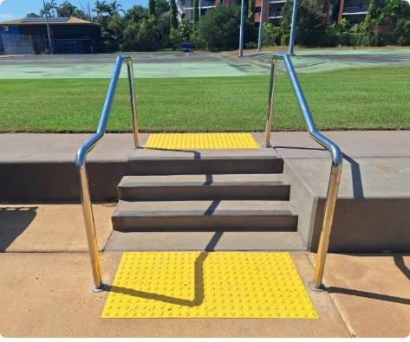Three stairs also access the viewing areas with rails on the right and left sides with a height of 900mm and Tactile Ground Surface Indicators in place

## Lockers

* Lockers are located in the changing rooms. You can collect a locker key at reception. You will be asked to leave your identification with reception.

## Water Fountain

* The water fountain spout height is at 950mm
* The small press button has a height of 100 cm
* There is clear floor space approaching the fountain and to the right of the fountain

## Safety

* Lifeguards patrol during open hours
* Lifeguards wear red and yellow can be found around the pools
* A First Aid kit and an Automated External Defibrillator are available

## Wi-Fi

* City of Darwin free Wi-Fi is available

# Communication

## External Wayfinding

* The entrance is clearly marked with clear signage on the outside of the building

## Internal Wayfinding

* Toilet facilities are clearly marked with info graphics and Braille

## Information

* Safety and pool activity information is provided in standard printed format. Staff are available to assist as needed

# Lighting

* The facility is lit with natural lighting during the day
* There may be glare and reflections off the water
* In the evening, the pools and change rooms have bright lighting from 6:00pm

# Sounds

* The volume of other visitors will depend on the number of other people enjoying the pool on the day
* There is typically no background music unless other visitors are playing music on their personal devices or as part of a pool party
* The music played for Aqua Aerobics can be loud and can be adjusted on request
* Ear plugs are available for purchase at the venue

# Quieter and Peak Periods

## Quieter Periods

* Monday- Friday 12:30pm- 3:30pm the pool is typically quiet, unless there are school activities or groups

## Peak Periods

* Monday- Friday 9:00am-12:00pm
* Monday- Friday 3:30pm- 6:00pm
* Saturday and Sunday 8:30am- 12:30pm
* Saturday is the busiest day for the 25m pool
* You can check the [Parap Pool 50m Pool Lane Availability Calendar](https://teamup.com/ksavtpebi7c796e3v6) and the [Parap Pool 25m Pool Lane Availability Calendar](https://teamup.com/ksowdk3xujj3cjnwnz) to see what bookings have been made on the day. The calendar may not include all one-off or casual bookings, please contact the pool directly for further information.

# Programs and Events

## Aquatic Programs

* A number of organisations provide swimming lessons, training and aqua fitness classes for children and adults at Parap Pool
* Participants with access needs are invited to participate and classes can be modified to suit a range of participation levels
* Pool entry is generally not included in the cost of programs
* Contact the facility or visit the [Parap Pool webpage](https://www.darwin.nt.gov.au/community/community-facilities/parap-pool) for information on the current programs on offer

## Events

* Several community events are held at Parap Pool during the year. Visit the [Parap Pool webpage](https://www.darwin.nt.gov.au/community/community-facilities/parap-pool) for details.

The City of Darwin would like to acknowledge the support and assistance provided by Flare Access Pty Ltd in helping to prepare this Accessibility Guide.

This Accessibility Guide was designed and developed in collaboration with Flare Access Pty Ltd. For feedback on the guide please contact City of Darwin.

© Flare Access, All Rights Reserved. 2024 DISCLAIMER: Accessibility Guide developed by Flare Access. Observations made by Flare Access and additional information provided by Parap Pools. All materials have been compiled from information available at the time of production. All materials have been compiled from information available at the time of production. They are not intended to replace professional advice including; but not limited to, access audits. All necessary care has been taken to design and produce Work(s). All measurements provided are within an approximate range. Full implementation guidelines are supplied in accordance with Work(s) in its entirety. You acknowledge and agree that you are using all services and facilities provided by the City of Darwin at your own risk and you agree to defend, indemnify, save and hold the City of Darwin and Flare Access Pty Ltd harmless from any and all demands, liabilities, costs, losses and claims, howsoever suffered, including but not limited to legal fees that may arise directly or indirectly from any service provided or agreed to be provided by the City of Darwin and Flare Access Pty Ltd. You agree that this indemnification extends to all aspects of the Work(s), including but not limited to implementation and usage. The City of Darwin and Flare Access Pty Ltd are indemnified of all claims, liability, and expenses that may arise from use of Work(s) as per usage and acceptance of these terms and conditions.