Car Park Contribution Plan
  - Non CBD
Date 2000

- Policy summary
This plan provides the basis for collection of development contributions for car parking for which a need will arise as a result of development within the Darwin Municipality.
- Scope
The overall objective of City of Darwin’s car parking policies is to facilitate and supply a sufficient amount of on-street and off-street parking to minimise the adverse affects on residents, shoppers, traders, commuters and visitors and to produce outcomes consistent with other economic, development and planning goals. This Plan now addresses these issues in those parts of the Municipality falling outside the CBD.
- Background
This plan was developed in accordance with the requirements of the NT Planning Act which enabled a development contribution to be made towards infrastructure or public car parking in accordance with a Contribution Plan which is specific to:
- a location;
- land uses of the area; and
- anticipated future developments.

- Policy statement
Car Parking Contribution Plan as it applies to the City of Darwin area outside the Central Business District.
Note that the Plan has some obsolete references as a strategy and updated contribution plan have been developed for the CBD.
5 Legislation, terminology and references
SKM Economics City of Darwin Draft Contribution Plan – Car Parking, Brisbane, 1999
SKM Economics The Economics of Car Parking in Darwin CBD, Brisbane,1997 NT Local Government Act
NT Planning Act
- Introduction

  - Purpose of the plan
This plan provides the basis for collection of development contributions for car parking for which a need will arise as a result of development within the Darwin Municipality.

This plan has been developed in accordance with the requirements of the NT Planning Act 1993. The Planning Act 1993 (Section 27), enables a development contribution to be made towards infrastructure or public car parking in accordance with a Contribution Plan which is specific to:

- a location;
- land uses of the area; and
- anticipated future developments.

Furthermore, establishment of a Contribution Plan for infrastructure capital work is consistent with the city management, community services, and infrastructure services goals as detailed in the City of Darwin Corporate Plan 1996-2000.

With respect to car parking these are:

- provide effective and environmentally sensitive traffic management and parking systems to ensure safe, flexible, cost effective and convenient movement of vehicles and pedestrians.

  - Administration
Developer contributions managed by the City of Darwin must be kept in a Trust Account for Car Parking Development Contributions (one for each Plan Area) in accordance with the requirements of the Planning Act. The funds expenditure must be auditable, and within a reasonable period of time expended on the appropriate infrastructure. All interest in these accounts will be retained in the Trust Accounts and expended on management of the Contribution Plan or on relevant infrastructure.
Any expenditure from the above accounts will be specified in Council’s Annual Report. Also, within the Annual Report, Council will detail the extent to which infrastructure is funded from this Contribution Plan and / or other funding sources.
  - Standards
The minimum standards for car parking infrastructure to be implemented are those set out by the City of Darwin in any document adopted by Council.
  - Other issues
City of Darwin has established the Darwin CBD Car Parking Advisory Committee which will provide advice to Council with respect to car parking provision and management within the CBD. This committee is made up of representatives from Council professional officers, elected members, the NT Government and the private sector.
This Contribution Plan will be reviewed periodically to ensure that it reflects changing circumstances, such as:
- changes to costs;
- population trends and community needs and expectations; and
- modifications to proposed capital works.

Contribution plans are developed using information available at the present time. A number of variables will be monitored by Council to facilitate the review process, such as:
- land costs;
- construction costs;
- projected development rate;
- levels of demand / need;
- land use intensity / development intensity;
- infrastructure standards;
- anticipated population;
- tourist activity; and
- public transport provision and use.

Where major changes are observed to key variables used in determining contributions, Council may review this plan at any time. Any changes to this Contribution Plan will be placed on public exhibition.

- Policy

  - Introduction
The overall policy of the City of Darwin is to have a Contribution Plan for car parking infrastructure that provides certainty to the City of Darwin, to developers and to the community with respect to the funding and provision of such infrastructure through:
- setting of infrastructure standards and service provision;
- consideration of the impact of the proposed development;
- consideration of Council’s policies;
- consideration of the type and capacity of infrastructure already in place; and
- the methodology for determining the amount and timing of the developer contribution.

  - Policy objectives
The over-arching policy objectives with respect to car parking infrastructure provision of the City of Darwin relate to:

- the Council’s financial position;
- appropriate infrastructure standards;
- orderly development within the Municipality of Darwin; and
- appropriate management of infrastructure.

The Council recognizes that developers are seeking the efficient supply of affordable land and housing to the community and the provision of commercially viable development projects.
  - Underlying philosophy
Developers should contribute to the cost of physical and community infrastructure to the extent that the demand for such infrastructure is generated by their specific development, at appropriate standards and to meet threshold demand, in accordance with legislative provisions” (Urban Development Institute of Australia, 1998).
Council supports the view that the requirements of the existing population should be provided for separately from the development. That is, development is viewed as incremental to the existing situation and costs of infrastructure (new or enhanced) should be borne by the developer (i.e. the beneficiary).
Council also recognizes that the obligation to fund infrastructure beyond the extent to which it is required by a specific development and beyond the appropriate standard must rest with the community.
  - Other issues
The implementation of a Contribution Plan for car parking infrastructure is underpinned by the following elements:
- an infrastructure need must exist;
- equity in the apportionment of the cost of car parking infrastructure;
- a nexus between proposed development and infrastructure provision; and
- accountability in the expenditure of the developer contributions.

- Plan Areas

3.1 Introduction
Development will result in an increased need for car parking facilities due to:
- an increase in the local population; and/or
- a change in land use; and/or
- the development of vacant land resulting in additional total demand.

Increased intensity of land use can also increase the infrastructure requirement.

  - Catchment
This Contribution Plan will apply to the following Plan Areas as detailed in the Car Parking Locality Plan:
- Central Business District (CBD)
- Highway Commercial / Industrial
- Residential

Council will ensure that all new car parking provision is within the Plan Area for which contributions have been collected. Furthermore, for contributions associated with the Highway Commercial / Industrial and Residential Plan Areas, Council will endeavour to ensure that facilities are provided within a reasonable distance of the development(s) for which contributions have been collected. Where this is not practical, Council will endeavour to ensure that reasonable and sensible location of facilities is undertaken. Council will not guarantee that facilities will be provided in a single site in these Plan Areas.
The following key assumptions are incorporated in this Contribution Plan:
- new facilities in the CBD Plan Area will be multi-story; and
- new facilities in the Highway Commercial / Industrial and Residential Plan Areas will be ground level.

Council will provide to developers (upon request) details of the existing car parking facilities such as:
- location;
- entry / exit points;
- revenue collection devices;
- signage; and
- capacities.

Council will also supply details of system performance / capacity and infrastructure standards. Furthermore, Council will provide to developers (upon request) a Car Parking Locality Plan, which indicates the location of on-street and off-street car parking facilities within the Darwin Municipality, identified by Plan Area.
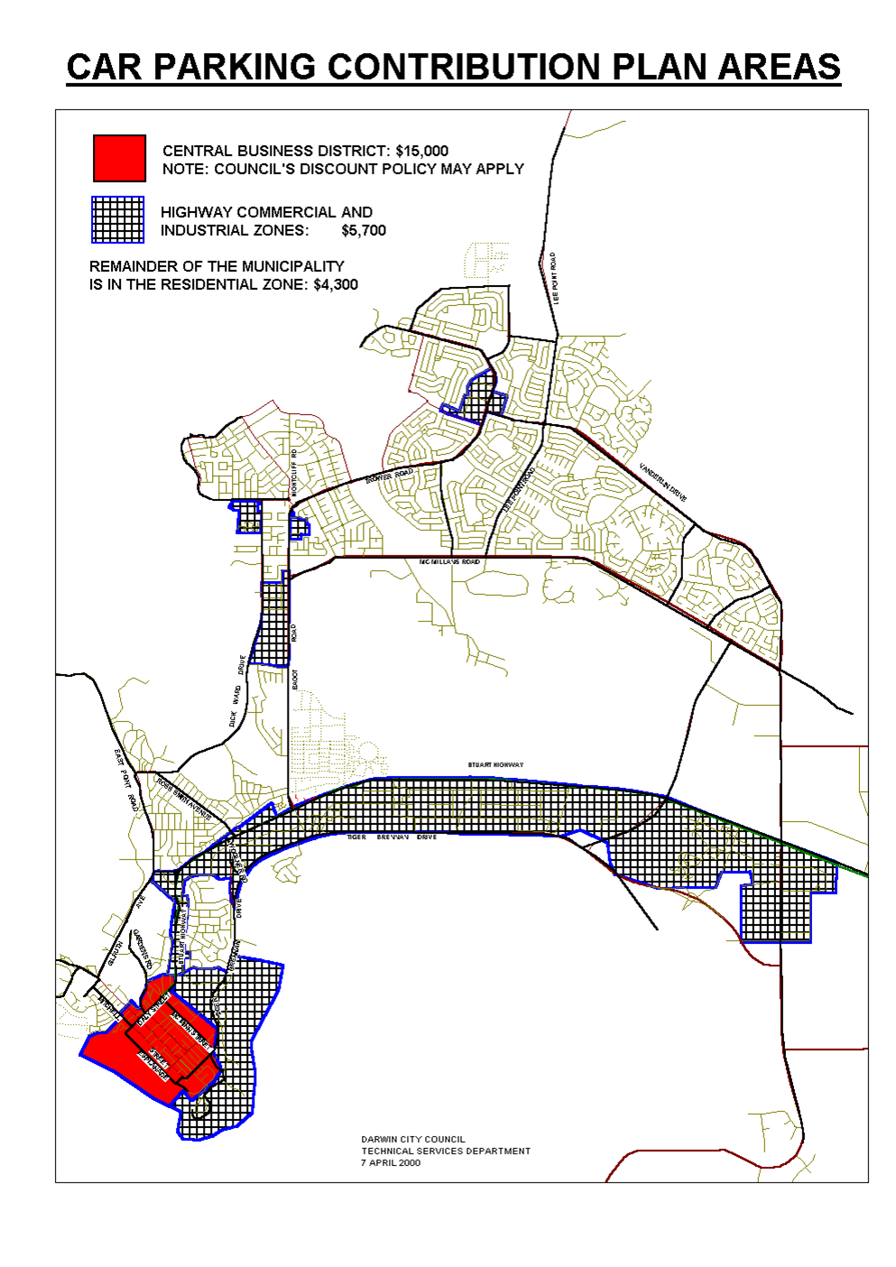
- Basis of charges

  - Introduction
Consistent with Council’s objective of certainty, developer contributions will be assessed on the basis of the NT Planning Act 1993 (Section 28) provisions including amendments and any relevant studies such as, The Economics of Car Parking in Darwin CBD, SKM Economics, June 1997.
In general, in determining the level of developer contributions, the following costs need to be considered when assessing infrastructure required to meet the defined need:
- studies;
- acquisition of land;
- construction costs (including entry/exit barriers, revenue collection devices, signage etc).

Contribution charges for provision of facilities in the CBD Plan Area have been based on the land and construction costs of a multi-storey (>500bay) facility.
  - Nexus
Development within the Municipality of Darwin will lead to increased demand for car parking facilities. Much of this additional capacity will be provided by developers under existing planning requirements. Where car parking is not provided at the prescribed level under planning requirements, Council will ensure that adequate provision is made.
With respect to car parking provision within the CBD Plan Area, a key input to consideration in terms of demand (needs analysis) and Council’s expected capital works in this area is the report - The Economics of Car Parking in Darwin CBD, SKM Economics, June 1997. This report provides estimates of the future requirement for Council-provided car parking within the CBD Plan Area. Furthermore, a key finding of this report is that future Council-provided car parking facilities within the CBD Plan Area will be by way of multi-story facilities. Note: See also Council’s Discount Policy with respect to contribution rates in the CBD, at Attachment A.
The SKM Economics’ report found that Council would be required to provide approximately 555 new spaces by 2006.
In preparing capital works programs for future investment by Council (which will be designed to accommodate growth in population and other outcomes of growth in economic activity, such as demand for car parking spaces), it will be necessary to provide assessments of the key ‘drivers’ of demand for infrastructure or infrastructure enhancement, including:
- identification of sites within the Municipality in terms of location, area (total and developable), likely development timeline, car parking requirements, itemized capital costs, and population (density, occupancy ratios etc.);
- likely changes to land use density in the Municipality;
- expected trends in commercial and residential construction (density, style of development etc.);
- changes to infrastructure standards; and
- identification of potential car parking facility sites within each Plan Area.

  - Staging
The staging of the car parking infrastructure investment associated with development will be dependent on:
- rate of growth / take up of development sites;
- land acquisition processes / site availability; and
- funding availability.

A crucial element of staging will be ensuring optimum and efficient resource use by way of ‘preferred sequencing’ of development. The capital works program of Council will be such that it incorporates consideration of efficient sequencing of development to ensure costs are not excessive or inefficiently incurred.

  - Calculations – CBD plan area
On the basis of the estimated cost to provide a multi-story car parking facility (>500 bays), the following formula is used to determine the Contribution Charge for car parking infrastructure in the CBD Plan Area:
C_{CP} = B * TC_{B}
where:
C_{CP} = contribution rate (per “bay not provided”)
B = number of “bays not provided” as per NT Planning Act 1993 requirements
TC_{B} = cost per multi-story bay
= $15,000 based on estimated construction costs and average land values in the CBD as of 21 June 1999
Note: See also Council’s Discount Policy with respect to contribution rates in the CBD, at Attachment A, and Council’s Discounting Mechanism for Provision of Basement Parking in CBD at Attachment B.
Highway Commercial / Industrial Plan Areas and Residential Plan Areas
The following formula is used to determine the Contribution Charge for car parking infrastructure in the Highway Commercial / Industrial and Residential Plan Areas:
C_{CP} = B * TC_{B}
where:
C_{CP} = contribution rate (per “bay not provided”)

B = number of “bays not provided” as per NT Planning Act 1993 requirements
TC_{B} = cost per off-street ground level bay constructed to Council standard plus the cost of respective land in each plan area.
= $5,700 (Highway commercial / Industrial Area) or
= $4,300 (Residential Plan Areas)
Average area per bay = 28 square metres
Average construction cost per bay = $1,500
Average land value in Highway Commercial / Industrial area = $150/square metre
Average land value in Residential Plan Area = $100/square metre

- Payment of contributions

  - Method of payment
The most common method of payment will be by way of a cash payment. However, Council will consider “works in kind” and land transfers as either partial or full payment. Council would need to be assured of a material public benefit when considering “works in kind” or a land transfer arrangement. Any valuation of “works in kind” or land transfer must be agreed with Council.
The works in a “works in kind” payment should be those which are listed in a current capital works program of Council. Council’s decision as to acceptance of “works in kind” and / or land transfer in lieu of cash payments (partially or in full) is final.
  - Timing of payment
Where payment is associated with a subdivision, payment is required on completion of physical infrastructure and prior to issue of titles. City of Darwin will not support the issue a Certificate of Completion until all contribution payments are received.
Where a development is associated with a change of use or is a new development (other than a subdivision), payment is required prior to occupation. A Certificate of Occupation will not be acceded to until all contribution payments have been received by Council.

Council and the holder of a Development Permit may enter into other arrangements for payment of developer contributions as otherwise specified in a written agreement.
Late payment of contributions shall incur interest at the same rate as those charged on late payment of Council rates under the Local Government Act.
  - Adjustment of contributions
Contributions will be adjusted at the time of payment in order to keep them relative to current day values.
The per bay charge and refunds will be adjusted quarterly in line with the Consumer Price Index (CPI) for Darwin, using the following formula:
Contribution at time of payment C x CPI₁
CPI₂
where:
C = original contribution
CPI₁ = latest CPI for Darwin from the Australian Bureau of Statistics
CPI₂ = the CPI for Darwin from the Australian Bureau of Statistics available at the time of calculating C

References

SKM Economics City of Darwin Draft Contribution Plan – Car Parking, Brisbane, 1999
SKM Economics The Economics of Car Parking in Darwin CBD, Brisbane,1997
NT Local Government Act 1993
NT Planning Act 1993

Attachment A

Council’s Discount Policy with respect to Contribution Rates in the CBD.
The Council, at its special meeting held on 10 December 1999, resolved as follows:
“That following the gazettal of the draft contribution plan, the Council’s discount policy, in terms of Section 32 of the Planning Act, shall provide for a net contribution rate of $7,500 per bay in the Central Business District, having regard for the value of a parking space based on the income stream which can be derived from the asset.”
The contribution rate in the CBD Plan Area is therefore $7,500.

Attachment B

Council’s Decision No.18\225 (25/07/00)

Policy
Council adopts the following Policy based on recommendations of Council’s CBD Car Parking Advisory Committee having regard for the Land Use Objectives and Incorporated Documents applying to the Central Darwin Planning concepts and Land Use Objectives 1999 (Central Darwin District).
“Car Parking Shortfall Contribution Discount Policy for Basement Parking July 2000”.
The number of bays to which a shortfall payment is required to be paid under this policy will be based on the following formula:
CB = SFB – 0.3BB or 0 whichever is the greater
CB = No. of Bays that attract a shortfall – (Contribution Bays)
Shortfall Payout = CB x Contribution rate as determined by Council’s Contribution Plan
= CB x $7,500 (at July 2000)
SFB = Shortfall determined by the Consent Authority
BB = No. of Basement Car Parking Bays that meet Standards
This Policy relates to Car Parking contributions as determined by the Consent Authority in accordance with Section 70(3) of the NT Planning Act 1999.

