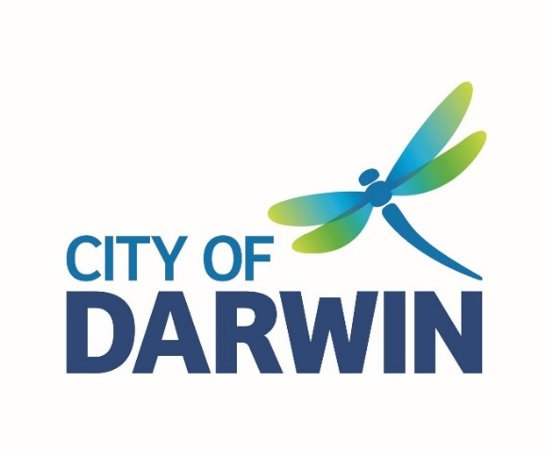
AGENDA

Ordinary Council Meeting
Tuesday, 28 May 2019
I hereby give notice that an Ordinary Meeting of Council will be held on:
Date: | Tuesday, 28 May 2019
Time: | 5.30pm
Location: | Council Chambers  Level 1, Civic Centre  Harry Chan Avenue, Darwin
Scott Waters
Chief Executive Officer

Ordinary Council Members
The Right Worshipful, the Lord Mayor Kon Vatskalis (Chair)
Alderman Andrew Arthur
Alderman Jimmy Bouhoris
Alderman Sherry Cullen
Alderman Justine Glover
Alderman Gary Haslett
Alderman Robin Knox
Alderman George Lambrinidis
Alderman Simon Niblock
Alderman Mick Palmer
Alderman Peter Pangquee
Alderman Rebecca Want de Rowe
Alderman Emma Young

Officers
Chief Executive Officer, Scott Waters
General Manager Innovation Growth & Development Services, Joshua Sattler
General Manager Community & Regulatory Services, Polly Banks
General Manager Corporate and Procurement Services, Chris Potter
General Manager Government Relations & External Affairs, Melissa Reiter
General Manager Engineering & City Services, Ron Grinsell
Coordinator Governance, Penny Hart

WEBCASTING DISCLAIMER
The City of Darwin is live webcasting the Open Section of Ordinary Council Meetings. Audio-visual recording equipment has been configured to avoid coverage of the public gallery area and the City of Darwin will use its best endeavours to ensure images in this area are not webcast. However the City of Darwin expressly provides no assurances to this effect and in the event your image is webcast, you will by remaining in the public gallery area be taken to have given the City of Darwin a non-exclusive licence to copy and broadcast your image worldwide for no reward.

Order Of Business
1 Acknowledgement of Country 5
2 The Lord’s Prayer 5
3 Meeting Declared Open 5
4 Apologies and Leave of Absence 5
5 Electronic Meeting Attendance 5
6 Declaration of Interest of Members and Staff 5
7 Confirmation of Previous Minutes 5
8 Matters of Public Importance / Lord Mayoral Minute 5
Nil
9 Public Question Time 5
10 Petitions 5
11 Deputations and Briefings 5
12 Notices of Motion 5
Nil
13 Officers Reports 6
13.1 3rd Quarter Budget Review - 2018/2019 6
13.2 Review of Policy 008 – Community Participation, Access and Inclusion 24
13.3 Access and Inclusion Advisory Committee Meeting Minutes 7 May 2019 48
13.4 Minutes and Committee Appointment for the Youth Advisory Committee Meeting 9 May 2019 61
14 Receive & Note Reports 65
14.1 MONTHLY FINANCIAL REPORT - APRIL 2019 65
14.2 Update on the Implementation of the Dog and Cat Management Strategy 2018-2022 75
14.3 ICT Request for Tender and Future Investment Update - May 2019 87
15 Reports of Representatives 89
16 Questions by Members 89
17 General Business 89
17.1 Acting Deputy Lord Mayor - 7 to 17 June 2019 89
18 Date, time and place of next Ordinary Council Meeting 89
19 Closure of Meeting to the Public 90
20 Adjournment of Meeting and Media Liaison 90

1 Acknowledgement of Country

2 The Lord’s Prayer

3 Meeting Declared Open

4 Apologies and Leave of Absence
4.1 Apologies

4.2 Leave of Absence Granted
Nil

4.3 Leave of Absence Requested

5 Electronic Meeting Attendance
5.1 Electronic Meeting Attendance Granted

5.2 Electronic Meeting Attendance Requested

6 Declaration of Interest of Members and Staff

7 Confirmation of Previous Minutes
Ordinary Ordinary Council Meeting - 14 May 2019

8 Matters of Public Importance / Lord Mayoral Minute
Nil

9 Public Question Time

10 Petitions

11 Deputations and Briefings

12 Notices of Motion
Nil

13 Officers Reports

13.1 3rd Quarter Budget Review - 2018/2019
Common No.: 2476534
Author: Executive Manager Finance
Authoriser: General Manager Corporate & Procurement Services
Attachments: 1. 3rd Budget Review Attachments A to E

Summary
The purpose of this report is to:
• Present the 3rd Quarter Budget Review and seek Council’s endorsement of recommended amendments to the budget.
• Provide additional financial information to supplement statutory monthly financial reporting and cost of services.

Recommendations
1. THAT the report entitled 3rd Quarter Budget Review - 2018/2019, be received and noted.
2. THAT Council amend the 2018/2019 budget, in accordance with Section 128 of the Local Government Act (2008), as detailed in report entitled 3rd Quarter Budget Review - 2018/2019 and contained in Attachments A-E with Municipal Budget Summary implications as per Attachment A:
a) “Operating Result (Income Statement)”, decrease of $708,000 (debit) leading to a reduction in “Funds from operations” of $708,000 (debit).
(Attachment A Notes 1).
b) “Purchases of assets”, decrease by $1,009,000 (credit). (Attachment E).
c) “Transfers to specific reserves” increases by $301,000 (debit)
(Attachment D).
d) The sum of the above (a-c) variations to the existing adopted budget results in a nil effect to the General Funds (Attachment A – Bottom Line).

Key Issues
• The 3rd Quarter Budget Review is presented as at 30 April 2019 and not as per past practice (as at March quarter ending). This is to ensure 2nd quarterly amendments are included in the amended budget and provides a more up to date presentation of actuals.
• There is currently no change in general funds.
• There is a decrease in the Net Operating Result (Income Statement) of $708k. This is mainly attributed to additional operational expenses that have been funded by transfers from capital accounts or utilisation of reserves.
• The 3rd Budget Review does not address additional expenditure for Cyclone Marcus clean up and recovery that has been incurred in 2018/19 - $2.1M YTD April. This will be addressed pending outcome of the first submission of NDRRA funding.

Background
Each quarter Council considers any variations required to the original budget. Where significant and urgent budget variations are necessary, these may be the subject of a separate more timely report and are then also included in the following quarterly budget review to ensure Council can be advised in relation to its overall projected results.

Discussion
This report outlines a high level summary of significant variations and should be read in conjunction with the detailed notes provided in the attachments for additional variations.

Net Operating Result
The budget variations decrease funds the Net Operating Result (the Income Statement) by $708,000. The detailed listings of all variations are provided in Attachment B.
The main reasons for the decrease are:
• Requests for additional operational expense funds for projects
funded by transfers from capital or request to utilise reserve funds $737k
Net reduction in operational income within Development program as targets will not be achieved $224k
• The decrease in the Net Operating Result funds has been partially offset by transfers of operational expense budgets to capital or as a result of reduction of income $46k.
• Net increase in capital income ($207k) due to recognition of grants which are offset by corresponding increases in capital expenditure (nil impact on general funds).

Purchases of Assets
Attachment E provides a full detailed listing of all capital expenditure (purchase of asset) budget adjustments with significant variations listed below.
Decreases in purchases of assets include:
• $1.3M transfer plant & equipment replacement program to Plant Reserve as 2018/19 program on hold (will resume in 2019/20).
• $633k reduction in Mindil Beach Seawall Reconstruction budget to offset increases in other programs (eg purchase of 4000 trees and Tambling Tce pedestrian crossing) and to offset overall funding required due to reductions in Development income.
• $591k Walkway Shading Smith and Bennett St Structures transfer to Unspent Grants Reserve as funds will be expended in 2019/20.
• $459k Weighbridge entrance works at Shoal Bay transfer to Waste Management Reserve due to project delays.
• $262k net transfer from capital budgets to operational expense budgets.
Increases in purchases of assets:
• $925k Shoal Bay Leachate Treatment design costs funded from Waste Management Reserve
• $556k Laneway Activation – Austin Lane Revitalisation transfer NTG funds from Unspent Grants Reserve for 18/19 expenditure
• $287k Blackspot grant program Lee Point Rd & Union Tce intersection
• $226k Smith St Greening transfer NTG funds from Unspent Grants Reserve for 18/19 expenditure
• $140k Tambling Tce pedestrian crossing funded from reduction in Mindil Beach Seawall Reconstruction
Reserve Transfers
The 3rd Budget Review includes an increase in transfers to reserves.
Transfers to reserves:
• $1.3M Plant Replacement Program transfer funds to Plant Reserve as 2018/19 program on hold (will resume in 2019/20).
• $591k Walkway Shading Smith and Bennett St Structures transfer funds to Unspent Grants Reserve as funds will be expended in 2019/20.
• $459k Weighbridge entrance works at Shoal Bay transfer funds to Waste Management Reserve due to project delays.
Transfers from reserves:
• $925k Shoal Bay Leachate Treatment design costs funded from Waste Management Reserve
• $557k Laneway Activation – Austin Lane Revitalisation transfer funds from Unspent Grants Reserve for 18/19 expenditure
• $226k Smith St Greening transfer funds from Unspent Grants Reserve for 18/19 expenditure
• $194k increase in operational expenses for supernumerary positions at Shoal Bay and costs associated with mulch fire at Leanyer Depot funded from Waste Management Reserve
• $146k increase in operational expenses for off street parking funded from Off & On Street Carparking Reserve. Increase in expenses includes $108k for mandatory EMV Upgrades to 30 off street parking meters and $38k increase in utility expenses.

Strategic Environment
The issues addressed in this Report are in accordance with the following Goals/Strategies as outlined in the ‘Evolving Darwin Towards 2020 Strategic Plan’:

Goal
5 Effective and Responsible Governance

Outcome
5.5 Responsible financial and asset management

Key Strategies
5.5.1 Manage Council’s business based on a sustainable financial and asset management strategy

Legislative/Policy
Nil

Consultation
This report was considered by the Strategic Directions Team on 23 May 2019 and is now referred to Council for consideration.

Internal
In preparing this report, the following City of Darwin officers were consulted:
• Budget Managers in relation to requests for budget variations

External

Budget/Resource Implications
Adoption of the recommendations in this report will result in Council varying the 2018/19 budget. Budget implications are detailed in the discussion of the report.

Risk
There is no legislative requirement for quarterly budget reviews.
Adoption of the recommendations in this report will result in Council varying the budget in accordance with Section 128 of the Local Government Act.

Legal
Section 127 (3) of the Local Government Act prohibits Council from adopting a deficit budget.

Arts, Culture & Environment
Nil
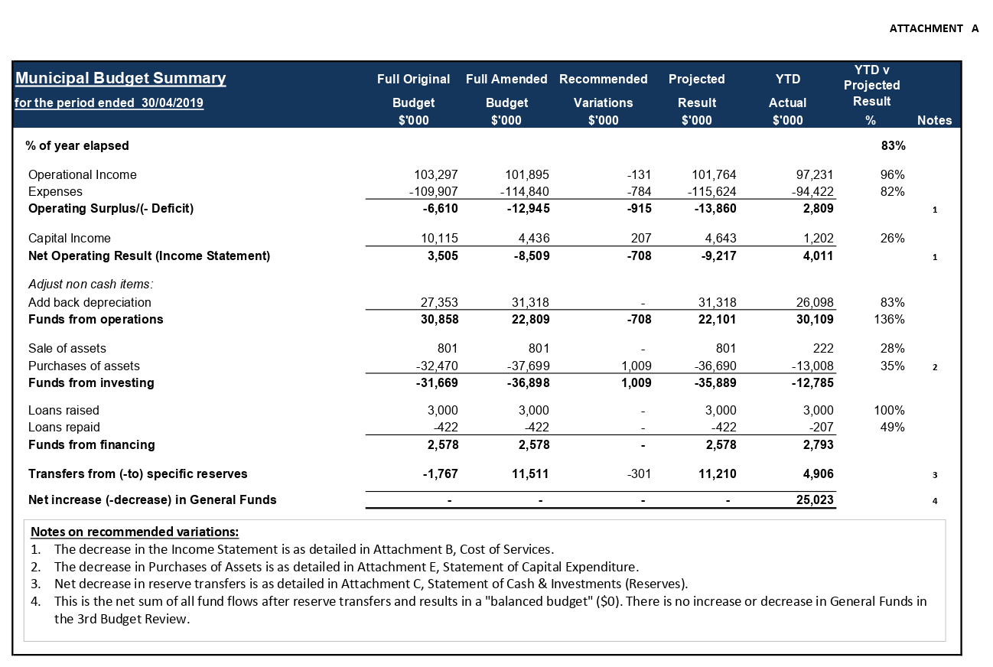

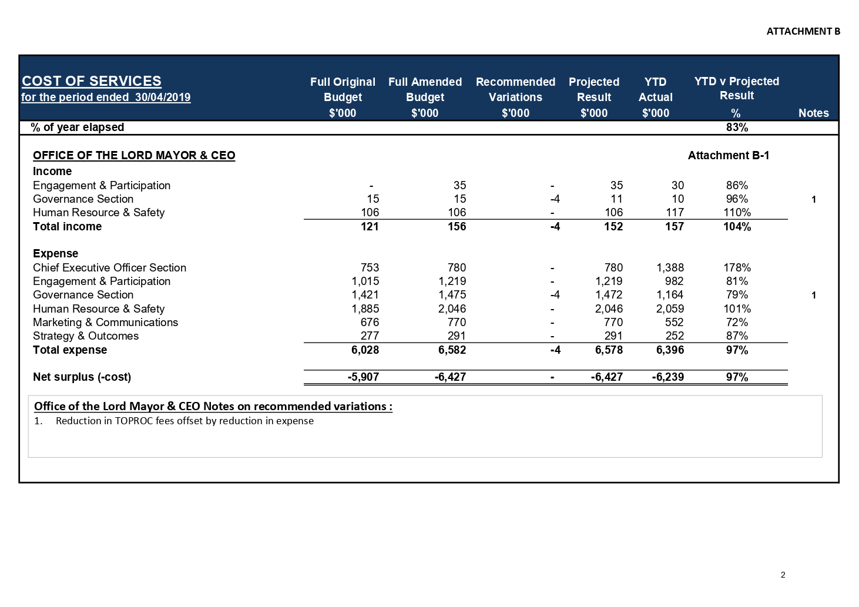

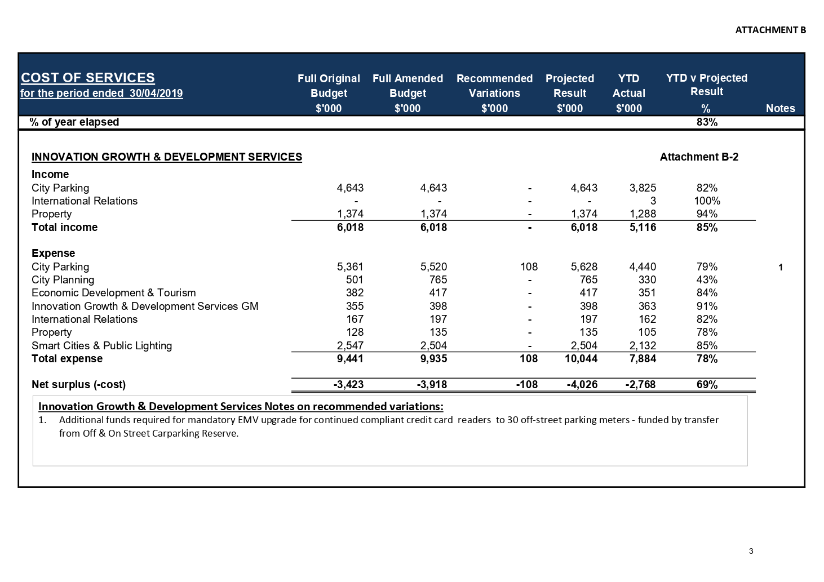

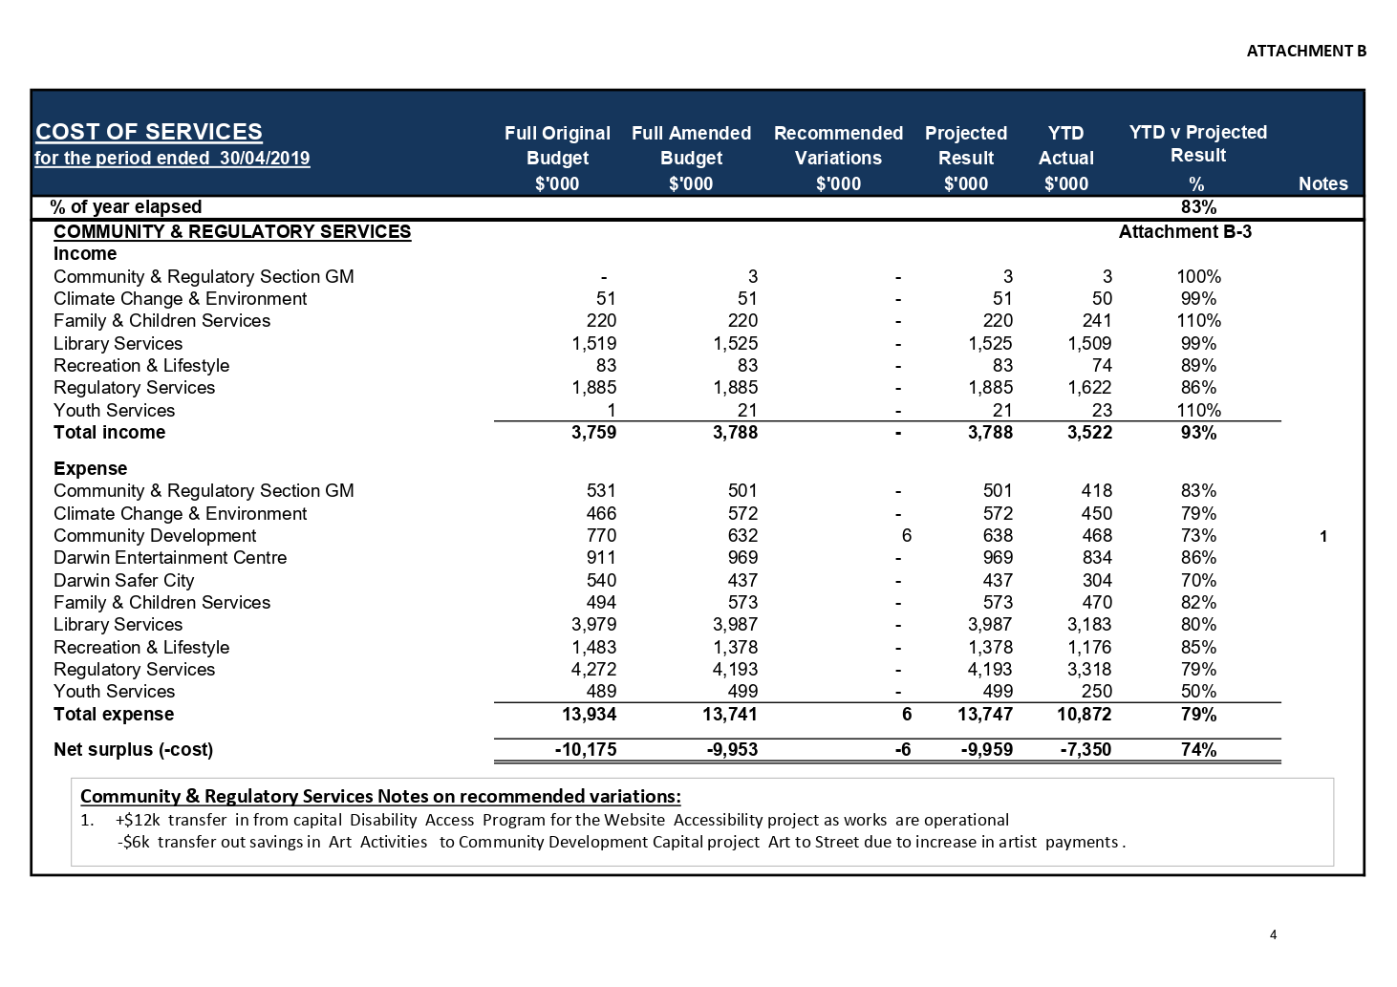

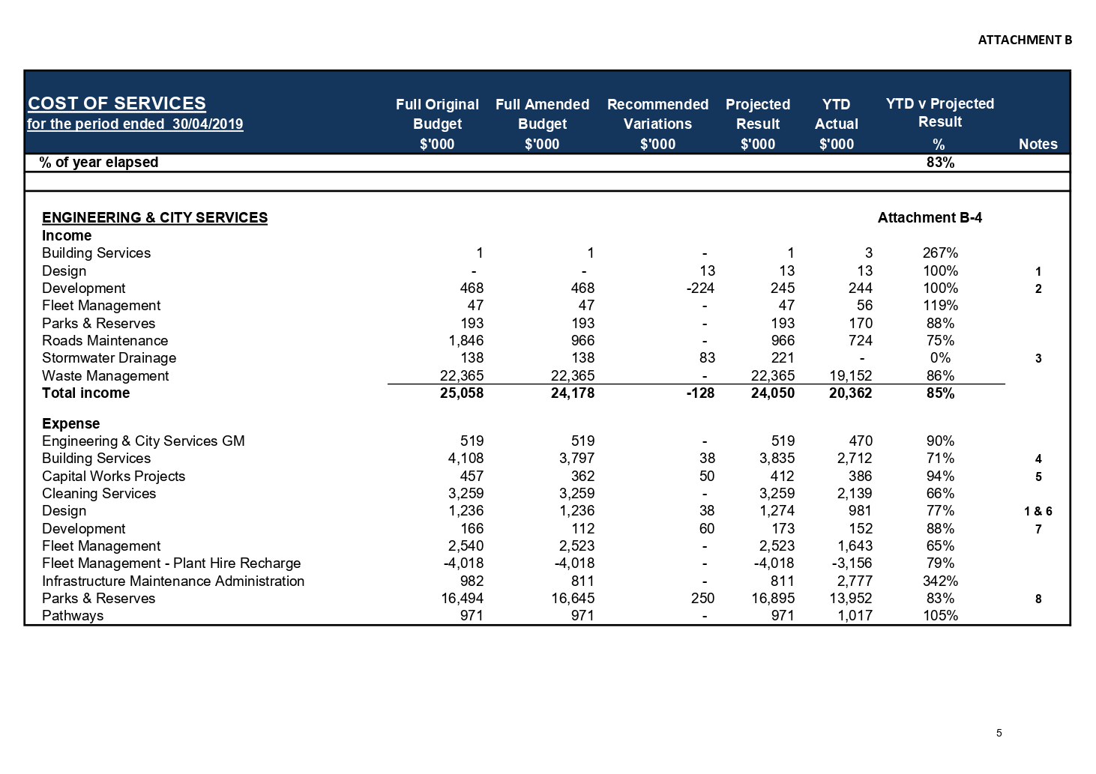

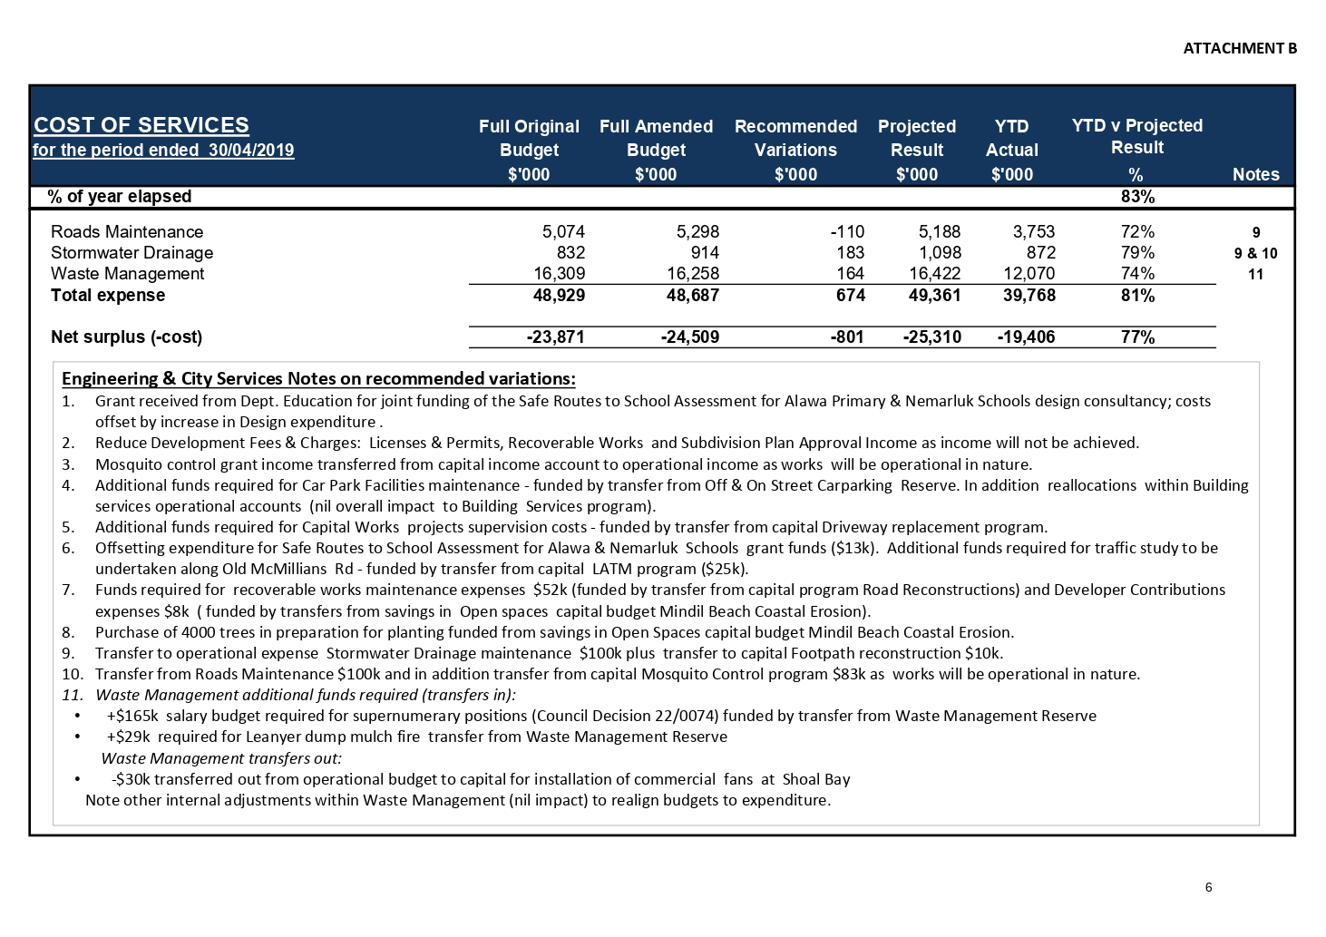

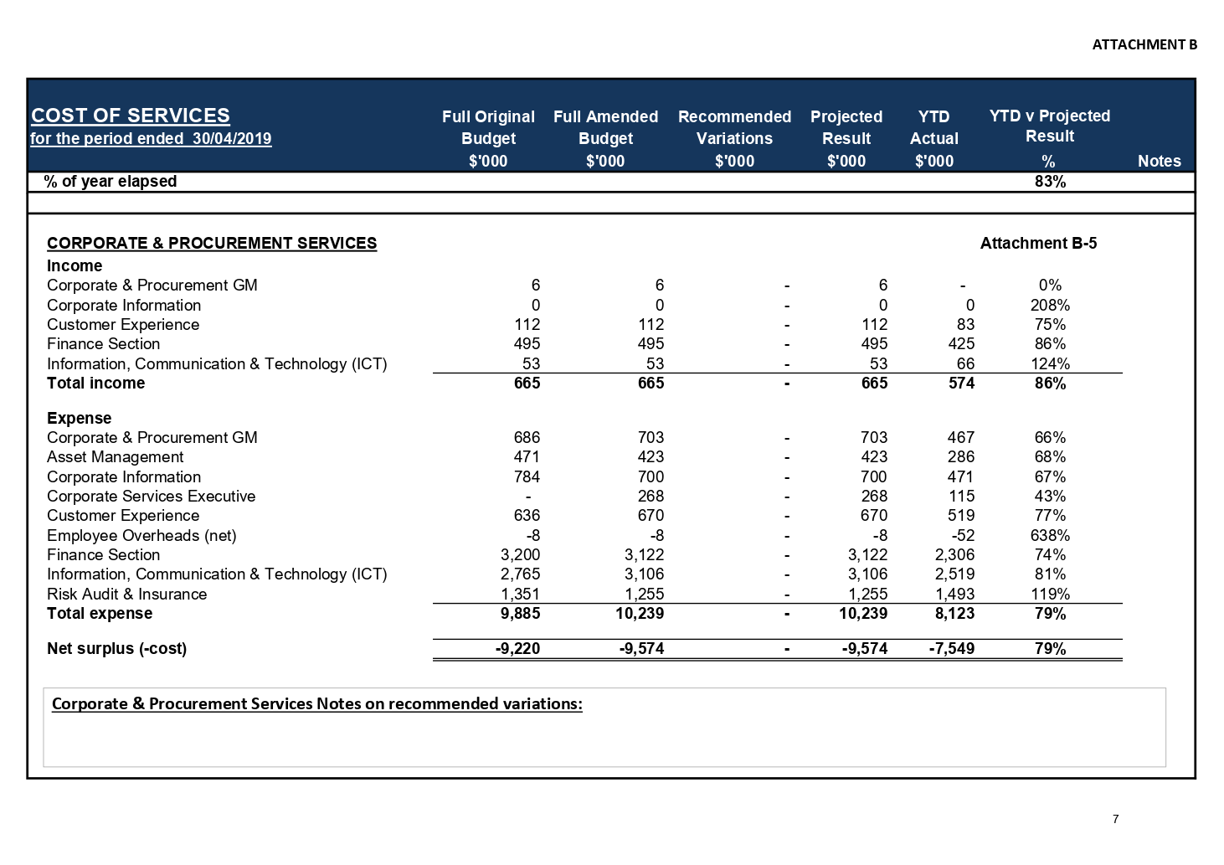

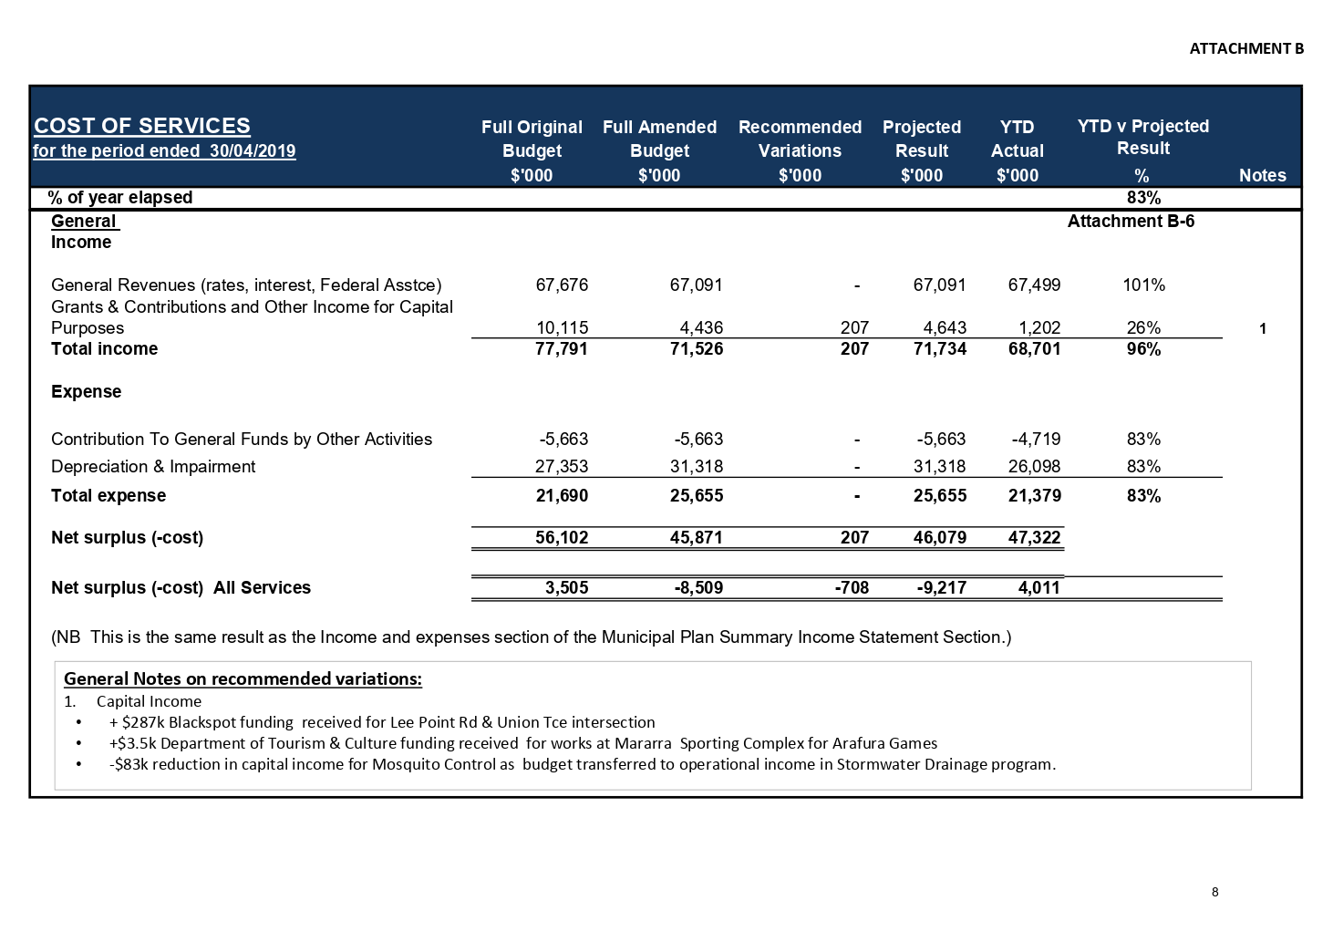

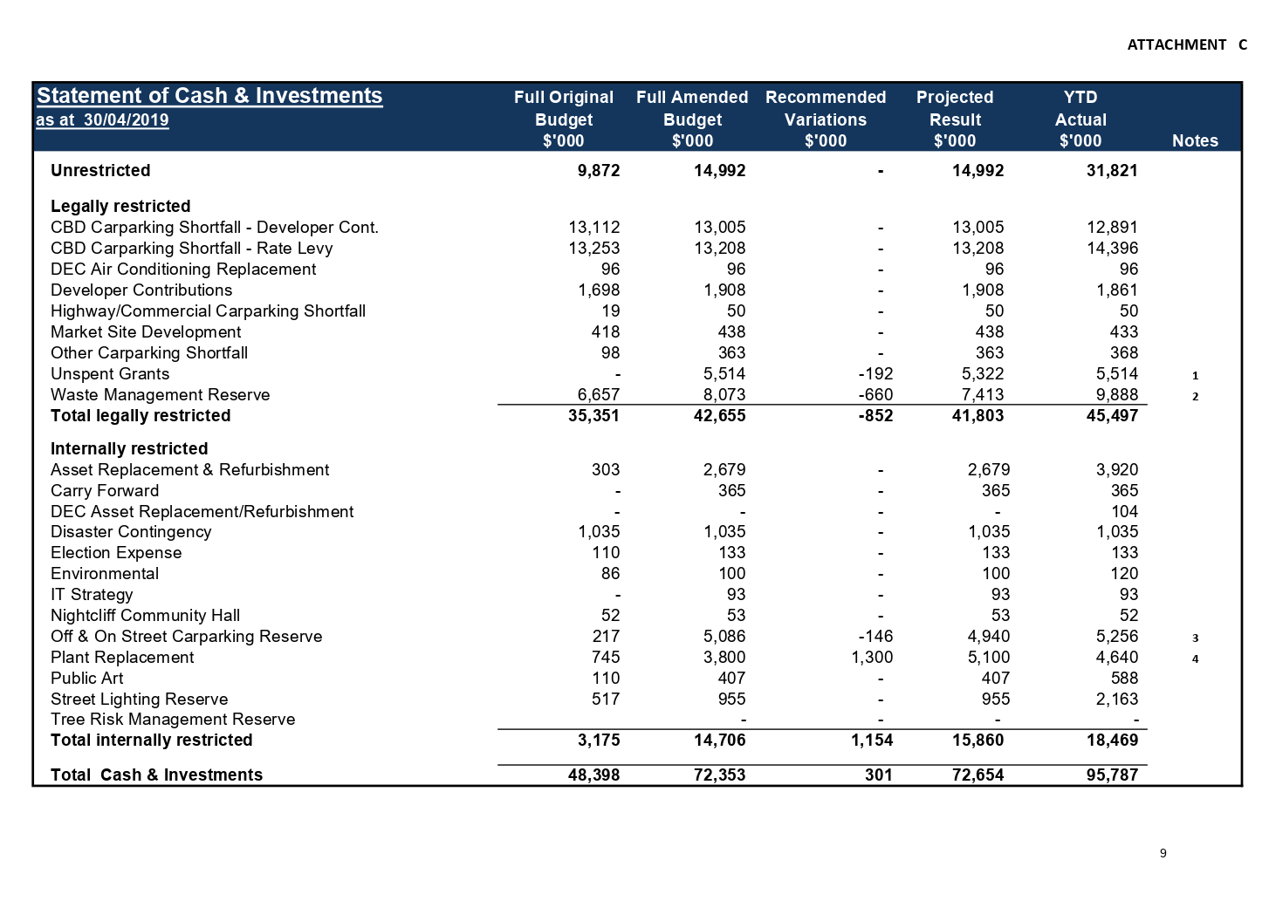

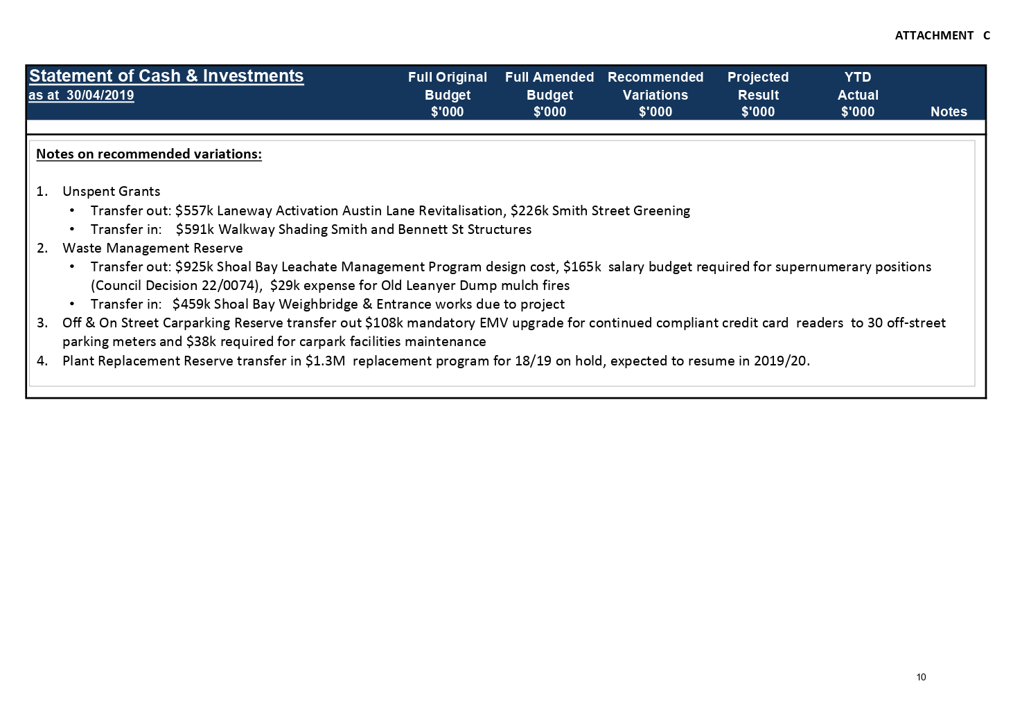

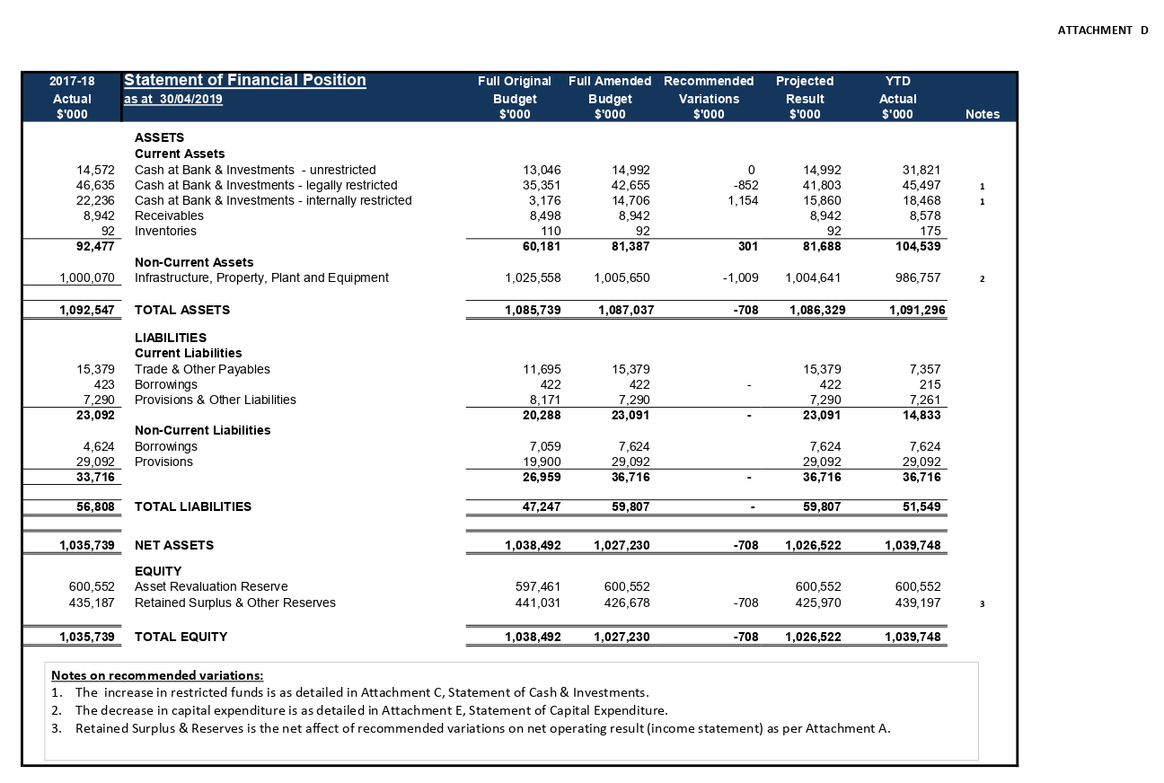

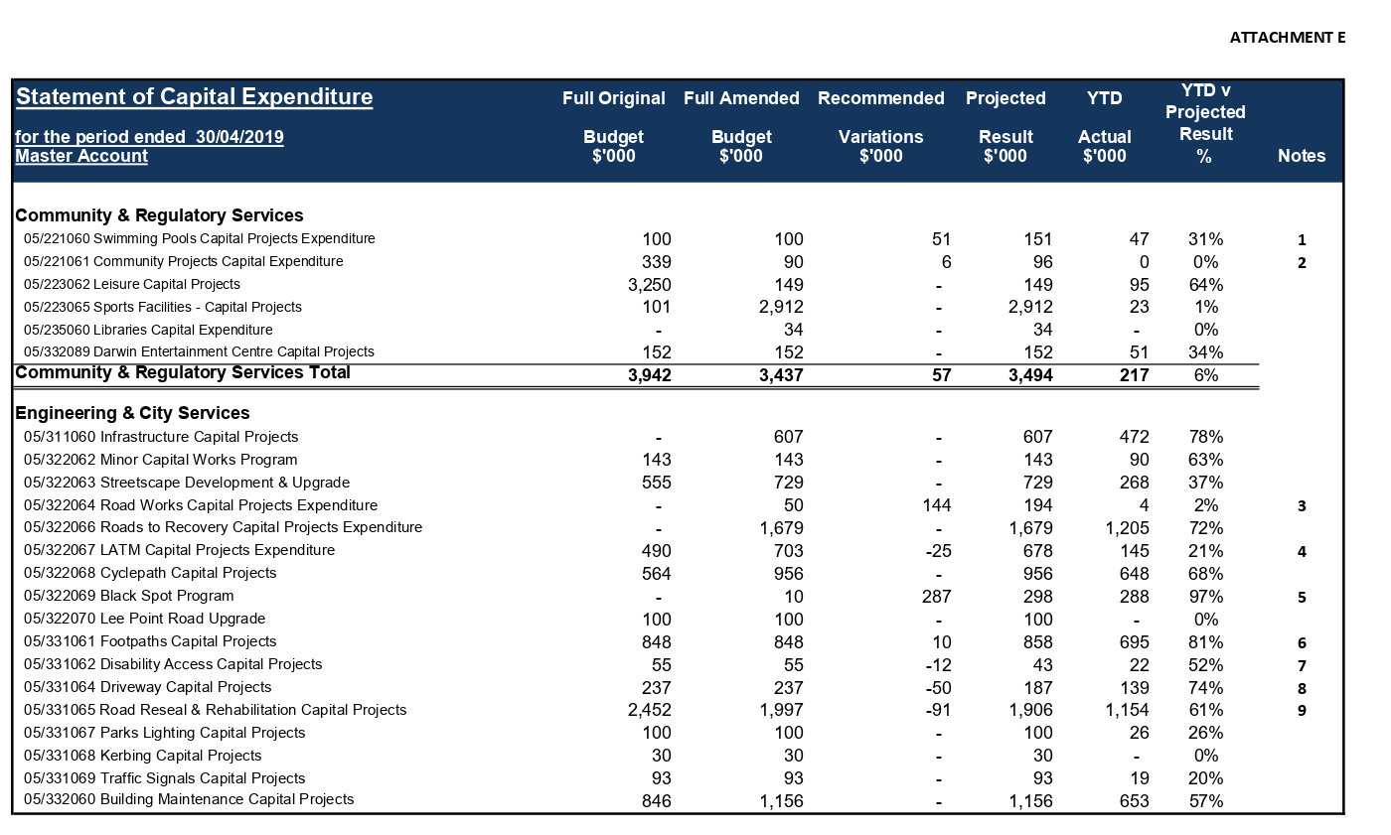

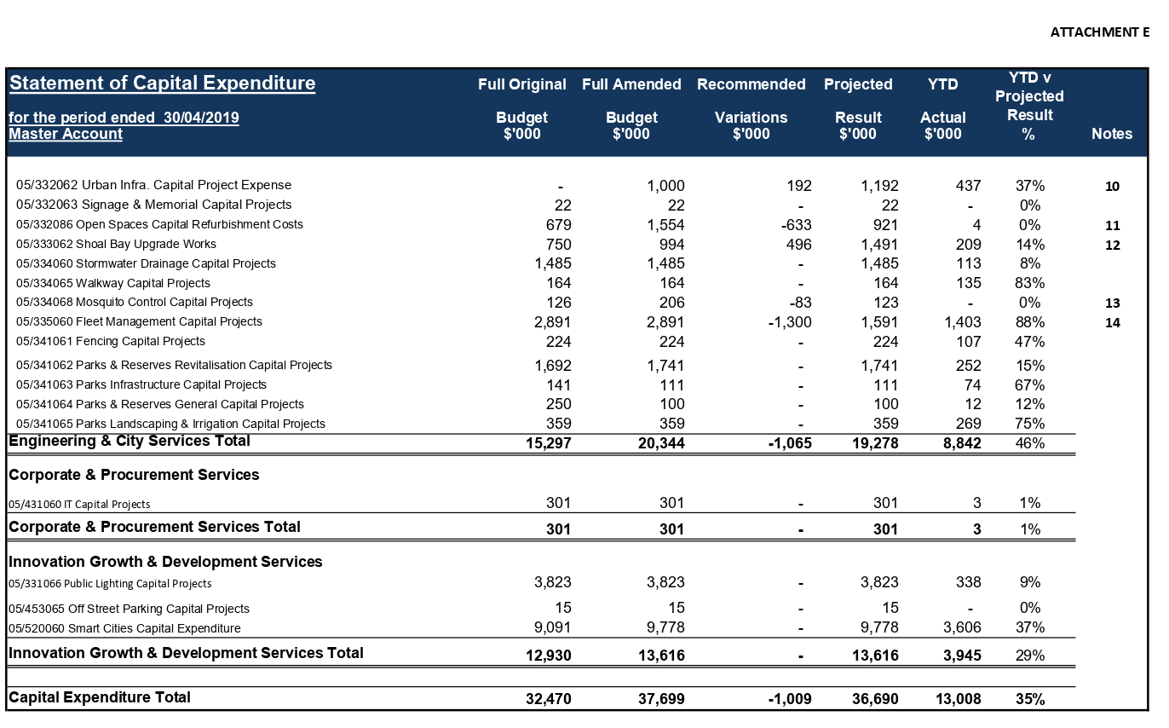

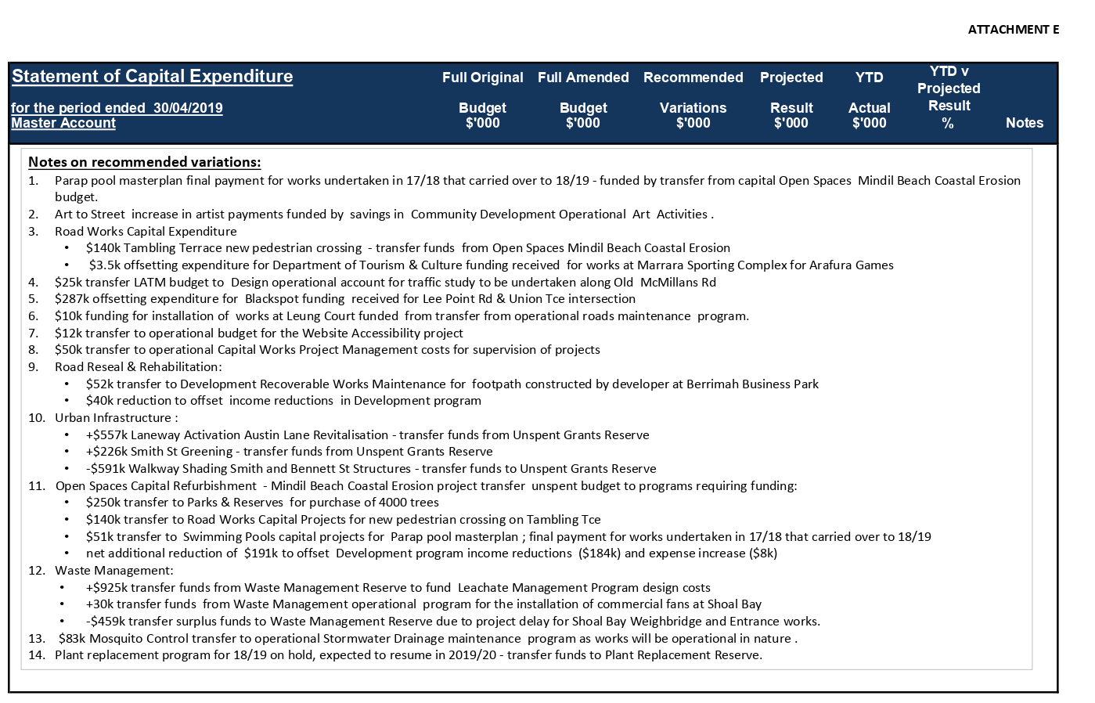

13.2 Review of Policy 008 – Community Participation, Access and Inclusion
Common No.: 2117979
Author: Community Development Officer
Authoriser: Executive Manager Environment & Community
Attachments: 1. Current Policy No. 008 - Community Participation, Access and Inclusion
2. Proposed Policy No. 008 - Community Inclusion
3. Track Changes Policy No. 008 Community Participation, Access and Inclusion

Summary
The purpose of this report is to seek Council endorsement of the revised City of Darwin Policy No. 008 – Community Inclusion.

Recommendations
1. THAT the Report entitled Review of Policy 008 – Community Participation, Access and Inclusion be received and noted.
2. THAT Council endorse City of Darwin Policy No. 008 – Community Inclusion at Attachment 2 to report entitled Review of Policy 008 – Community Participation, Access and Inclusion.

Key Issues
• City of Darwin Policy No. 008 – Community Participation, Access and Inclusion (Attachment 1) was first adopted in February 2010, and reviewed in 2015.
• The policy is being reviewed in line with the new term of Council.
• Council endorsed the Access and Inclusion Plan 2019– 2022 in February 2019.
• The Proposed City of Darwin Policy No. 008 - Community Inclusion (Attachment 2) aligns with this document and has been contemporised to reflect current and future practice.
• The review process has taken a principle driven approach and removes procedural information from the policy.
• A tracked changes document is provided at (Attachment 3).

Background
DECISION NO.22\1360 (12/03/19)
Access and Inclusion Plan (2019-2022)
Report No. 19C0115 SG:es (12/03/19) Common No. 1041889

B. THAT Council endorse the City of Darwin Access and Inclusion Plan 2019- 2022 at Attachment 1 to Report Number 19C0115 SG:es entitled Access and Inclusion Plan (2019-2022).

DECISION NO.21\3351 (26/05/15)

Community Services, Cultural and Social – General Policy Review
Report No. 15C0041 AH:es (18/05/15) Common No. 2117979

C. THAT Council endorse and adopt policy No. 008 Community Participation, Access and Inclusion at Attachment C of Report Number 15C0041 AH:es entitled Community Services, Cultural And Social – General Policy Review.

Discussion
City of Darwin Policy No. 008 – Community Participation, Access and Inclusion (Attachment 1) is required to be updated in line with the new term of Council. The Draft City of Darwin Policy No 008 – Community Inclusion (Attachment 2) has been strategically aligned with the Access and Inclusion Plan 2019 – 2022 endorsed by Council in February 2019. It has been contemporised to reflect current and future practice.
In addition, operational information that was contained in the policy and is already captured adequately in other Council strategic documents has been removed, and the draft policy instead focuses on embracing the principles of community inclusion across Council operations. The policy purpose, scope, statement, definitions, legislative references and related documents have been updated to reflect this. The policy has been revised to the new City of Darwin template.

Strategic Environment
The issues addressed in this Report are in accordance with the following Goals/Strategies as outlined in the ‘Evolving Darwin Towards 2020 Strategic Plan’:

Goal
1 Collaborative, Inclusive and Connected Community

Outcome
1.1 Community inclusion supported

Key Strategies
1.1.1 Develop and support programs, services and facilities, and provide information that promotes community spirit, engagement, cohesion and safety

Legislative/Policy
Each Council policy is required to be reviewed once in the term of each Council. The existing Council Policy 008 - Community Participation, Access and Inclusion was adopted in February 2010 and will be superseded by the updated policy once endorsed.
The revised policy and the Access and Inclusion Plan (2019 – 2022) will both support Council in meeting its obligations under the Commonwealth Disability Discrimination Act 1992 (DDA) and other relevant legislation outlined in the Draft Policy.

Consultation

Internal
In preparing this report, the following City of Darwin officers were consulted:
• Manager Strategy and Outcomes
• Executive Manager Environment and Community
• Executive Manager Operations
• Manager Design Development and Projects
• Community and Cultural Development Coordinator
• Family and Children’s Services Coordinator
• Youth Events and Training Officer
• Darwin Safer City Program Coordinator
• Senior Climate Change and Environment Officer
• Manager Library Services
• Recreation and Leisure Coordinator
• Marketing and Communications Manager
• Senior Capital Works Coordinator

External
• City of Darwin Access and Inclusion Advisory Committee

Budget/Resource Implications

NilRisk
City of Darwin Policy No. 008 – Community Inclusion will support Council in meeting its obligations under the Commonwealth Disability Discrimination Act 1992 (DDA) and other relevant legislation outlined in the draft policy.

Legal
Nil

Arts, Culture & Environment
City of Darwin Policy No. 008 – Community Inclusion provides a framework for the provision of key community services and programs that are responsive, celebrate diversity, provide equity of access, and build community capacity.

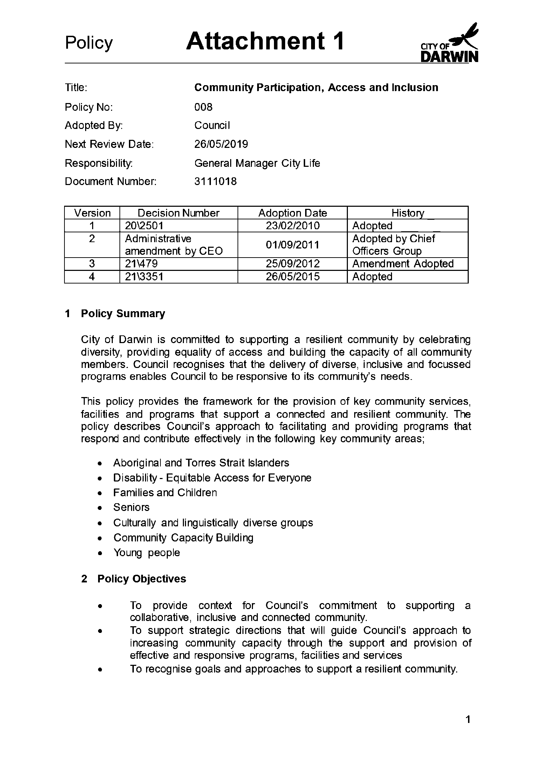

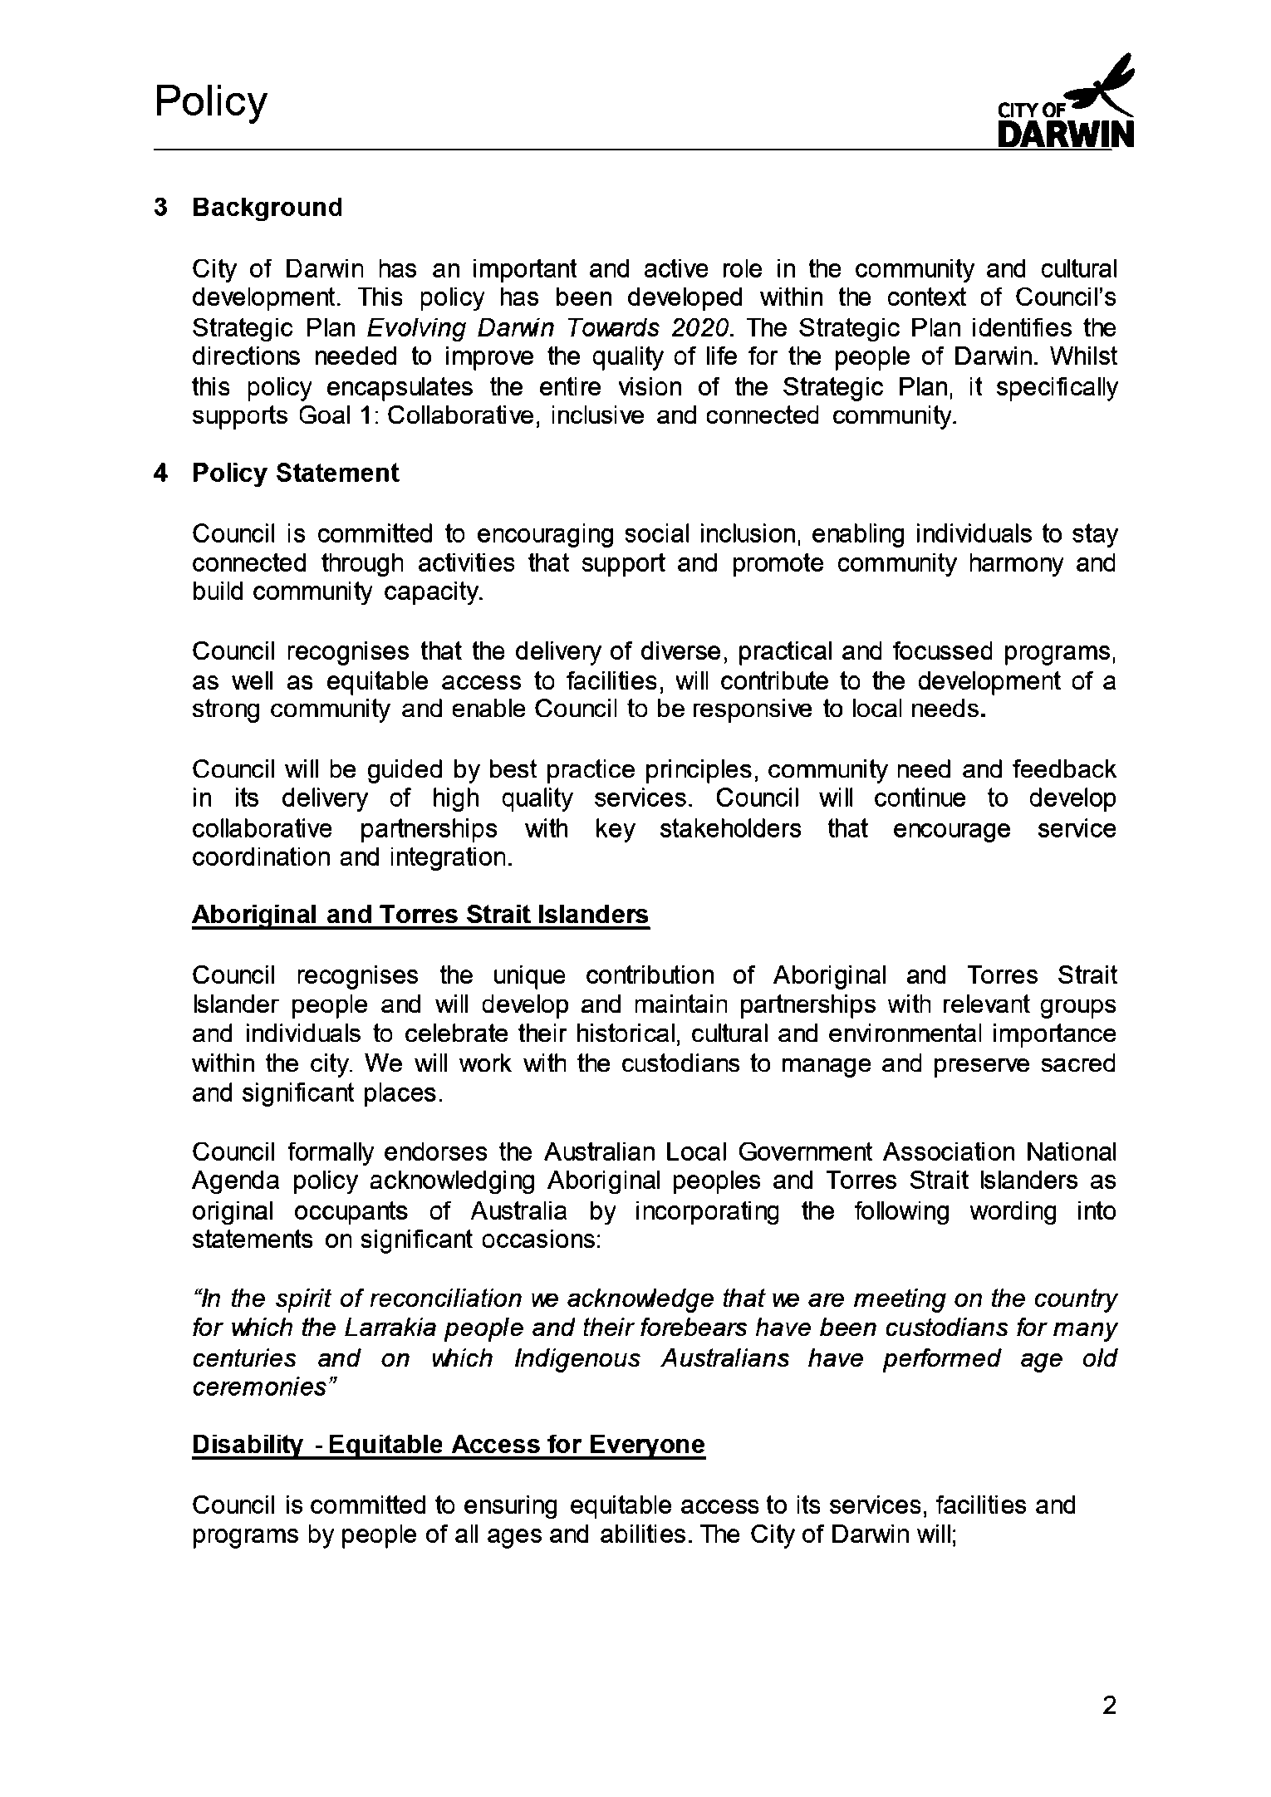

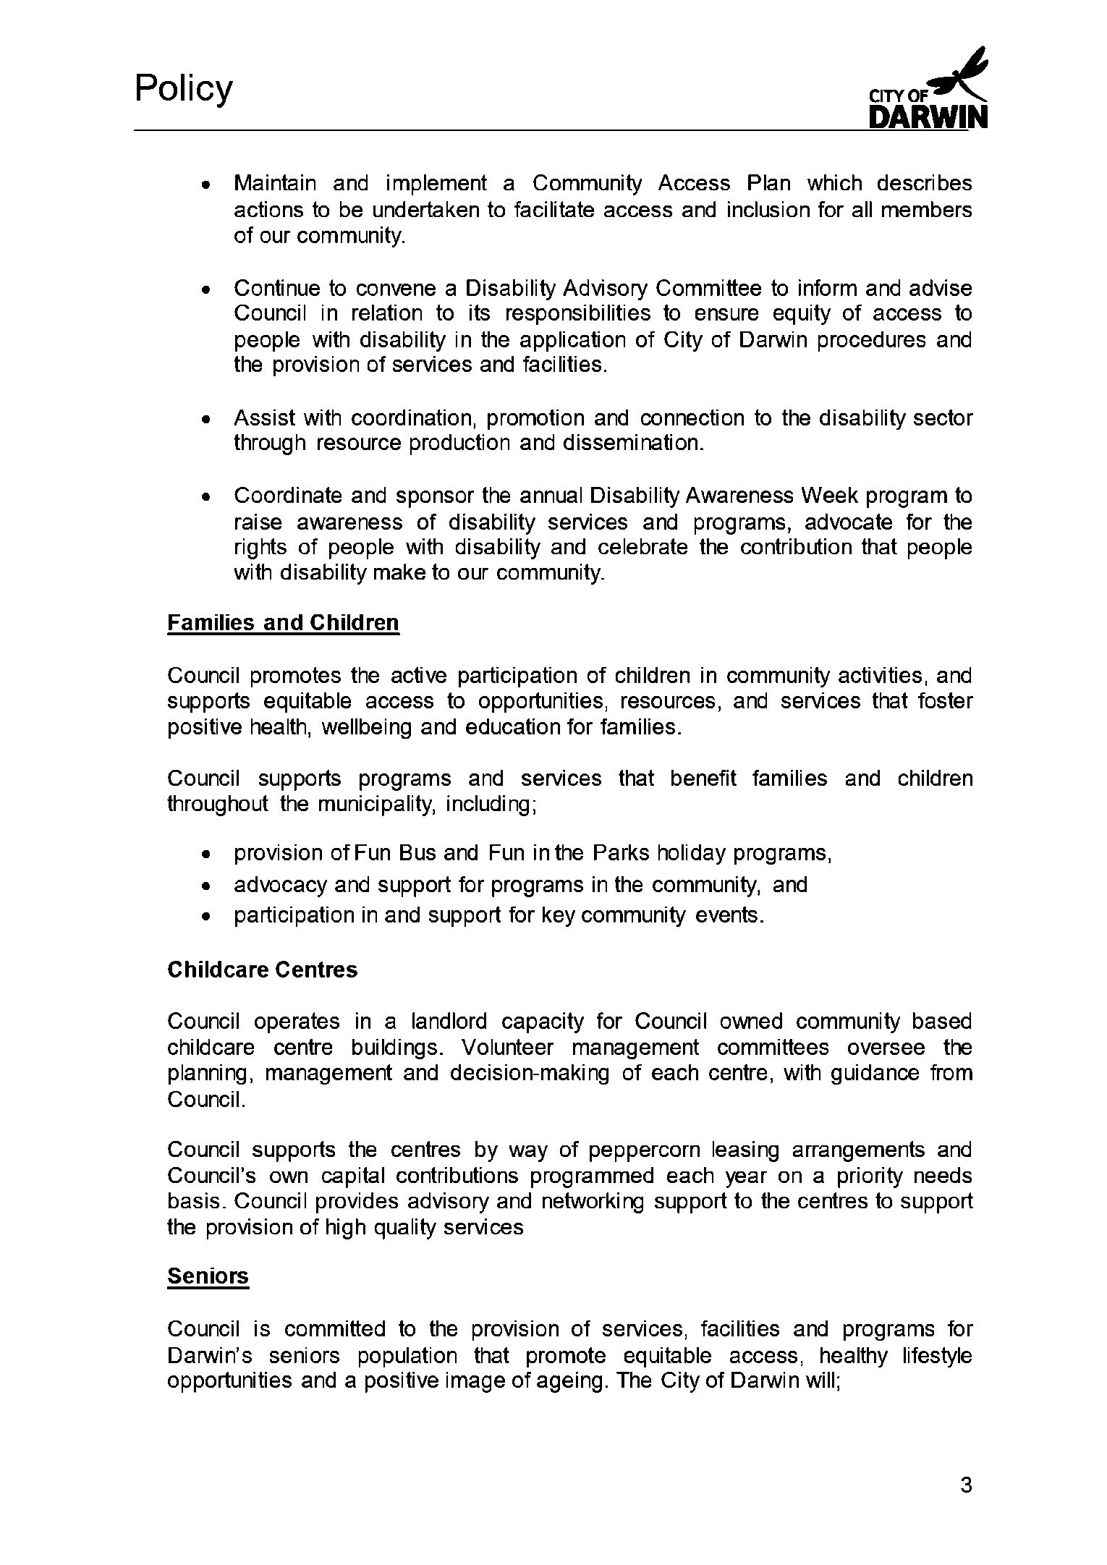

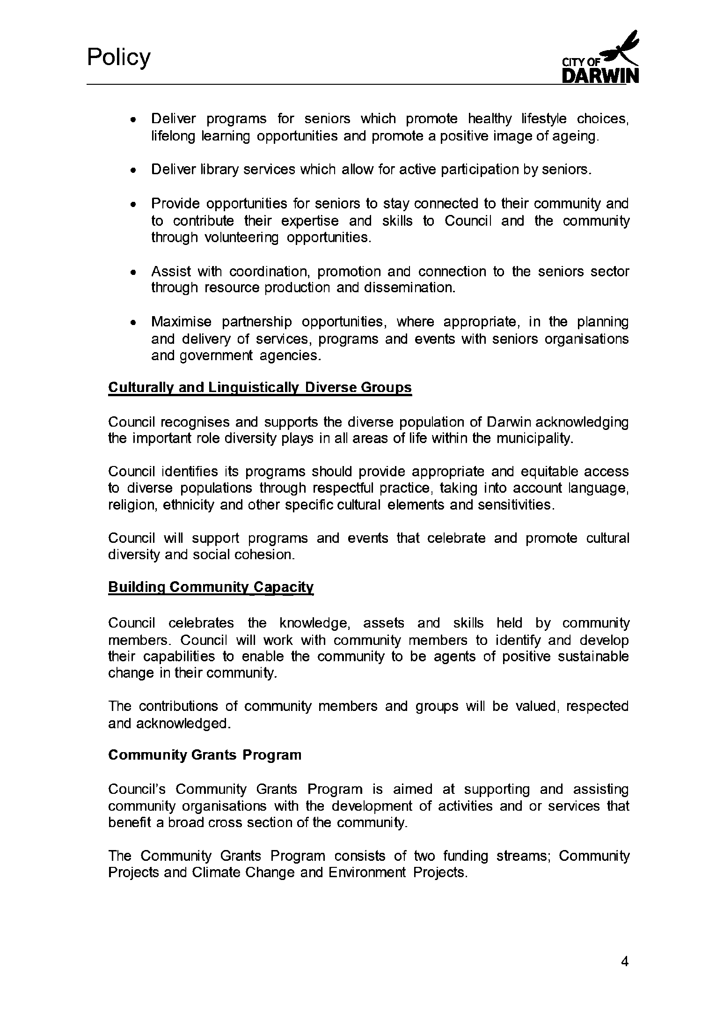

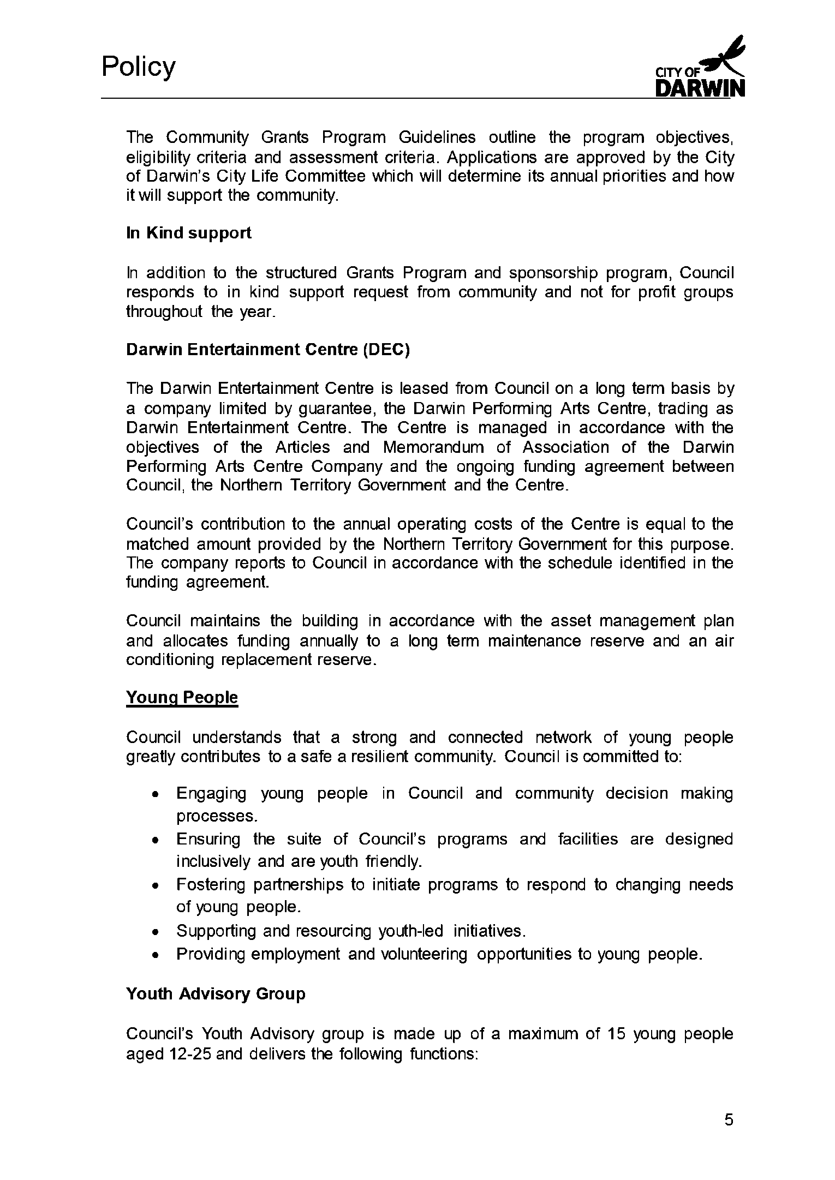

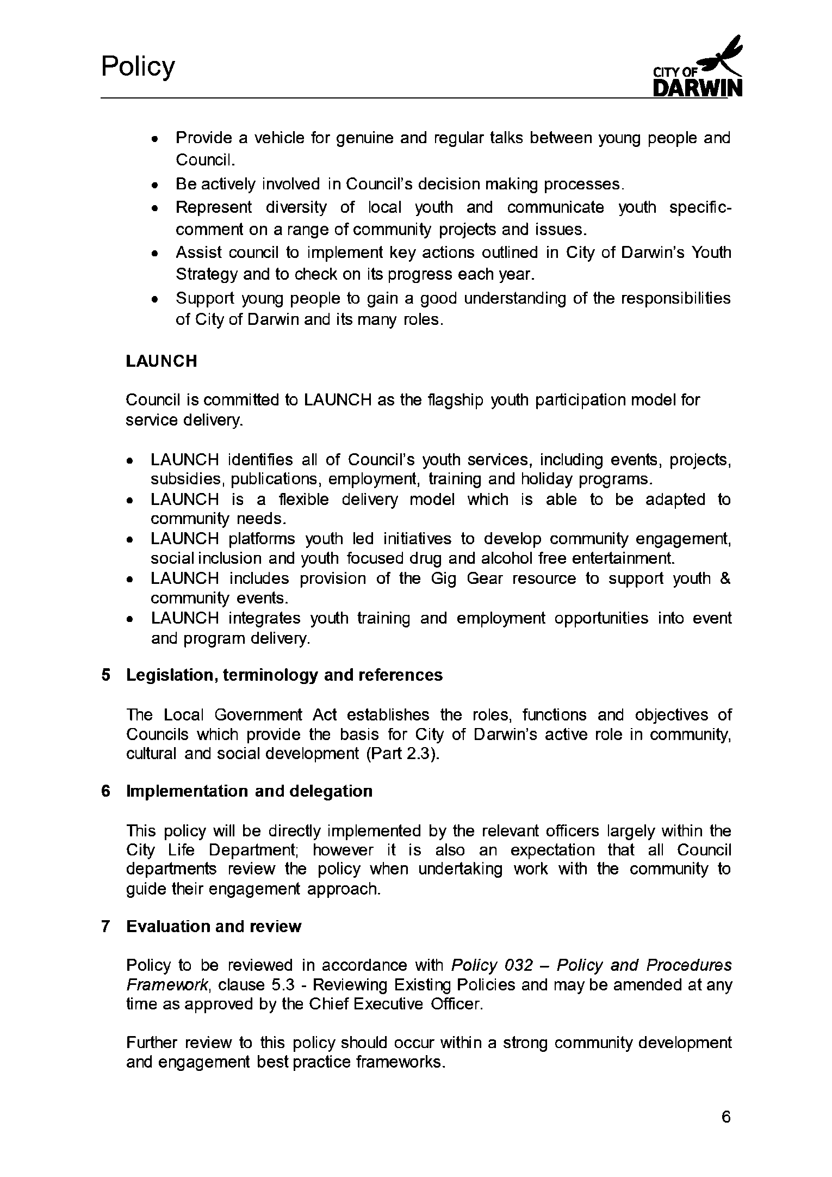

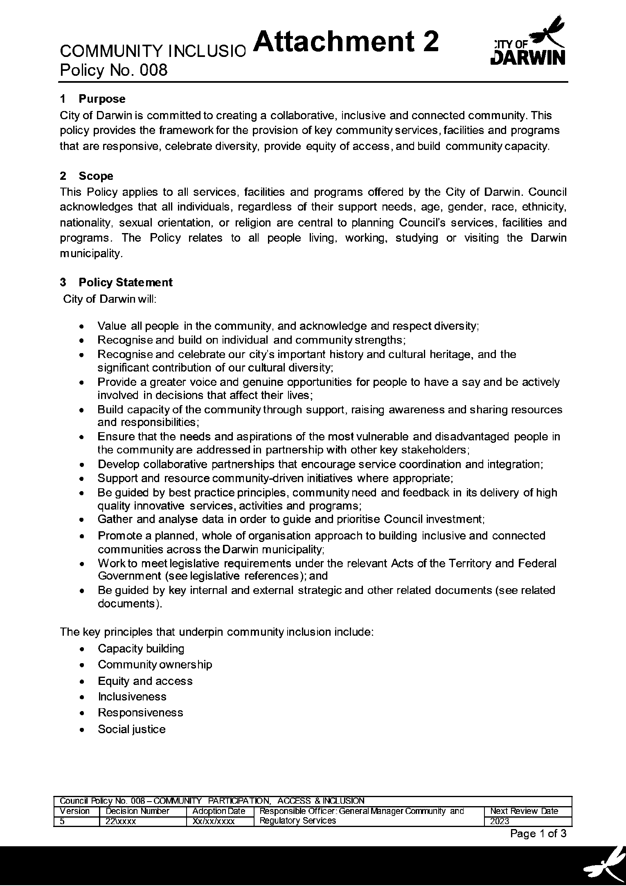

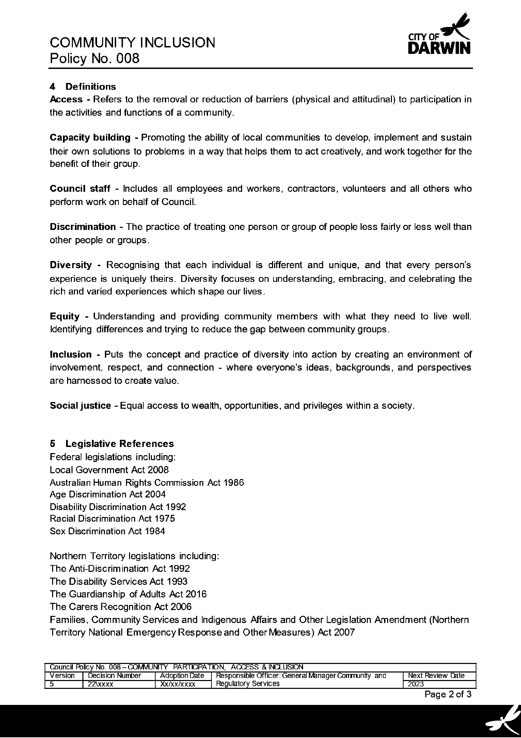

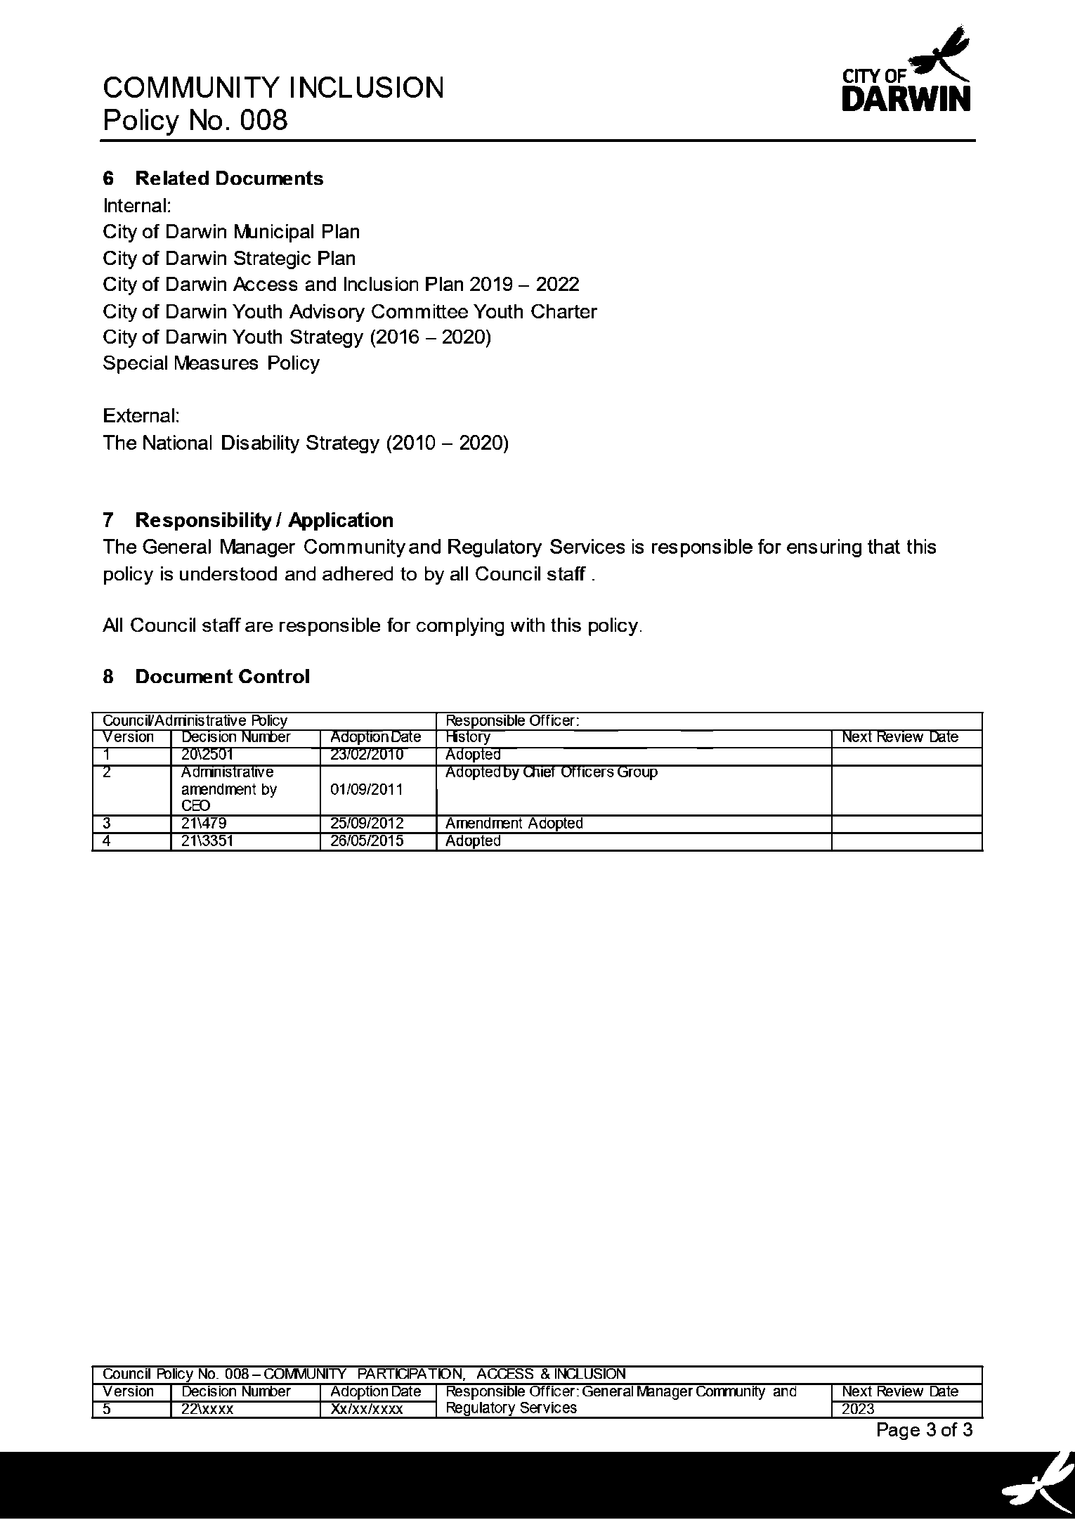

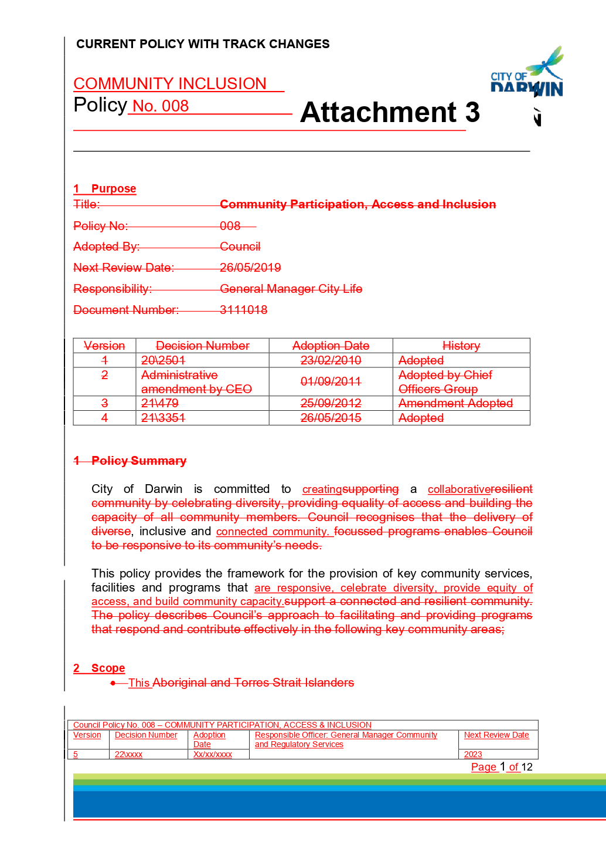

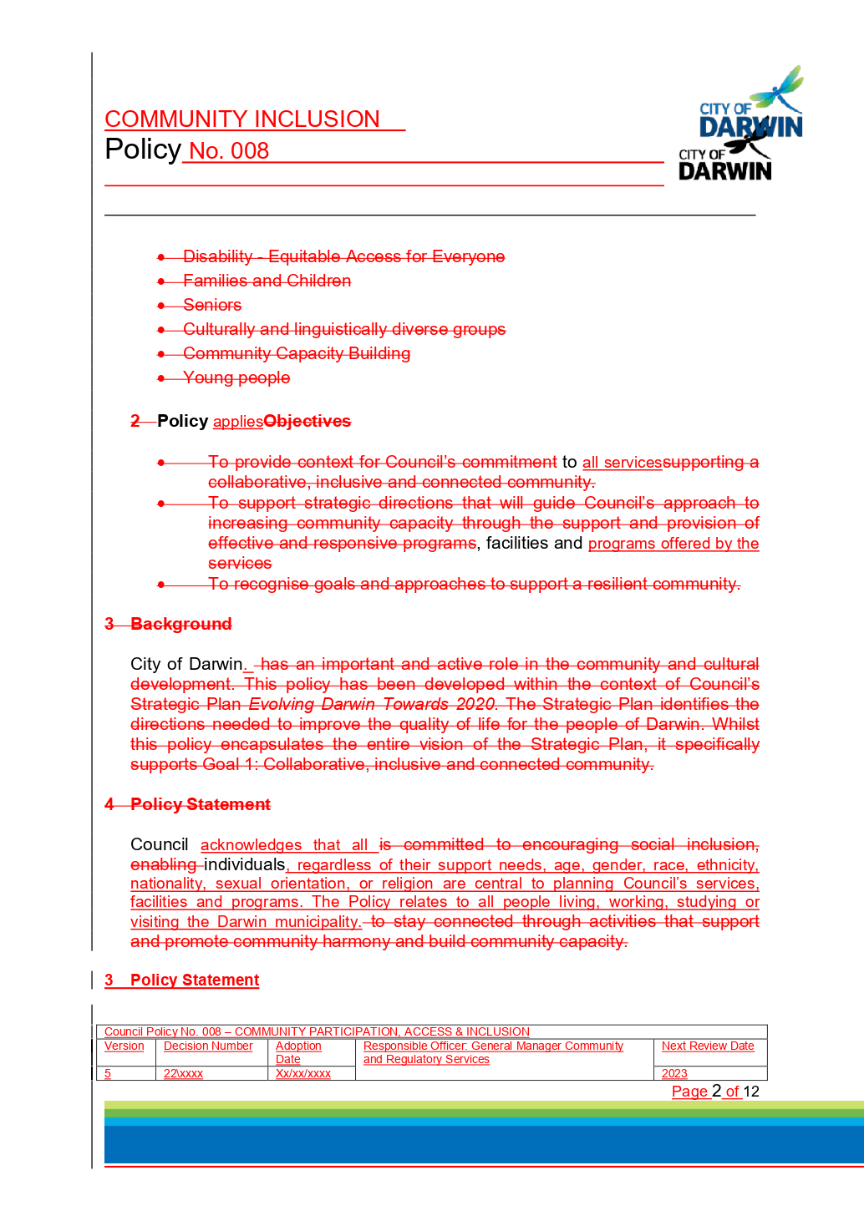

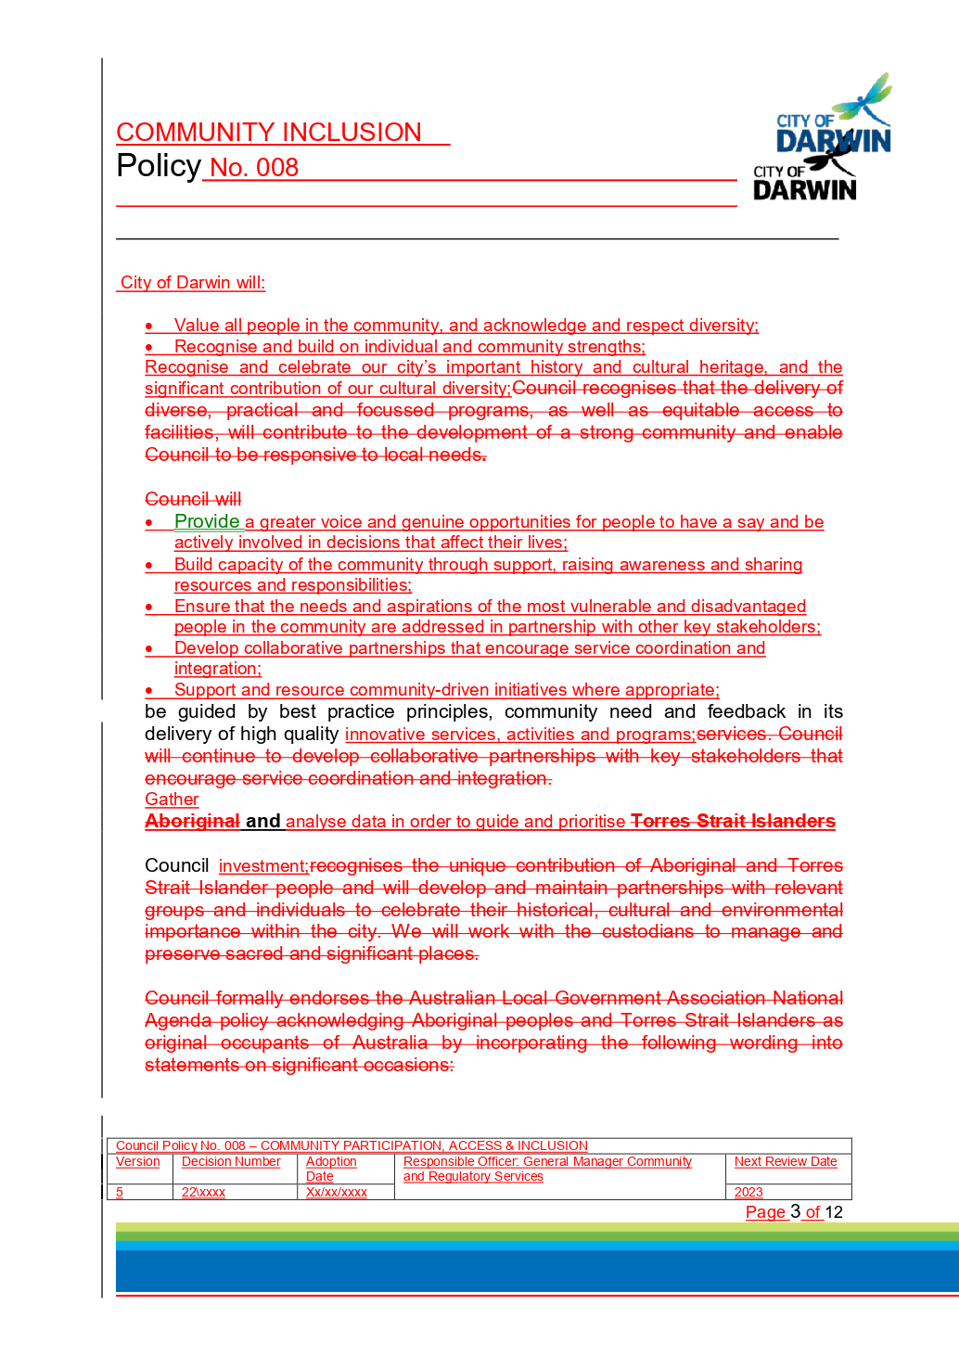

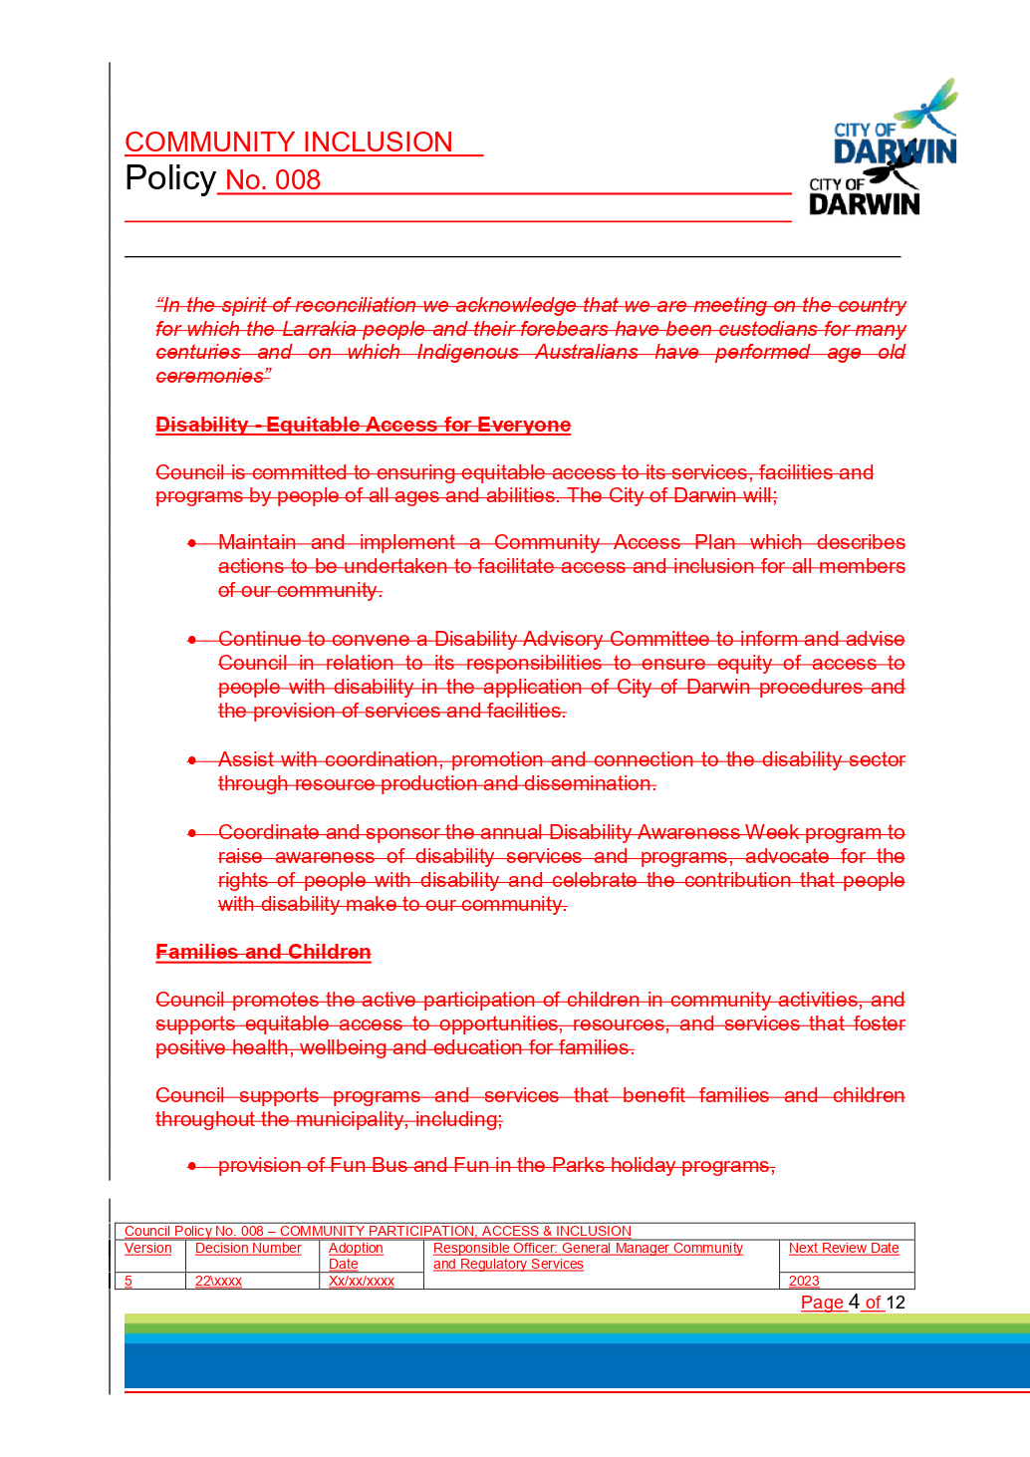

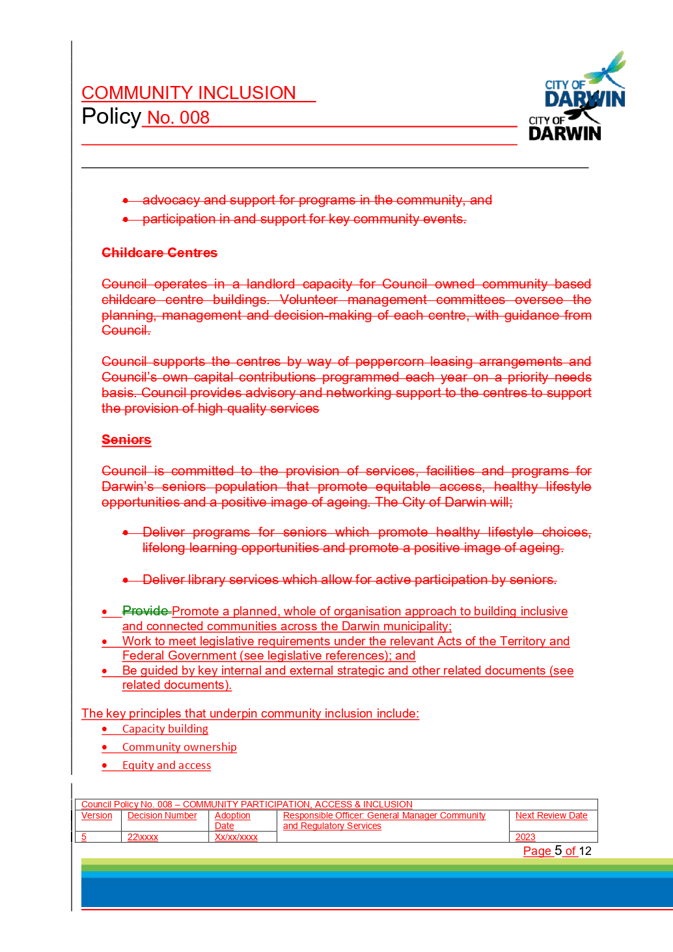

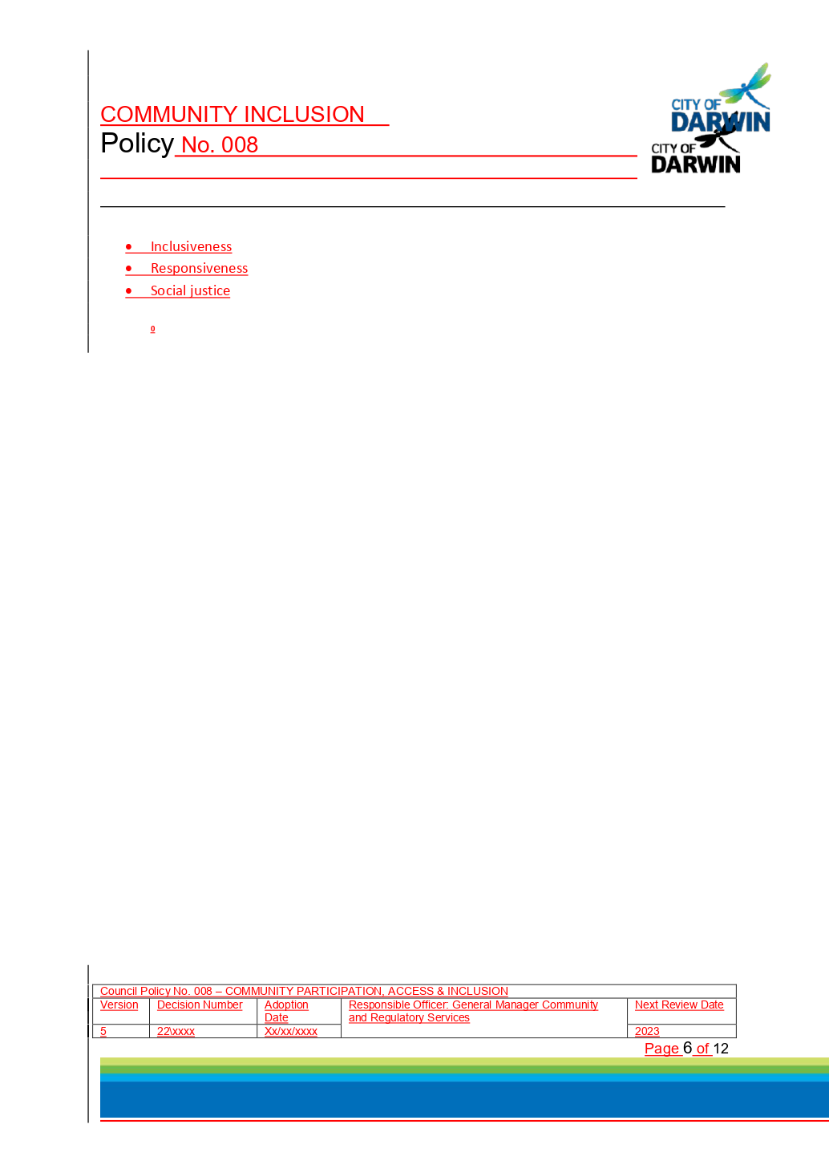

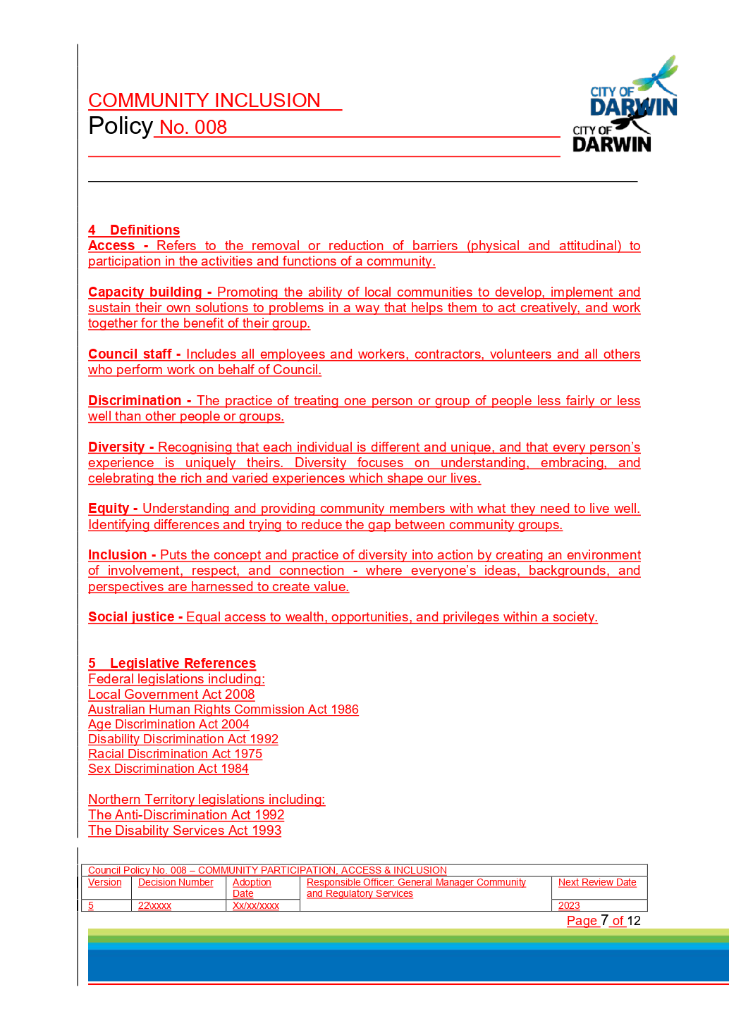

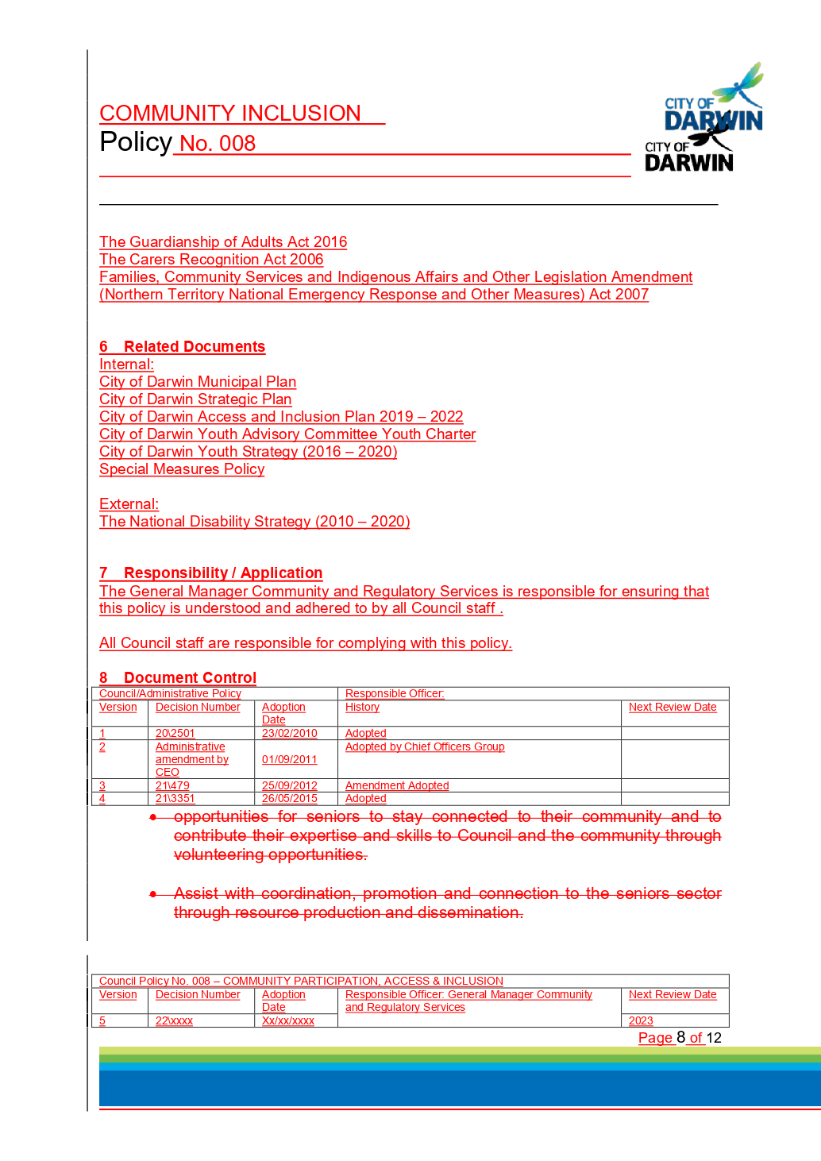

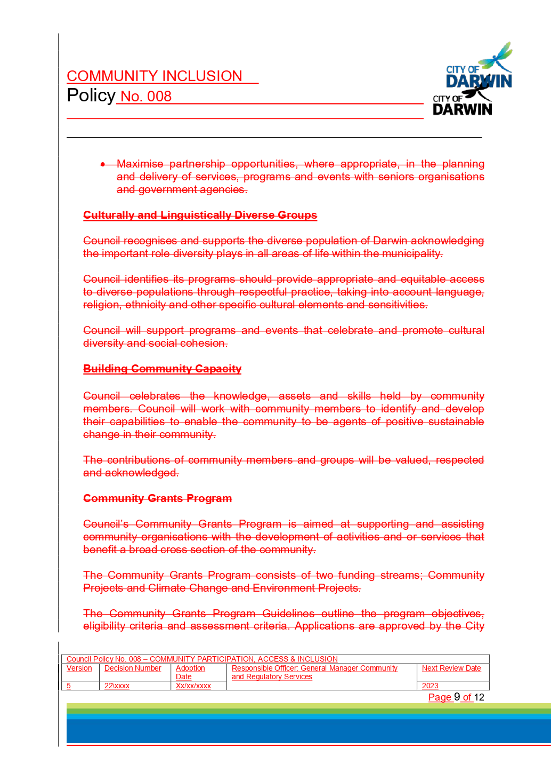

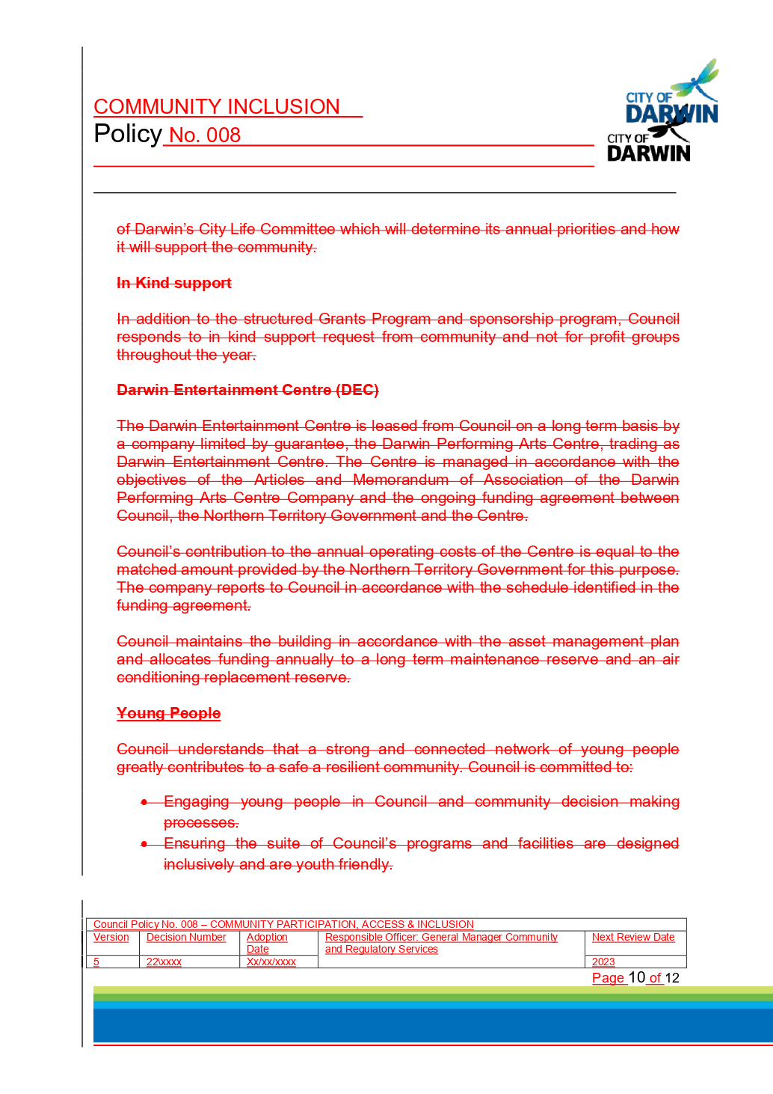

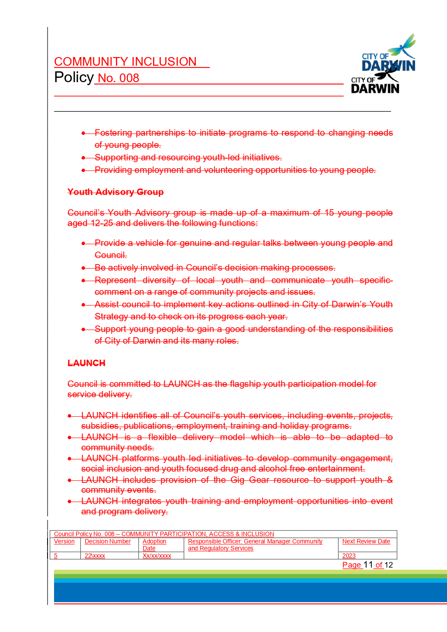

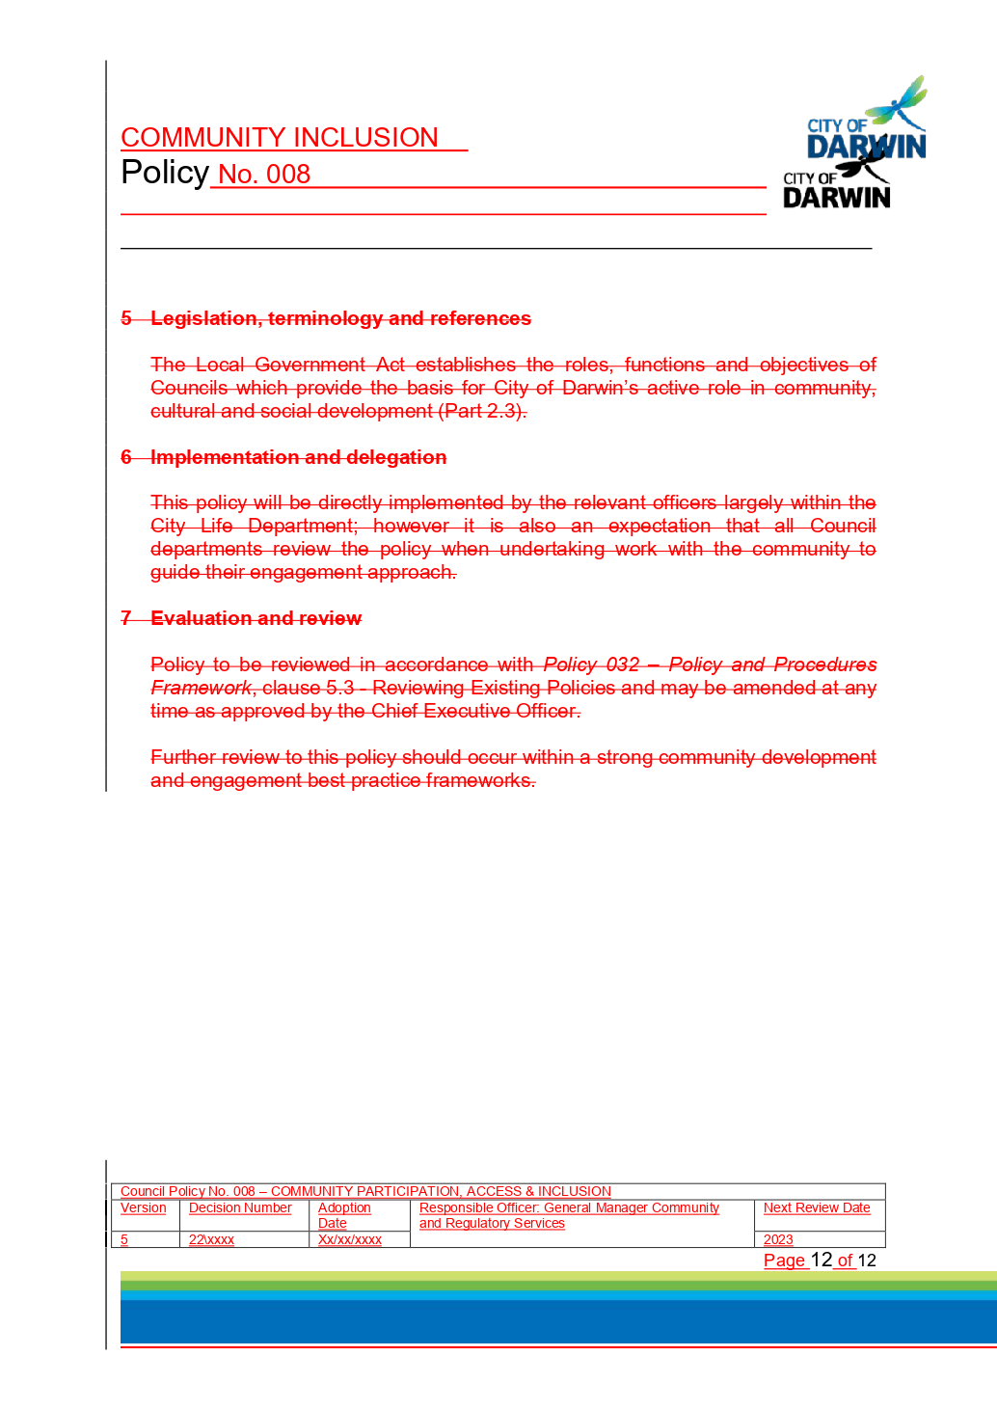

13.3 Access and Inclusion Advisory Committee Meeting Minutes 7 May 2019
Common No.: 3845697
Author: Community Development Officer
Authoriser: Executive Manager Environment & Community
Attachments: 1. Draft Minutes Access and Inclusion 7 May 2019

Summary
The purpose of this report is to present the minutes of the Access and Inclusion Advisory Committee meeting held on 7 May 2019.

Recommendations
1. THAT the Report entitled Access and Inclusion Advisory Committee Meeting Minutes 7 May 2019 be received and noted, as at Attachment 1.
2. THAT Council note the resignation of Nathan Alum, community representative on the Access and Inclusion Advisory Committee.
3. THAT Council note the resignation of Sue Shearer, specialist representative from the Council of the Ageing Northern Territory (COTA NT), and appoint Cecilia Chiolero as her replacement on the Access and Inclusion Advisory Committee in accordance with the Local Government Act, until 30 June 2020.

Key Issues
The minutes of the Access and Inclusion Advisory Committee meeting held on 7 May 2019 are provided at Attachment 1. • The Committee supports the allocation of $32,568 of the 2018/19 Access and Inclusion Budget for six items of work.
• Community representative, Nathan Alum tendered his resignation after almost two years on the Committee, and has been thanked for his contributions.
• The Committee received Sue Shearer’s resignation. Sue was the specialist representative from the Council of the Ageing Northern Territory (COTA NT) after a three year term. COTA NT’s Partners in Cultural Care and Office Manager, Cecilia Chiolero has been nominated by COTA NT as her replacement.
• Two observers attended the meeting to present projects: Vanessa Carusi Senior Project Manager, National Disability Services presented on the NT Human Services Industry Plan, and Janine Sims, Sector Support Coordinator, NTCOSS presented on the new stand-alone human services sector directory, currently in development.
• The Committee provided feedback on the review of City of Darwin Policy No. 008 – Community Participation, Access and Inclusion.

Background

DECISION NO.22\0118 (31/10/17)
Access and Inclusion Advisory Committee Appointments 1 October 2018 to
30 June 2020
Report No. 18CL0083 TS:es (11/09/18) Common No. 3845697

B. THAT Council appoint the following community representatives as members of the
Access and Inclusion Advisory Committee in accordance with the Local Government
Act, for a period commencing 1 October 2018 to 30 June 2019:
i) Ms Debbie Bampton
ii) Ms Lynne Strathie

Discussion
The minutes of the Access and Inclusion Advisory Committee meeting held 7 May 2019 are presented at Attachment 1.

2018/19 Access and Inclusion Budget Expenditure
The Committee supported the allocation of $32,568 of the 2018/19 Access and Inclusion budget to six items of work, which include:
1. Chrisp Street Oval toilet accessibility audit ($1,525): Consideration as part of an upgrade to basketball courts, surrounding pathways and parking areas.
2. Jingili Water Gardens toilet accessibility audit ($3,000): Part of a wider playground upgrade, involving inclusive play elements
3. Survivors’ Lookout, The Esplanade accessible parking bay footpath upgrades ($10,000)
4. Web accessibility ($12,000): Contracting local web design company, Captovate, to progress Council to Level AA World Wide Web Consortium (W3C) standard, as recommended in the recently endorsed Access and Inclusion Plan (2019- 2022)
5. Parap Recreation Facility accessible ramp ($3,043): A contribution towards the installation of an accessible ramp, requested by Royal Life Saving Society Northern Territory (RLSSNT) as part of the facility upgrade
6. Accessible portable toilet at Lakeside Drive Community Garden ($3,000): A contribution towards cost of hiring an accessible portable toilet for six months for the use of The Patch, an inclusive horticultural education program.

The Access and Inclusion Advisory Committee has a budget of $55,000 each year to use towards infrastructure improvements on Council infrastructure, to improve accessibility needs of the sector. The allocation of these six items of work will expend all remaining funds in the 2018/2019 budget.

Access and Inclusion Advisory Committee Membership
As outlined in the Access and Inclusion Advisory Committee’s Terms of Reference, membership of the Committee should comprise of up to 10 community members that are representative of a range of abilities and lived experiences of disability. Community representative, Nathan Alum tendered his resignation after almost two years on the Committee, and has been thanked for his contributions. The Committee also received Sue Shearer’s resignation. Ms Shearer was the specialist representative from the Council of the Ageing Northern Territory (COTA NT) for three years. COTA NT’s Partners in Cultural Care and Office Manager, Cecilia Chiolero has been nominated by COTA NT as her replacement.
The remaining five community representatives’ terms end 30 June 2019. The appointment process of new community representatives for the term 1 July 2019 – 30 June 2021 is underway to ensure the appointments allow the Committee to achieve its objectives.
Additionally, two observers attended the meeting to present projects: Vanessa Carusi Senior Project Manager, National Disability Services presented on the NT Human Services Industry Plan, and Janine Sims, Sector Support Coordinator, NTCOSS presented on the new stand-alone human services sector directory, currently in development.

City of Darwin Policy No. 008
The Committee provided feedback on the review of City of Darwin Policy No. 008 – Community Participation, Access and Inclusion, which is presented as a separate report in the 2nd Ordinary Council Meeting agenda.

Strategic Environment
The issues addressed in this Report are in accordance with the following Goals/Strategies as outlined in the ‘Evolving Darwin Towards 2020 Strategic Plan’:

Goal
1 Collaborative, Inclusive and Connected Community

Outcome
1.1 Community inclusion supported

Key Strategies
1.1.2 Develop equitable and accessible community participation opportunities

Legislative/Policy
The Committee operates to advocate, inform, and guide Council on improved access and inclusion for all people of all abilities, living, working, studying or visiting the Darwin municipality, assisting Council to meet its strategic goals of creating a more accessible and inclusive community.

The Committee is informed and guided by the City of Darwin Policy No. 008 - Community Participation, Access and Inclusion, and the Access and Inclusion Plan (2019- 2022).

Consultation

Internal
In preparing this report, the following City of Darwin officers were consulted:
• Executive Manager, Environment and Community
• Community and Cultural Development Coordinator
• Senior Coordinator Capital Works
• Recreation and Leisure Coordinator

External
• City of Darwin Access and Inclusion Advisory Committee

Budget/Resource Implications
The Access and Inclusion Advisory Committee has an annual budget of $55,000. The allocation of these six items of work will expend all remaining funds in the 2018/2019 budget.

Risk
The Access and Inclusion Advisory Committee works to support Council in meeting its obligations under the Commonwealth Disability Discrimination Act 1992 (DDA) and other relevant legislation.

Legal
The Access and Inclusion Advisory Committee is established pursuant to Section 54 of the Local Government Act.

Arts, Culture & Environment
The Access and Inclusion Committee operates to advocate, inform, and guide Council on improved access and inclusion for all people of all abilities, to create a collaborative, inclusive and connected community.

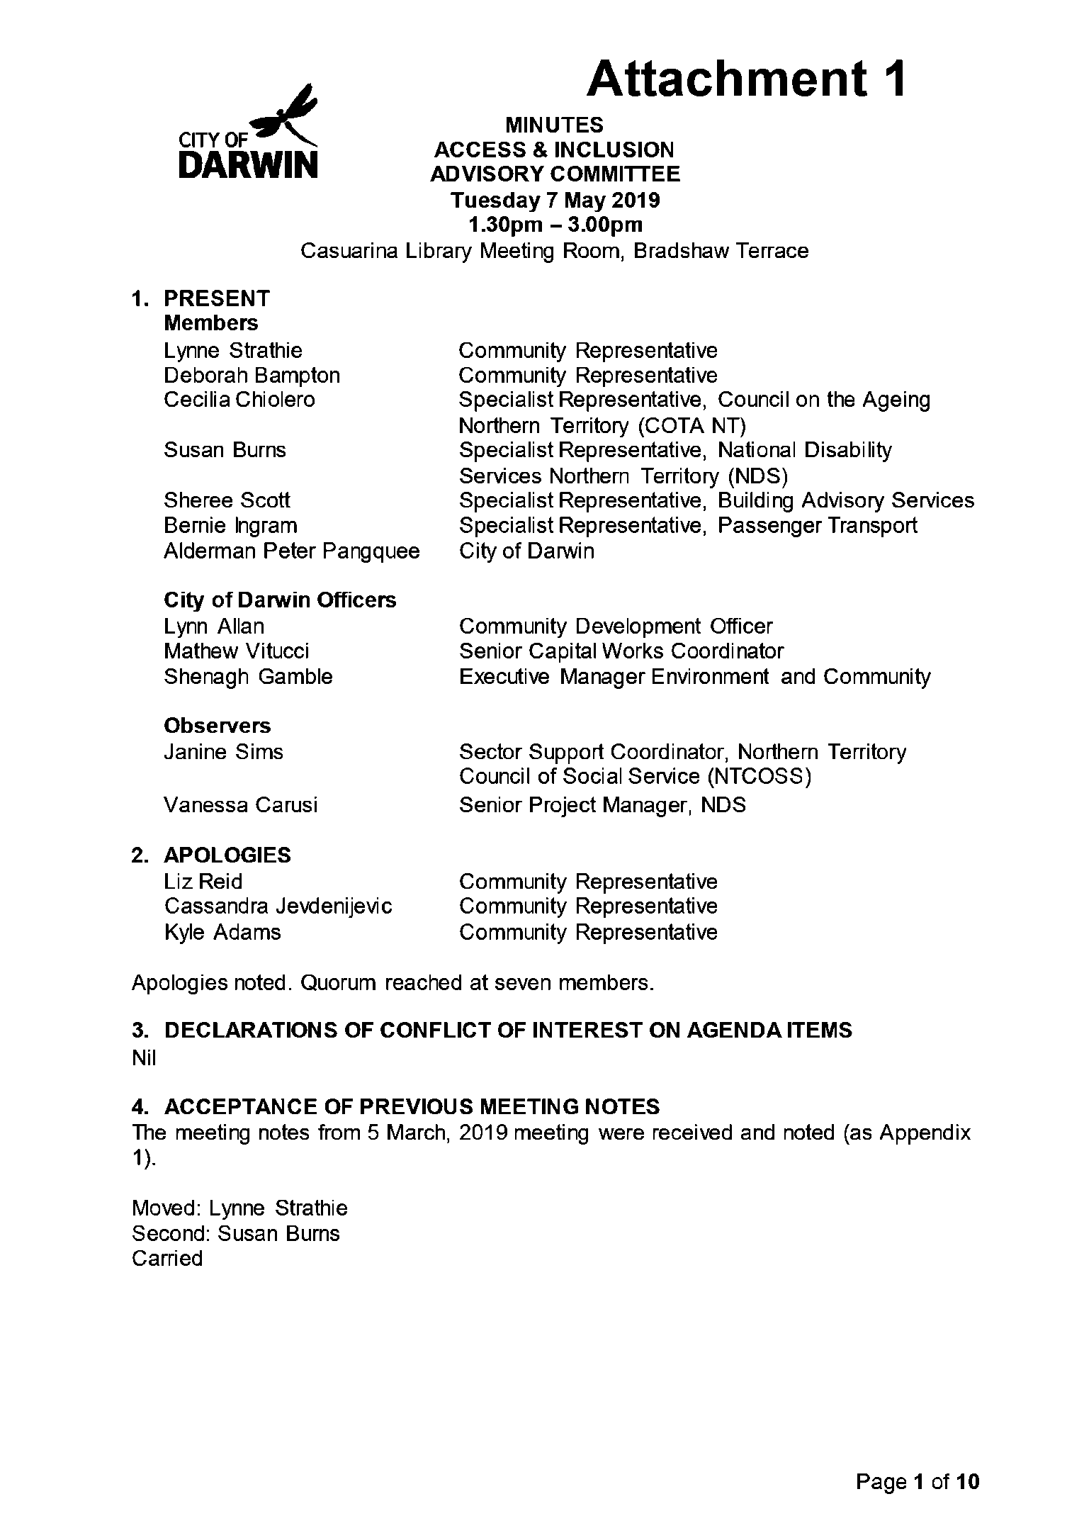

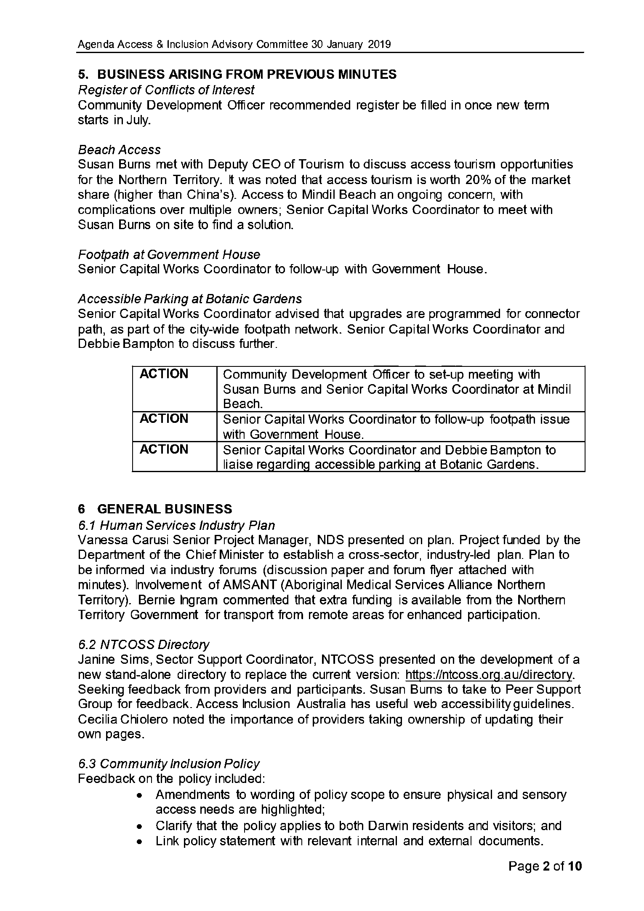

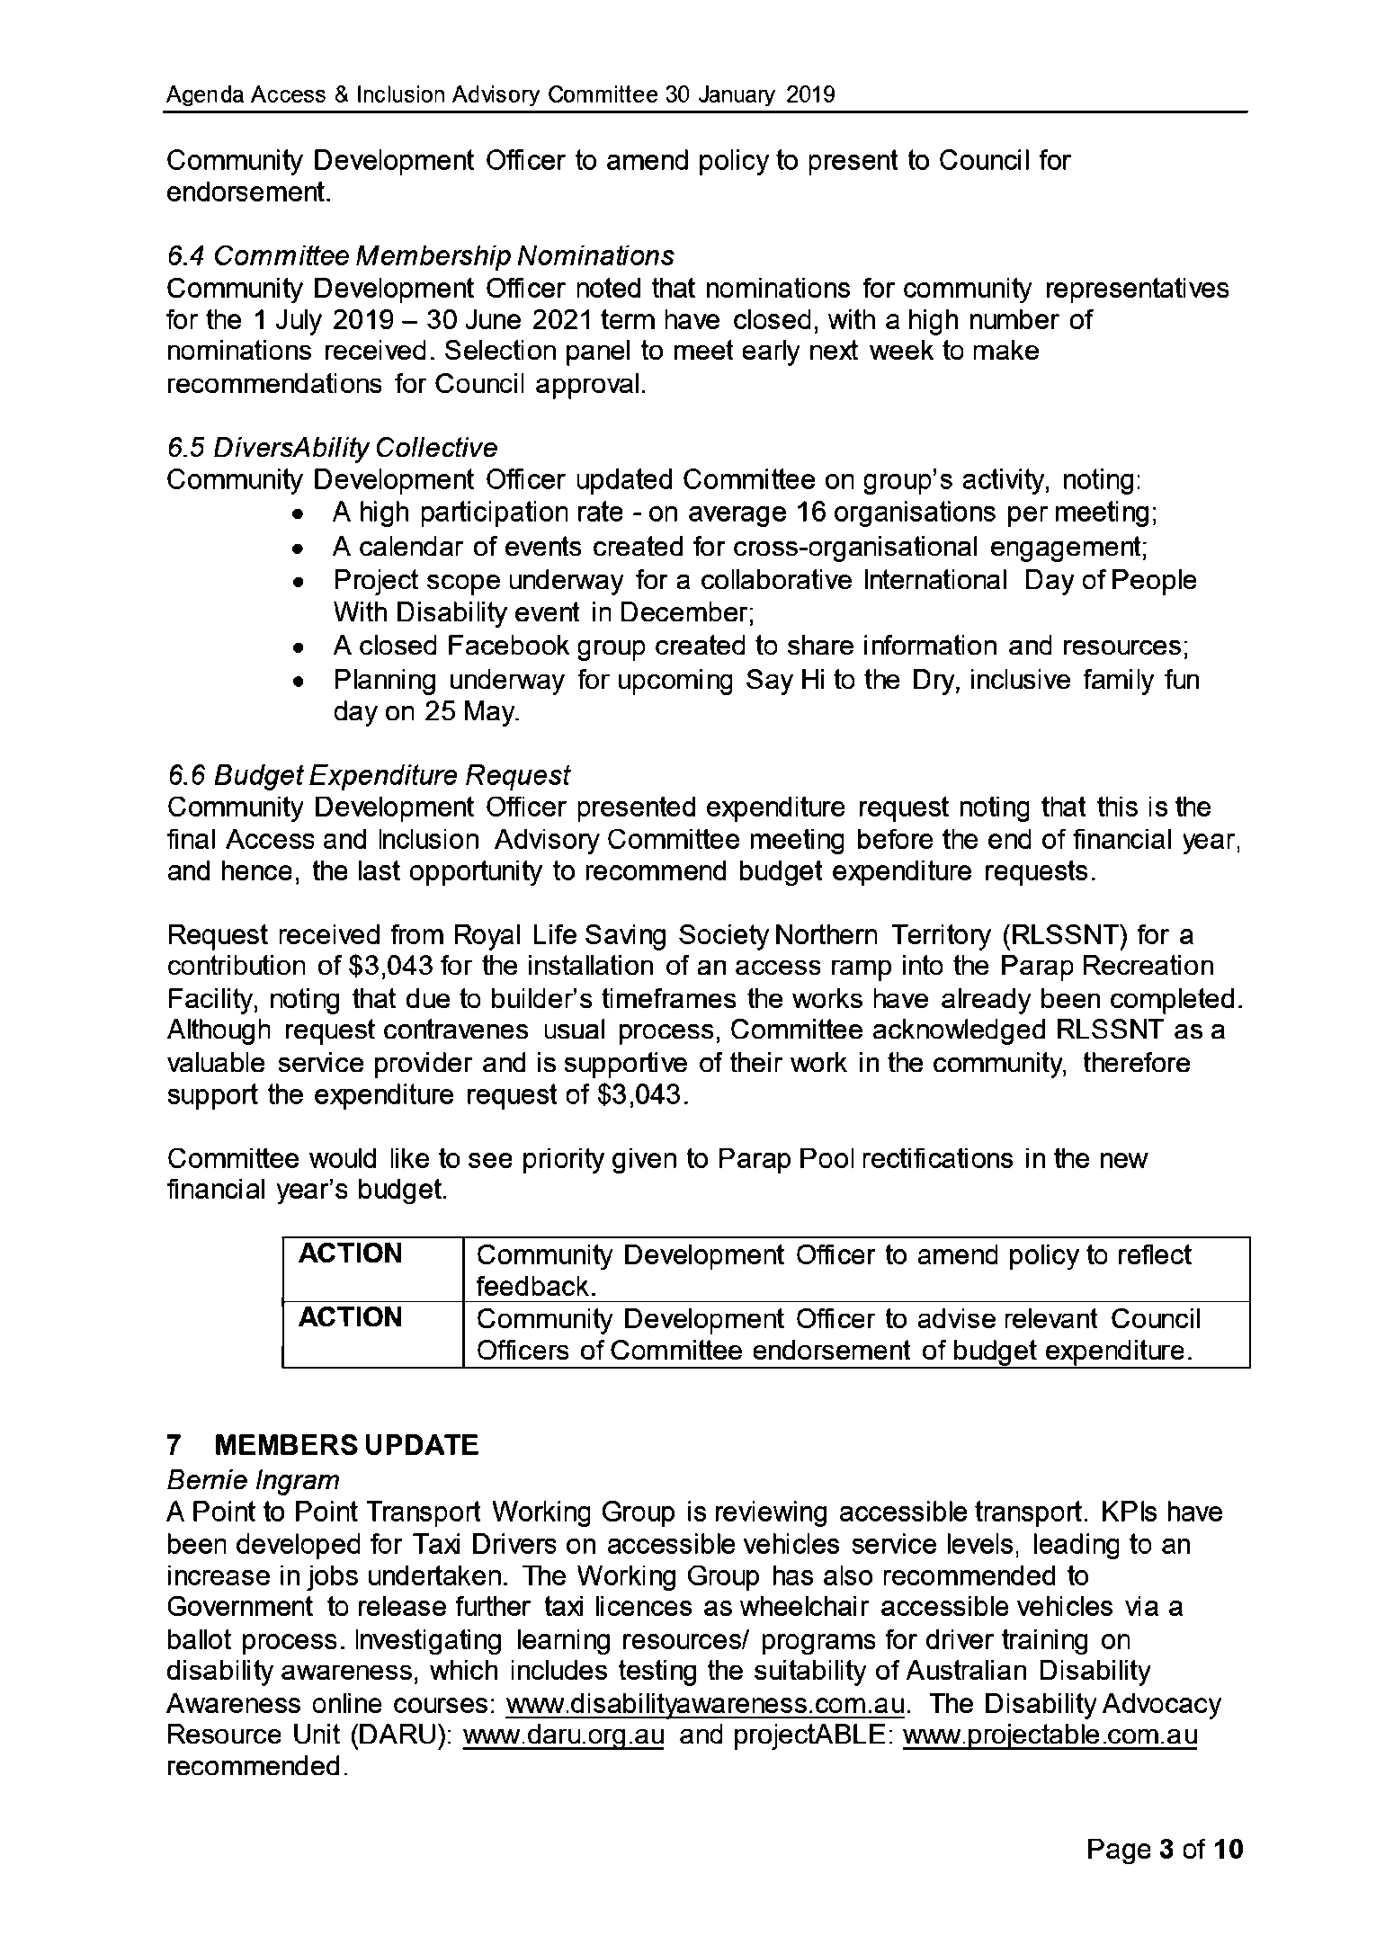

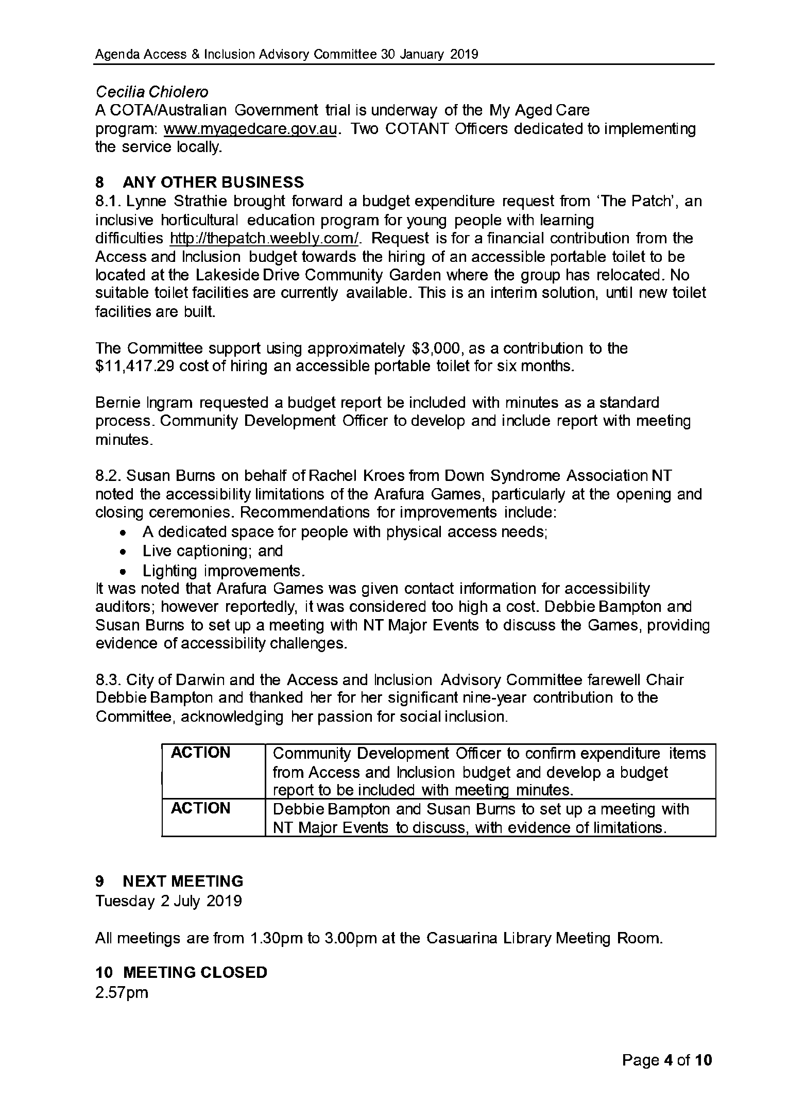
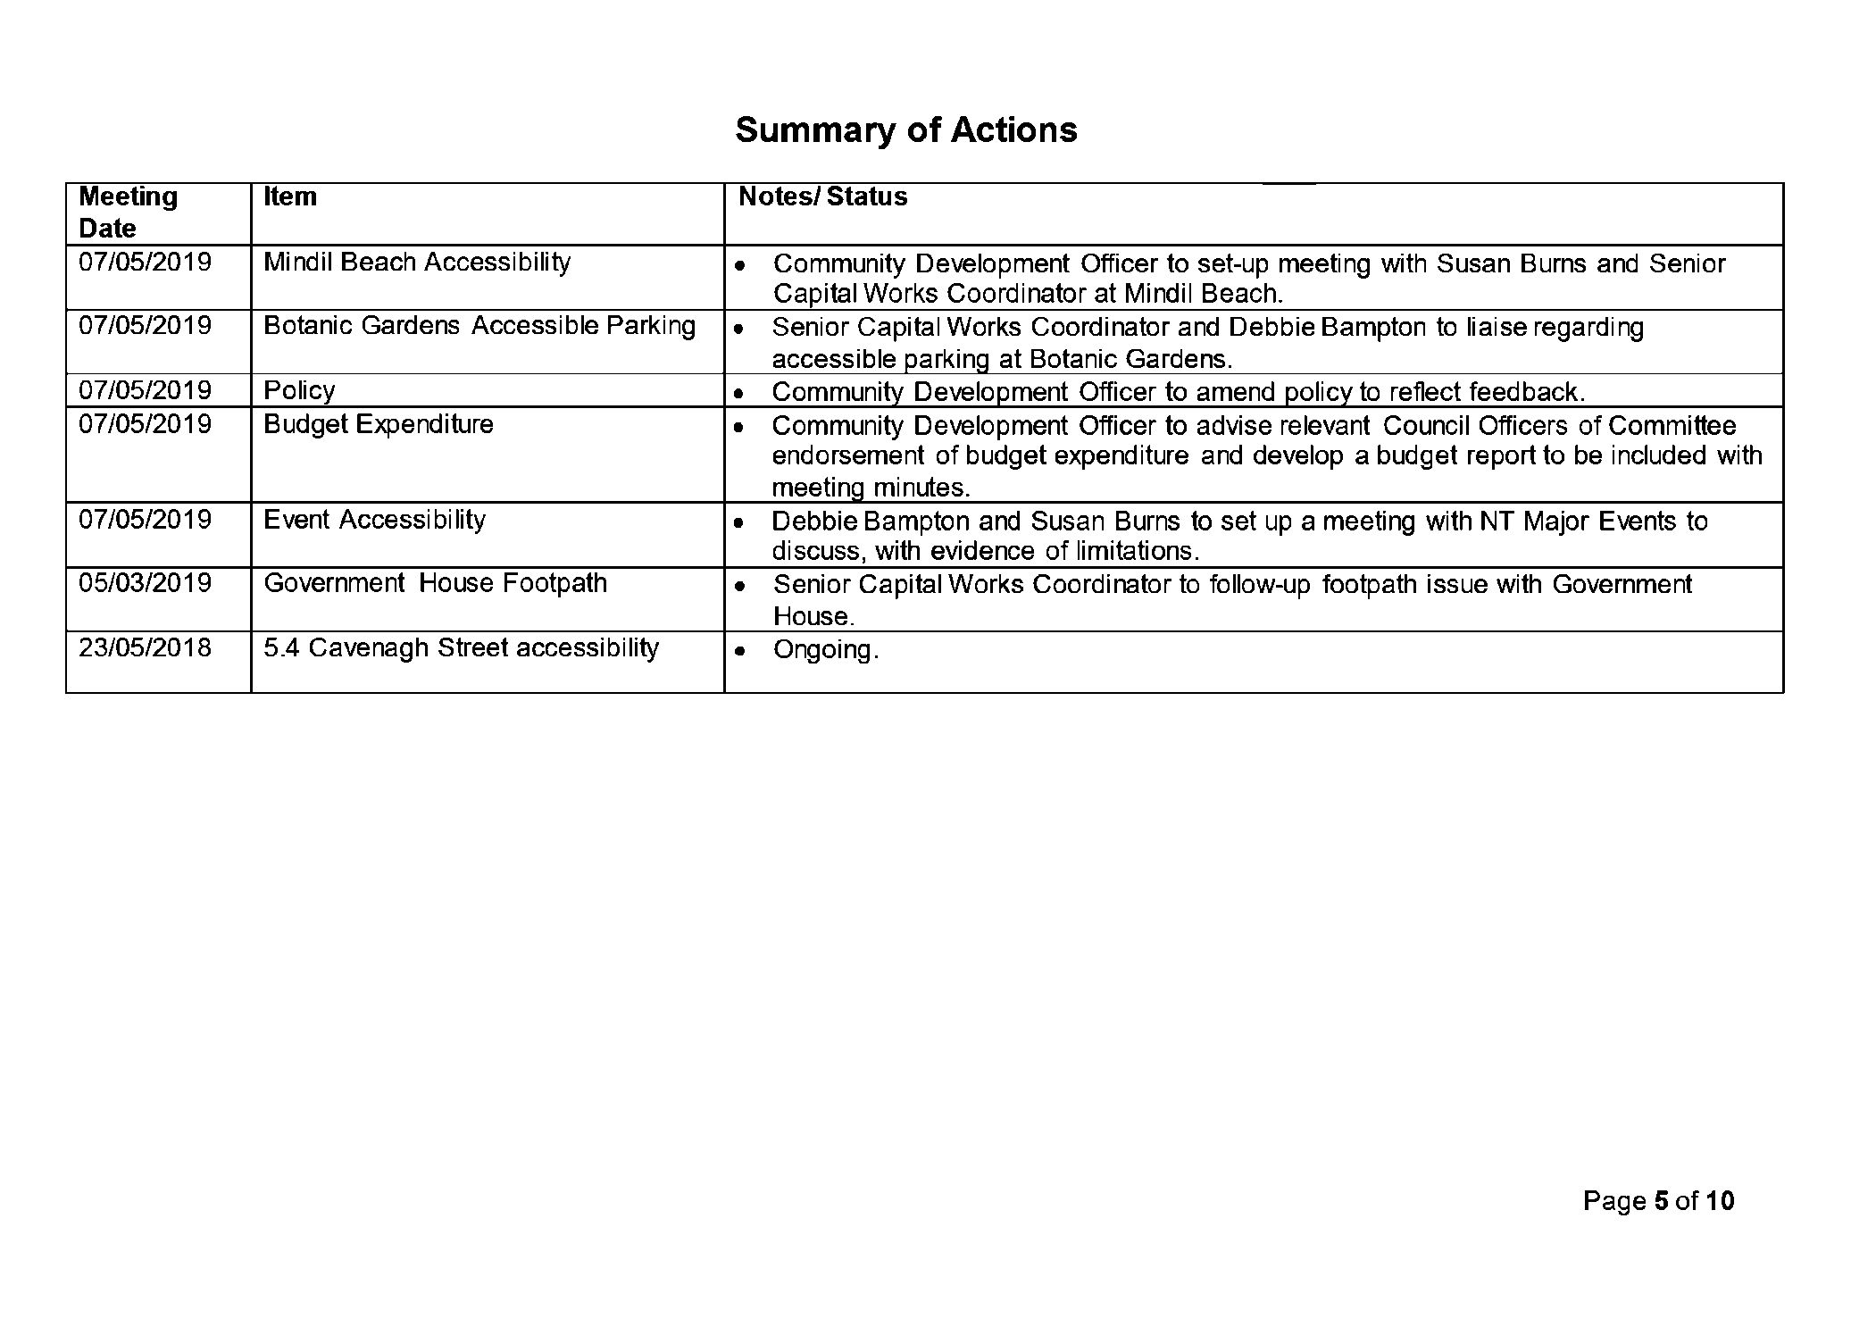
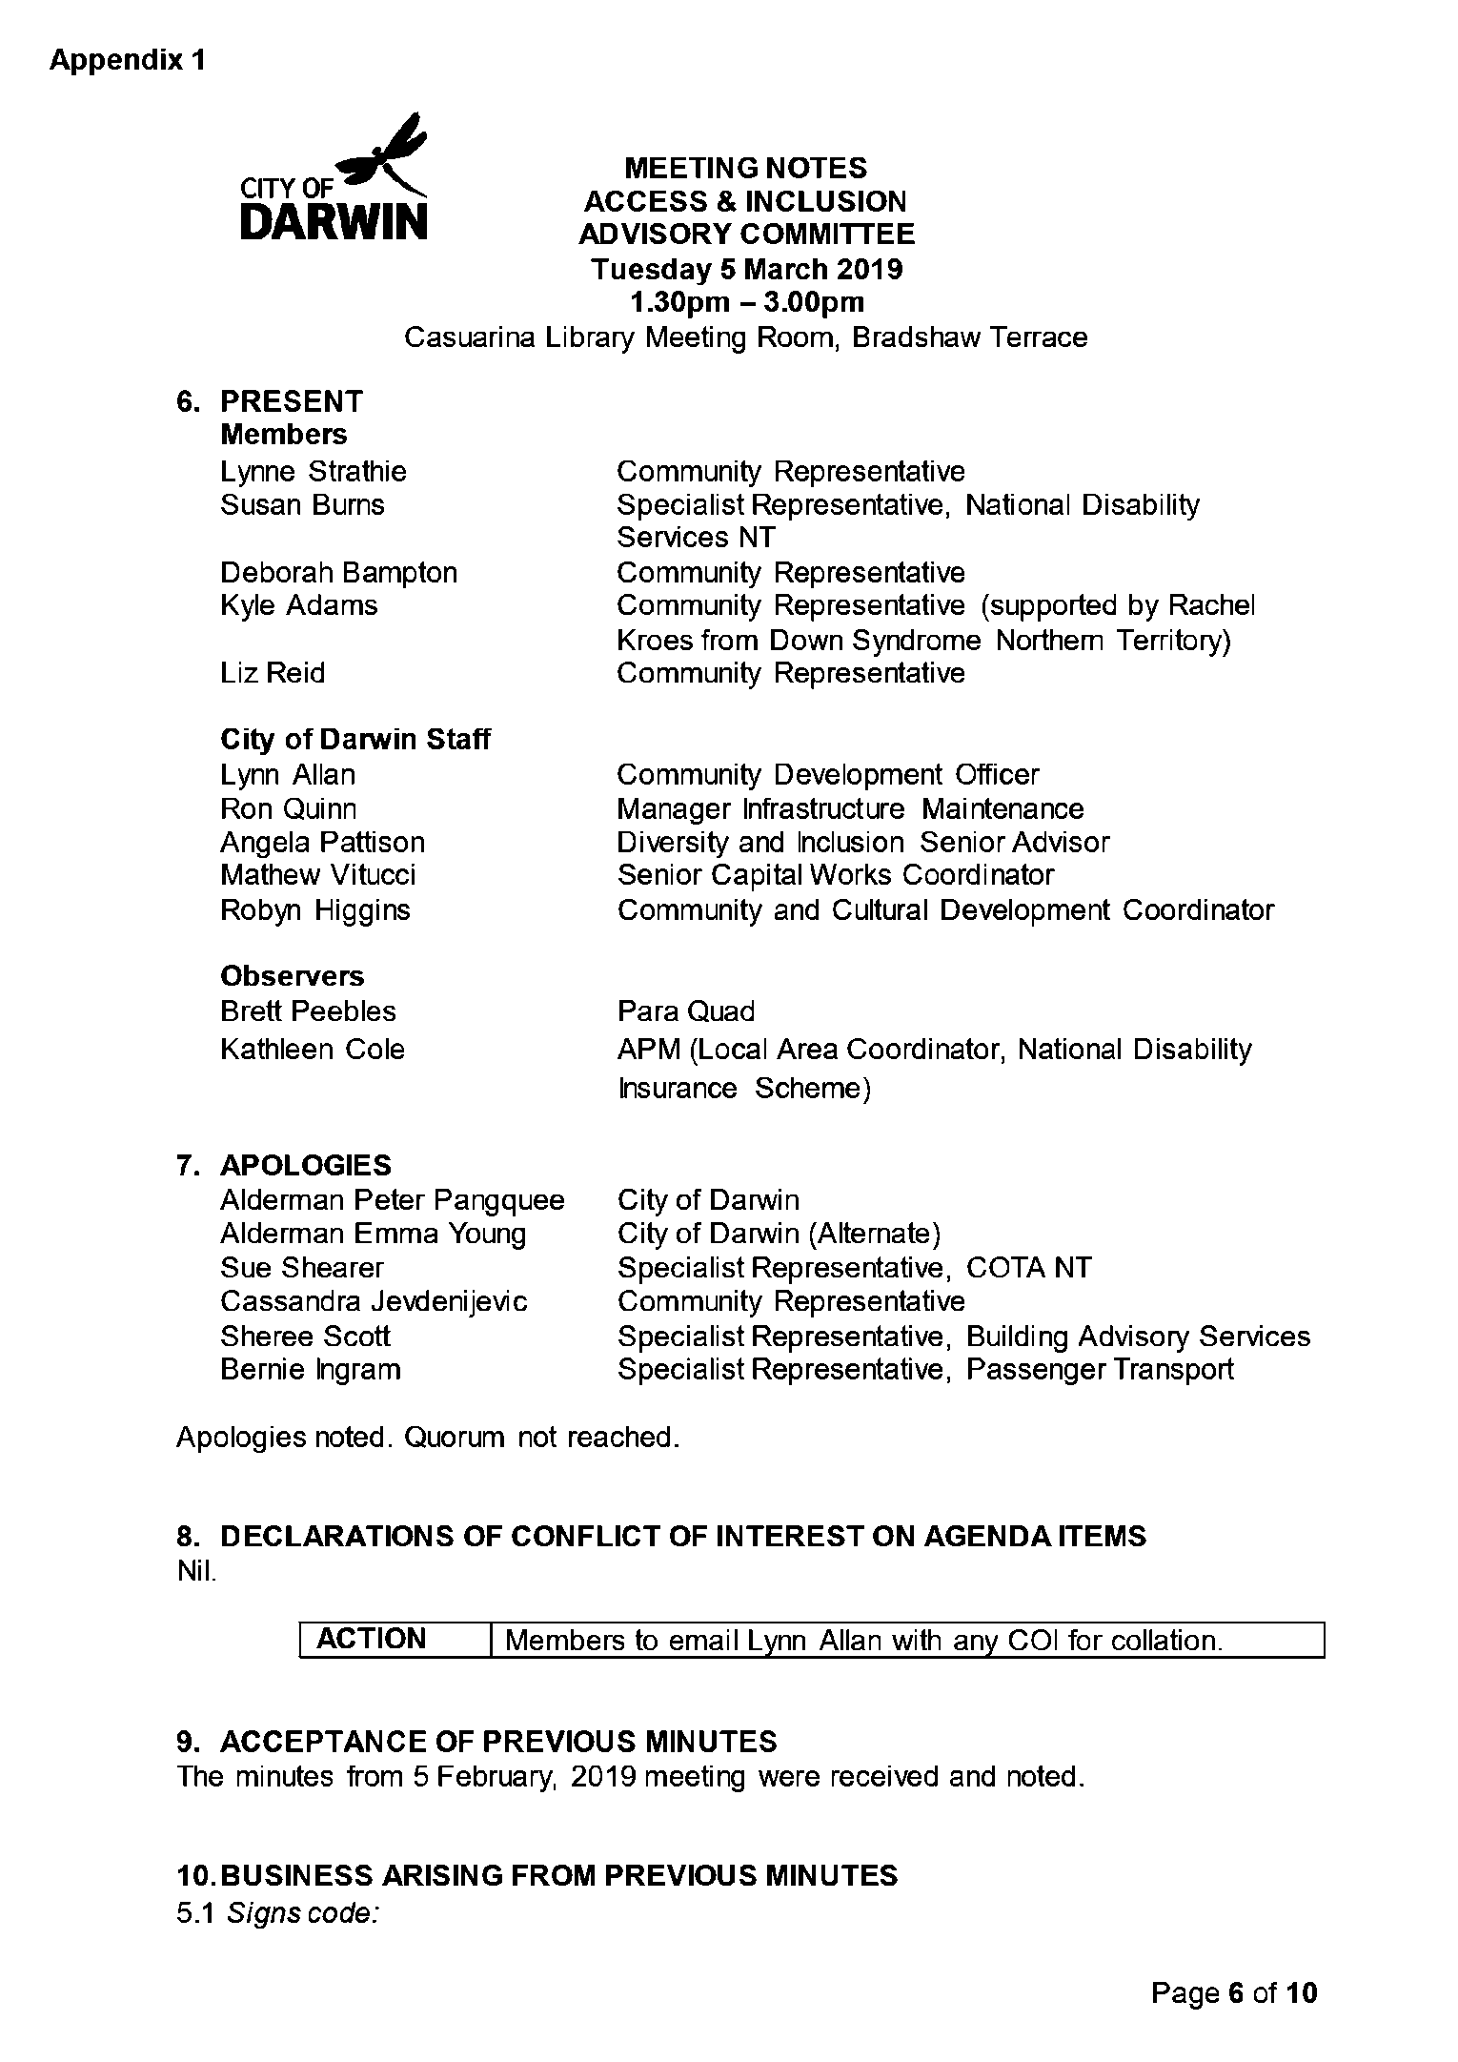

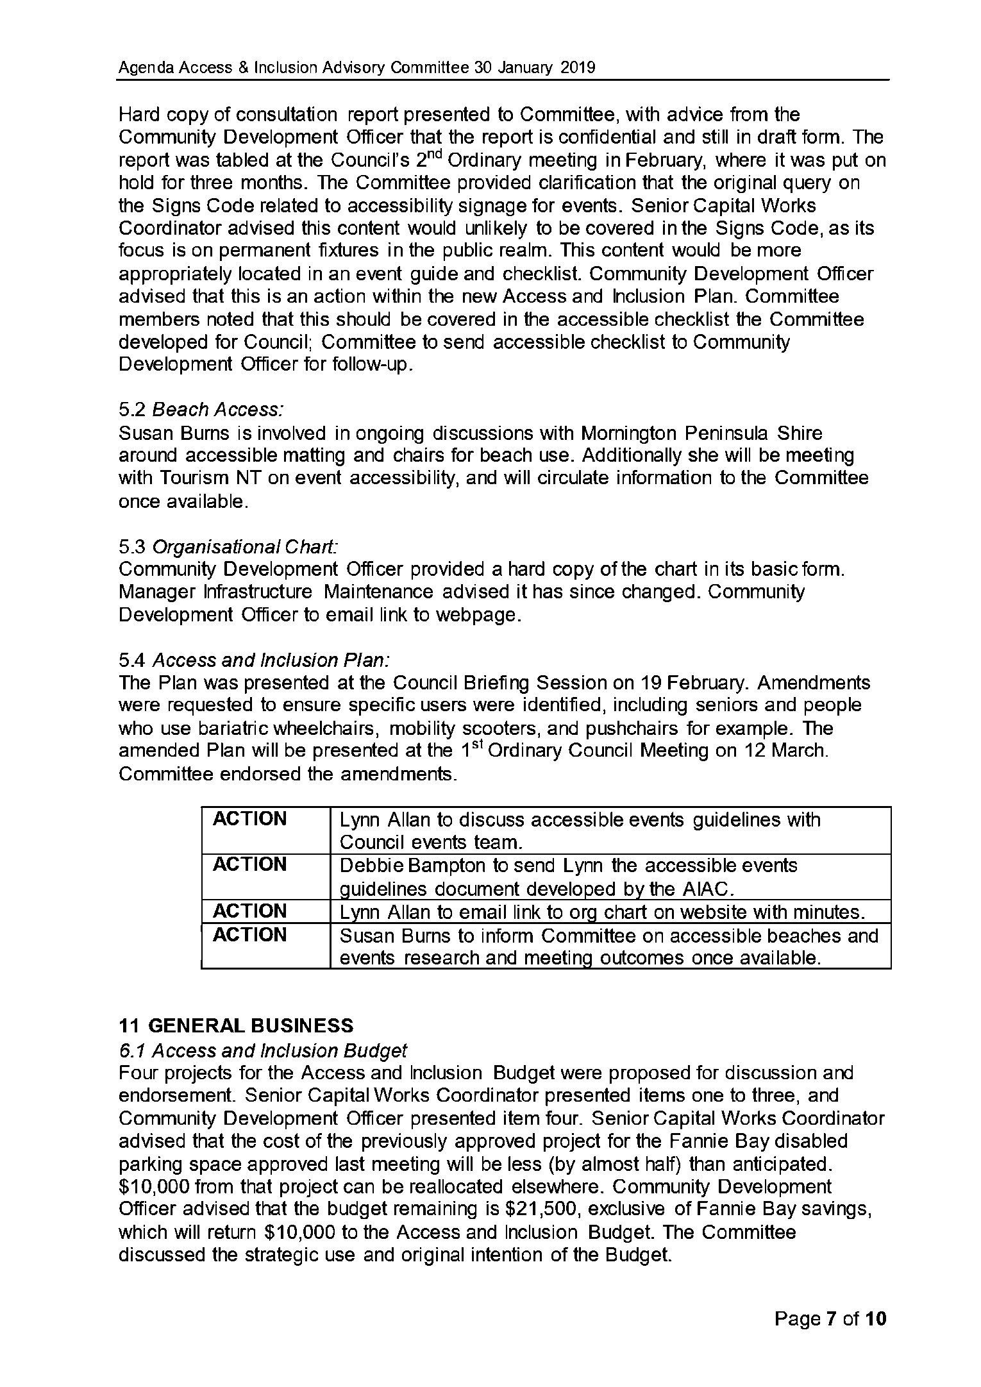

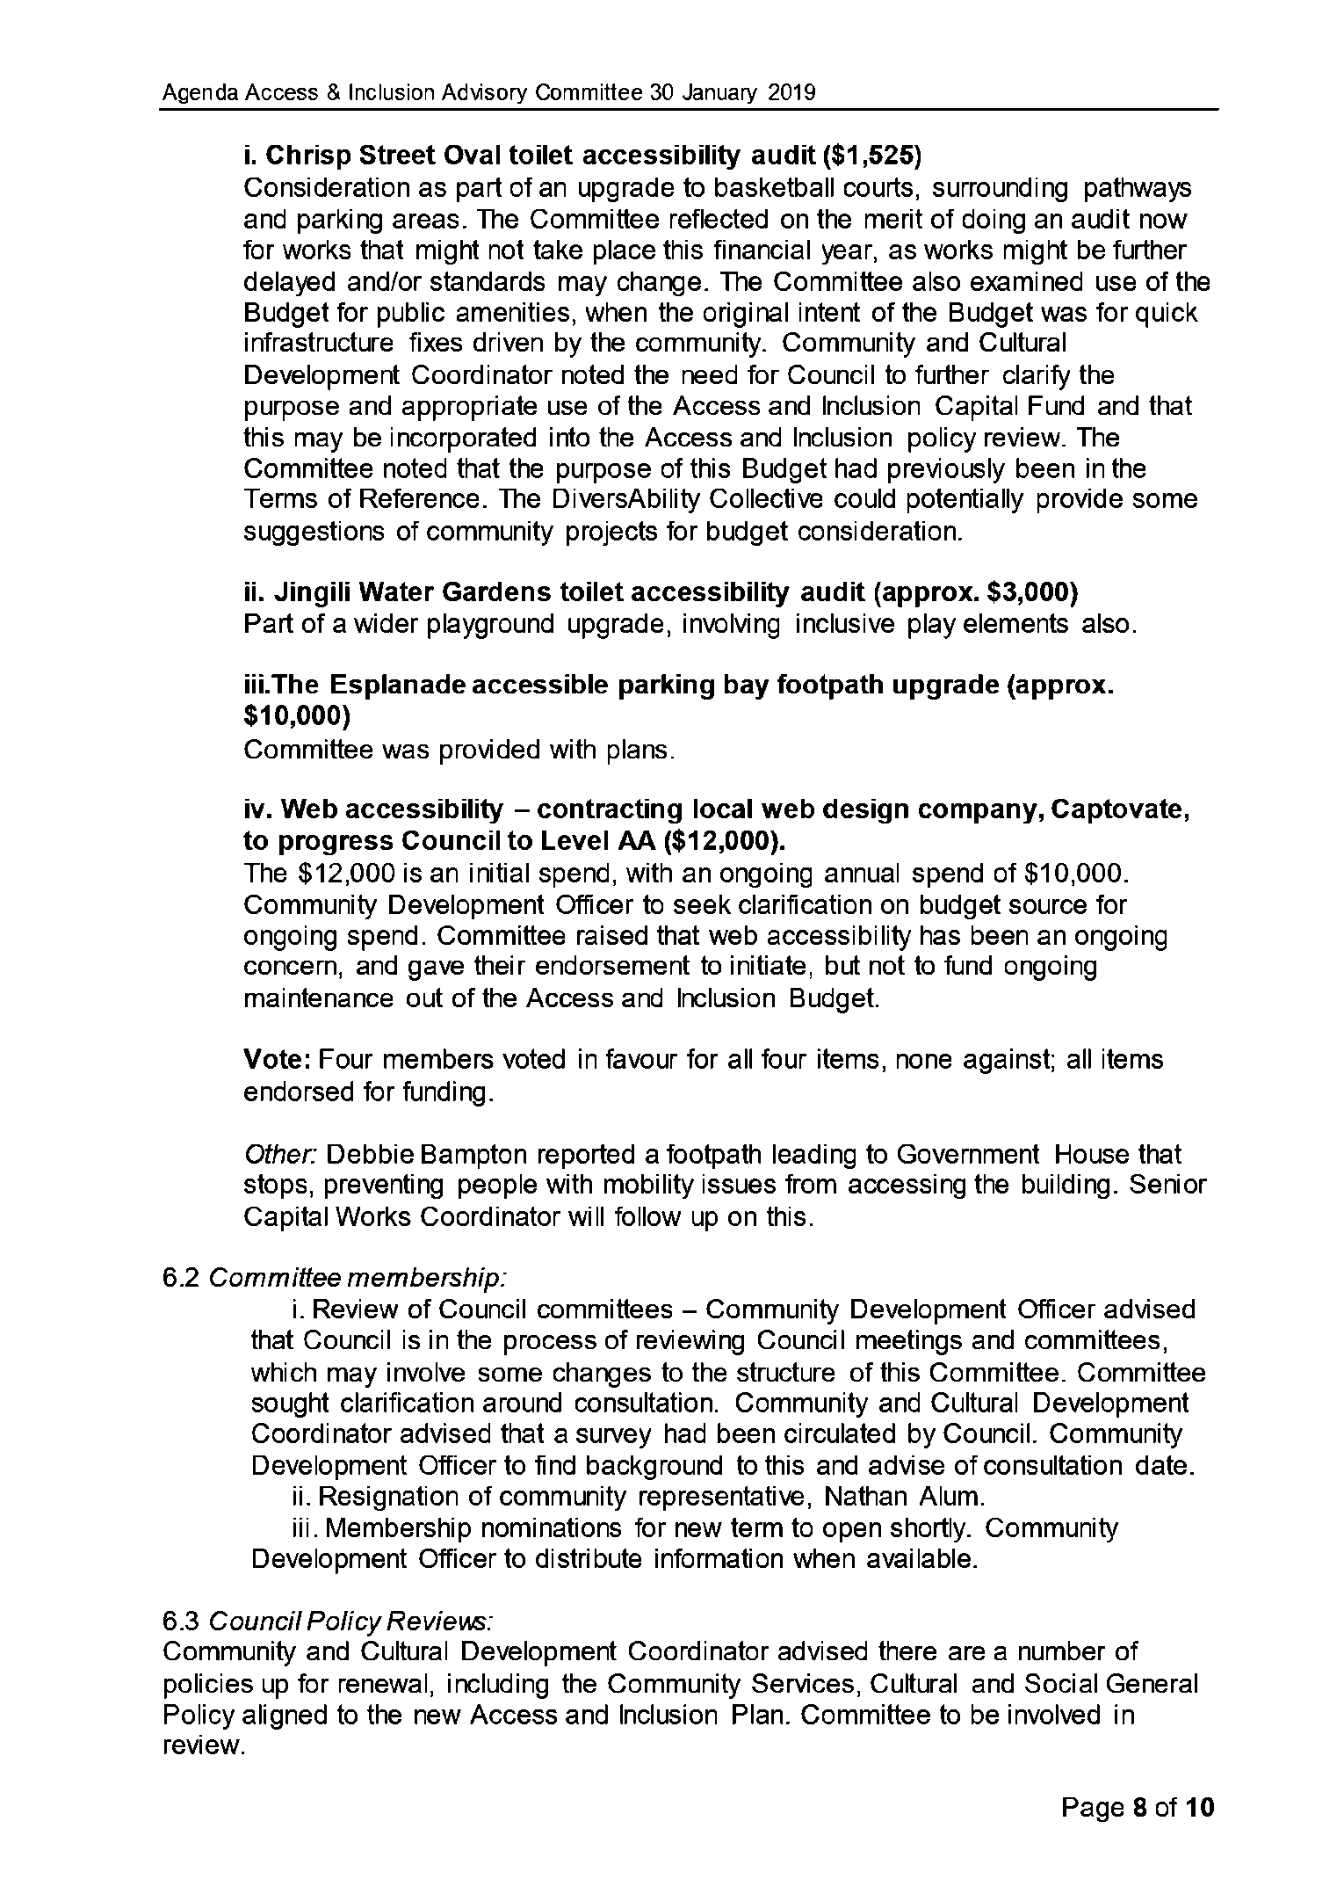

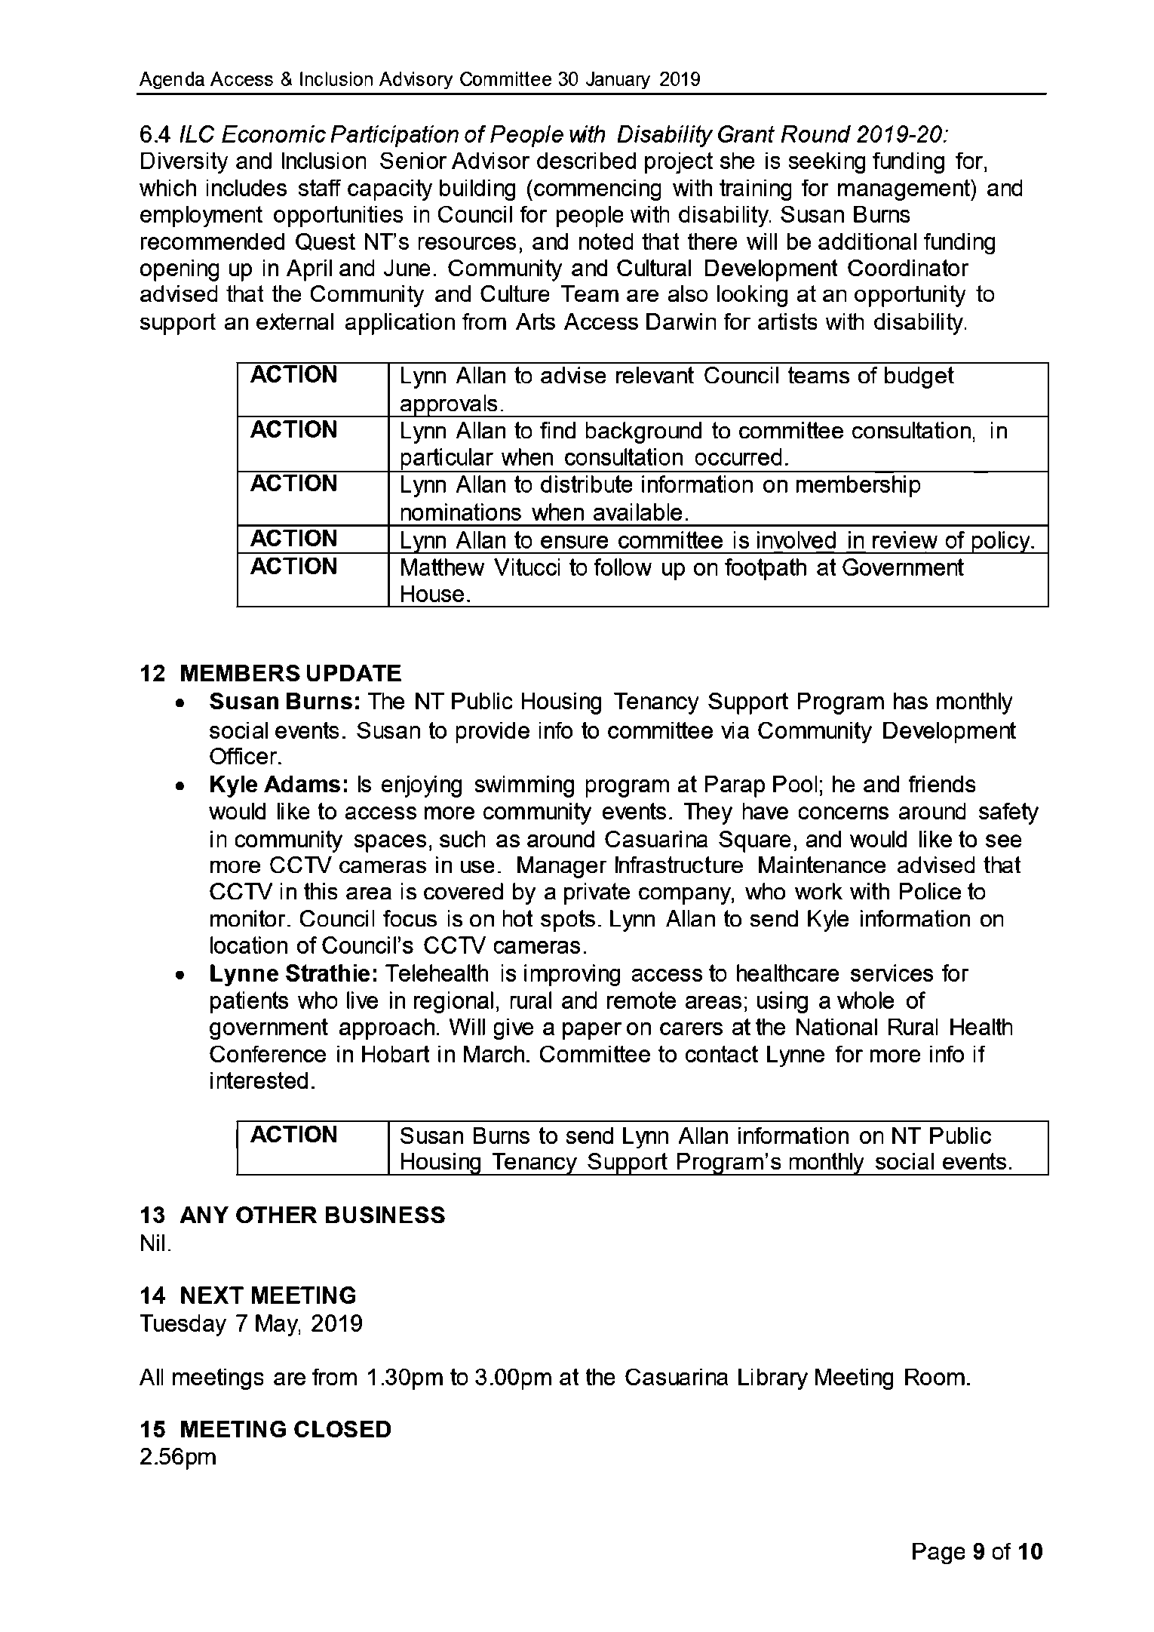
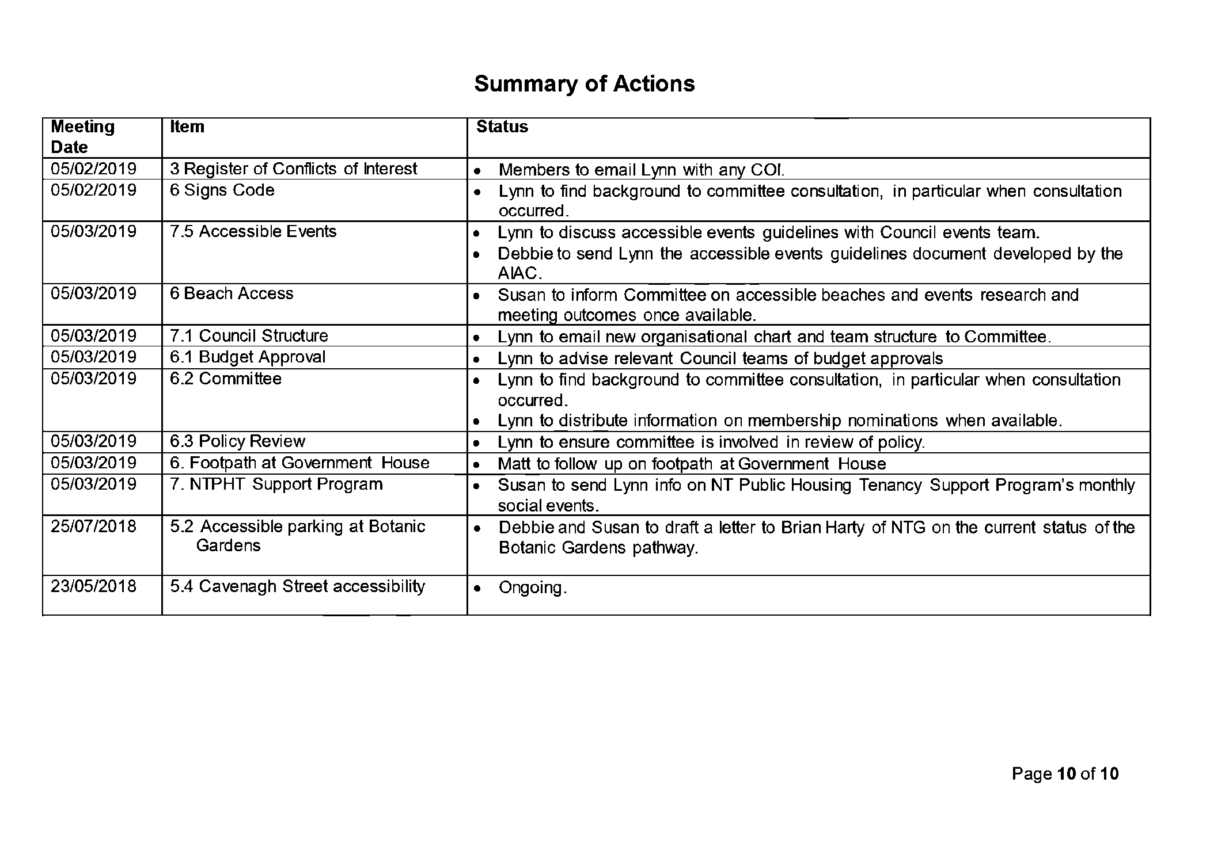

13.4 Minutes and Committee Appointment for the Youth Advisory Committee Meeting 9 May 2019
Common No.:
Author: Youth Engagement Officer
Authoriser: Executive Manager Environment & Community
Attachments: 1. Draft Youth Advisory Committee Minutes 9 May 2019

Summary
The purpose of this report is to present the minutes of the Youth Advisory Committee May meeting held on 9 May 2019 and seek approval of a nomination to the Committee.

Recommendations
1. THAT the report entitled Minutes and Committee Appointment for the Youth Advisory Committee Meeting 9 May 2019 be received and noted.
2. THAT, pursuant to Section 54 of the Local Government Act (2008), Council appoint Samantha Price to the Youth Advisory Committee from 9 May 2019 – 30 June.

Key Issues
• The Committee resolved to include Acknowledgement of Country at the commencement of future Youth Advisory Committee meetings.
• Quiz 4 Dili will be held on Thursday 27 June 2019.
• A nomination from Samantha Price was endorsed by the Committee.

Background
The Youth Advisory Committee met on 9 May 2019 and the minutes are presented and detailed at Attachment 1.

Discussion
Quiz 4 Dili
Planning is underway for the 2019 Quiz 4 Dili, which will be held at the Darwin Trailer Boat Club on Thursday 27 June 2019. Members of the Youth Advisory Committee are seeking sponsorship prizes from local businesses. Tickets are now on sale through Eventbrite.
Appointment of New Member
The Committee recommended the appointment of Samantha Price for two years, 9 May 2019 to 30 June 2021. Members are appointed for a two year term after which time they may either resign or re-apply for membership.

Implications
Nil

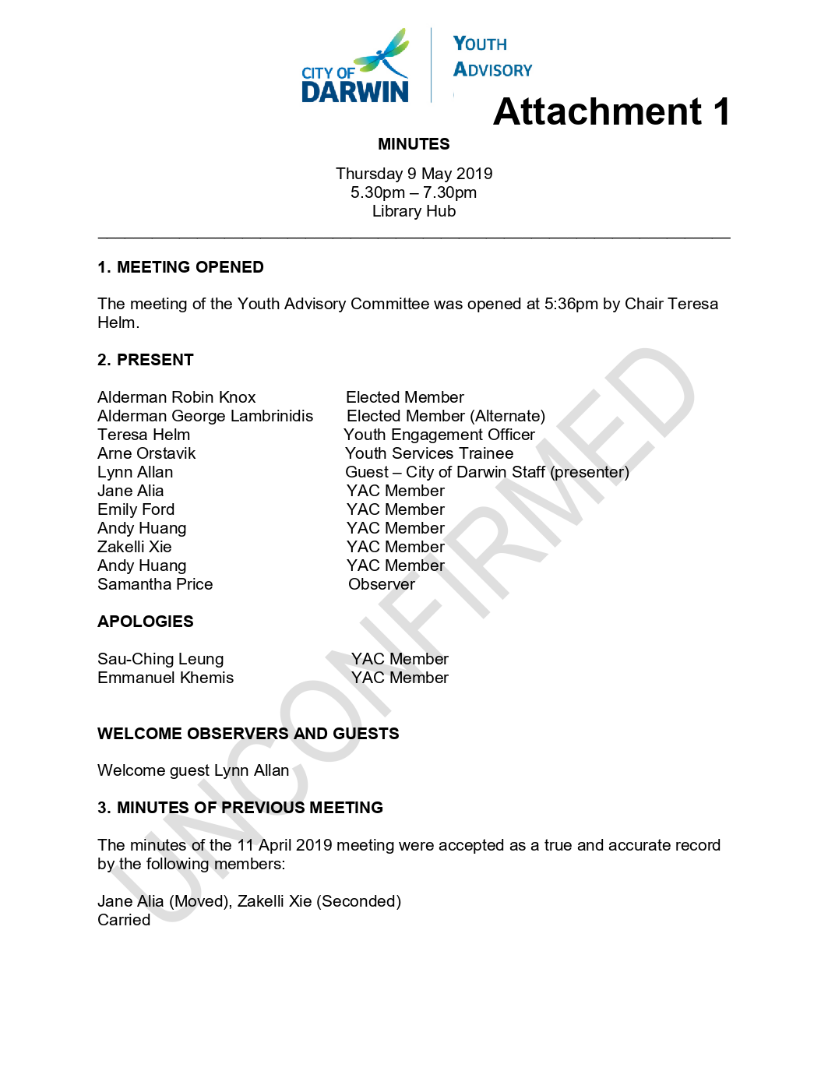

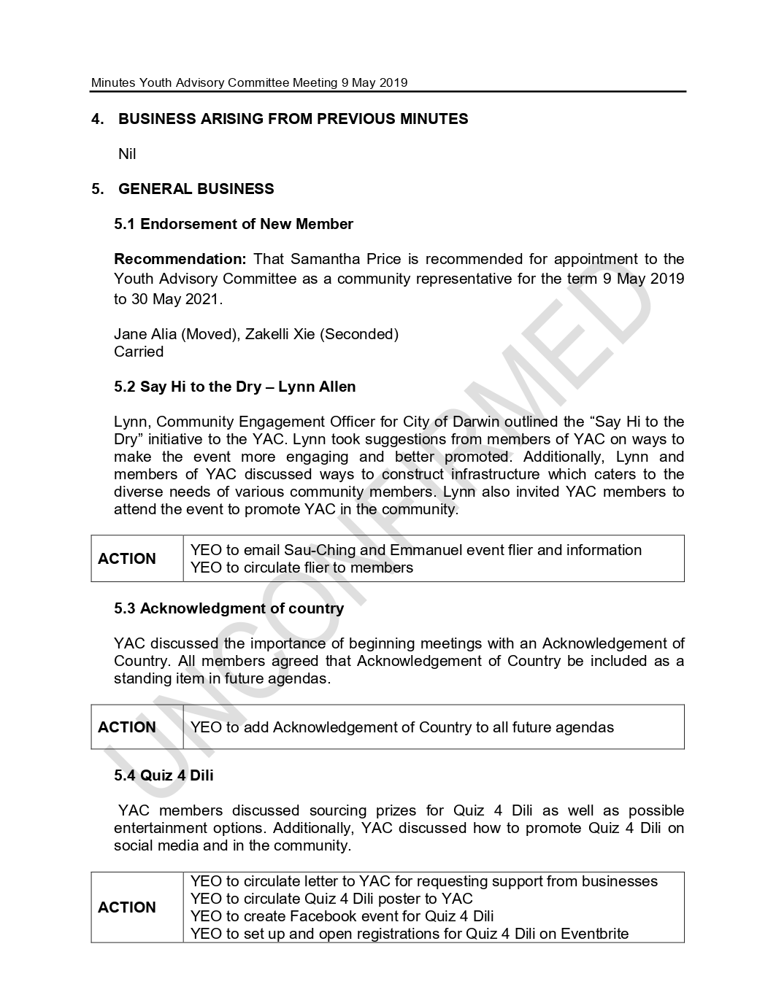

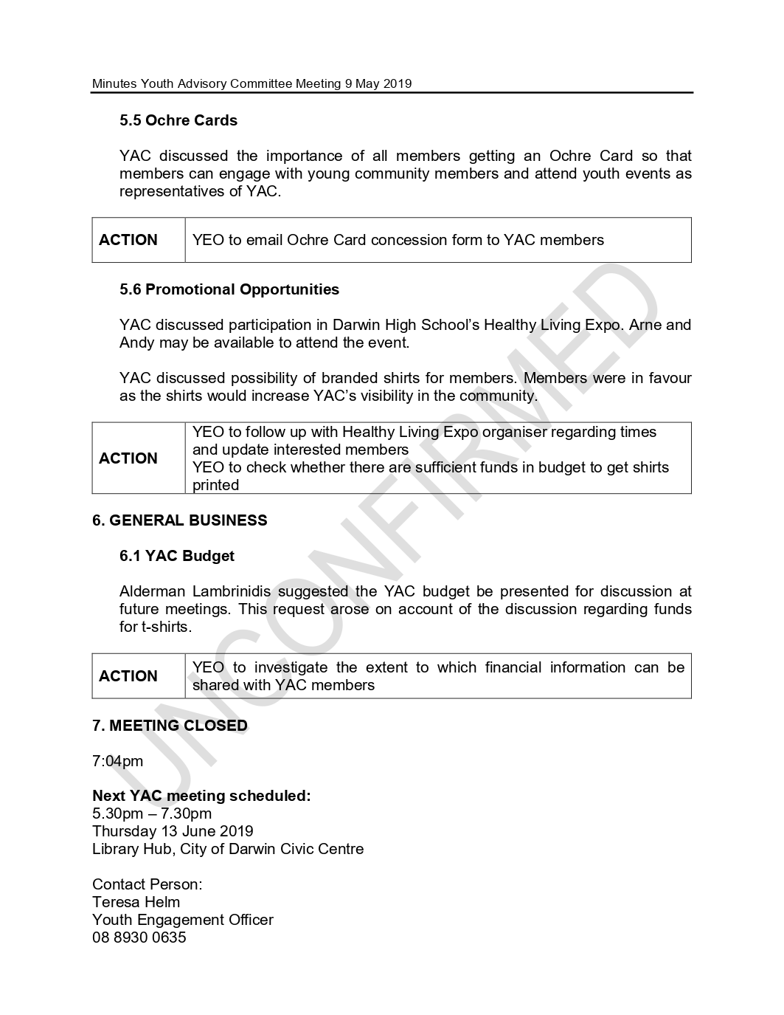

14 Receive & Note Reports

14.1 MONTHLY FINANCIAL REPORT - APRIL 2019
Common No.: 2476534
Author: Executive Manager Finance
Authoriser: General Manager Corporate & Procurement Services
Attachments: 1. MONTHLY FINANCIAL REPORT - APRIL 2019

Summary
The purpose of this report is to provide a comparison of income and expenditure against the budget for the period ended 30 April 2019 in accordance with the Local Government (Accounting) Regulations 2008.

Recommendations
THAT the report entitled Monthly Financial Report – April 2019 be received and noted.

Key Issues
• The Council operated at a better than budget position, before Capital Grants, of $1.06 million for the ten months to 30 April 2019.
• The monthly financial report meets Council’s statutory requirements.
• There are no overall concerns with this month’s report.

Background
Council has endorsed the format of the Monthly Financial Report. It complies with the Local Government (Accounting) Regulations 2008 in respect of monthly financial reporting.

Discussion
Significant items contributing to Councils better than budget position include;
• Increase in rates income through growth.
• Investment income is higher than anticipated.
• Savings in Employee Costs offsets with overspend in Temporary Staff Hire.

Overall Income Statement
The Overall Income Statement contains all sources of Council’s income (revenue) and operating expenses. Items of note include;

• Operating Income streams are performing as follows: (% is based against Revised Full Year Budget)
o Rates – 100%
o Fees & Charges – 78%
o Garbage & Recycling – 99%
o Parking – 85%
o Operating Grants – 84%
o Investment Interest -125%
o Property Rental / Leases – 92%
o Fines & Penalties – 81%
o Animal Registrations – 95%

• Capital Grants & Contributions are behind budget due to the timing of receiving Grants.
• Operating Expenses appears reasonable for this 10th month of the financial year. Amongst the operational activities, Materials, Contracted Materials & Services and Non Contract Services have been noted to be much lesser than its Year to Date Budget for the following Sections:
o Waste Management Section
o Civil Infrastructure
o City Parking
These costs will be continually monitored. Outstanding commitments will also be checked and verified in preparation for End of Year closing.

Within the Statement of Financial Position report, the Receivables figure of $8.6 million includes around $3.9 million of current Rates struck.

Municipal Plan Summary
The Municipal Plan Summary follows a similar format to the statement of cash flows, but is based on working capital rather than cash. Elected Members can also refer to the quarterly budget reviews for more detailed final information as these become available.

Amended Budget
The amended budget column in the Overall Income Statement and Municipal Plan Summary includes projects/programs carried forward from 2017/18 into 2018/19 for completion.

Treasury Comment
The Investment report details all cash and investments, by institution, and provides information on interest rate returns, maturities and policy compliance. Interest earned is at a weighted average return of 2.62%. This compares well to the 90 day bank Bill Swap rate, (BBSW), of 1.56%
Council has $90.6 million of invested funds, most of which is either; Grant monies received in advance or Reserves with are a mix of legally and internally restricted.

Council has recently uplifted the $3M loan funding provided by ANZ for the Streetlighting Upgrade project.
Financial commentators believe the Reserve Bank of Australia (RBA) will not cut interest rates.
Financial advisors validate that an easing bias in RBA policy statement and if the low inflation figures are confirmed at the next quarter or GDP growth remains low, unemployment rises or other indicators point to a slowing economy, only then, will the RBA cut interest rates.
Accounts Receivable Report
This report details Rate receipt collection, outstanding general debtors, and performance on Rates recovery compared to the previous year. The report also includes additional information on infringement debtors, rates arrears, rates struck and rates outstanding (bar chart).

Implications
The financial report is as at 30 April 2019. In completing the report reliance is placed on a number of matters including; accuracy of budget phasing, timely receipt of financial inputs, and accruals.

POLICY IMPLICATIONS

Nil

BUDGET AND RESOURCE IMPLICATIONS

Nil

RISK/LEGAL/LEGISLATIVE IMPLICATIONS

Part 8 of the Local Government (Accounting) Regulations 2008 require that a monthly financial report is presented to Council.

Regulation 18 states:-

1. The CEO must, in each month, lay before a meeting of the council a report, in a form approved by the council, setting out:

a) The actual income and expenditure of the council for the period from the commencement of the financial year to the end of the previous month; and

b) The forecast income and expenditure for the whole of the financial year

2. The report must include:

a) Details of all cash and investments held by the council (including money held in trust); and

b) A statement on the debts owed to the council including the aggregate amount owed under each category with a general indication of the age of the debts; and

c) Other information required by the Council.

1. If a council does not hold a meeting in a particular month, the report is to be laid before the
council committee performing the council's financial functions for the particular month.

This report is considered to a higher level of statutory compliance as outlined above.

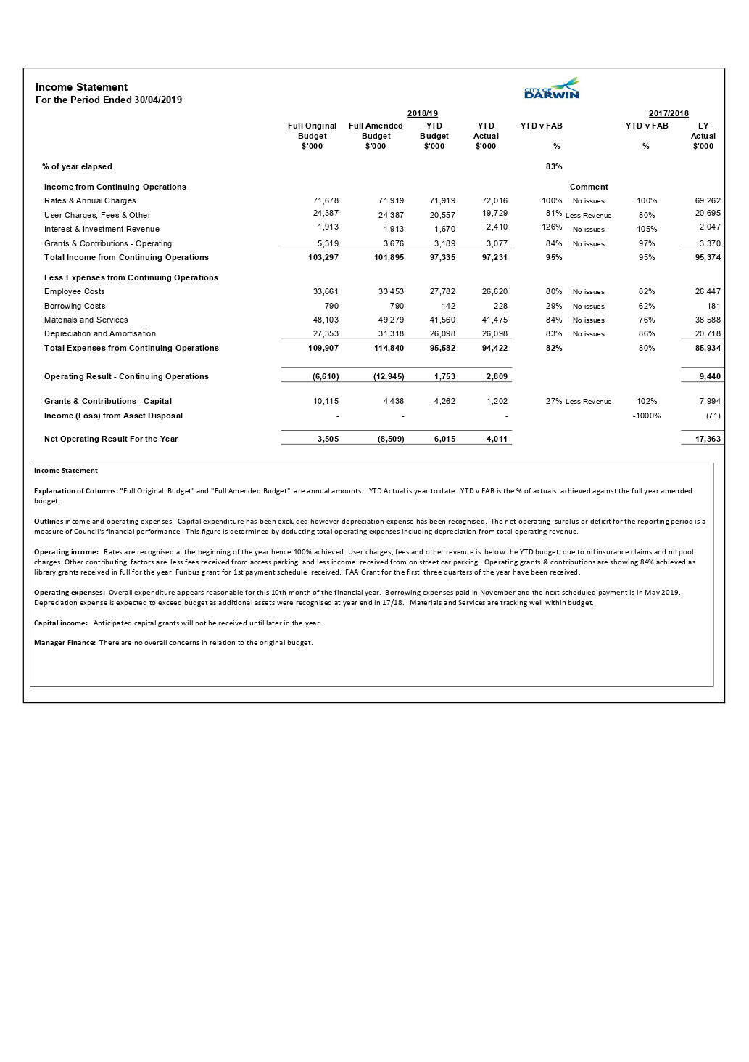

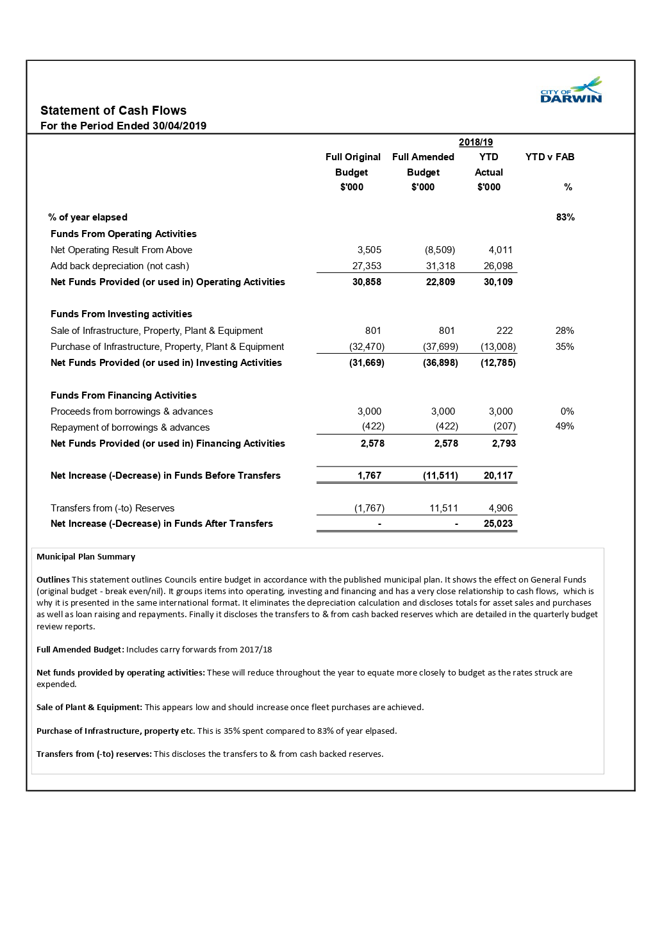

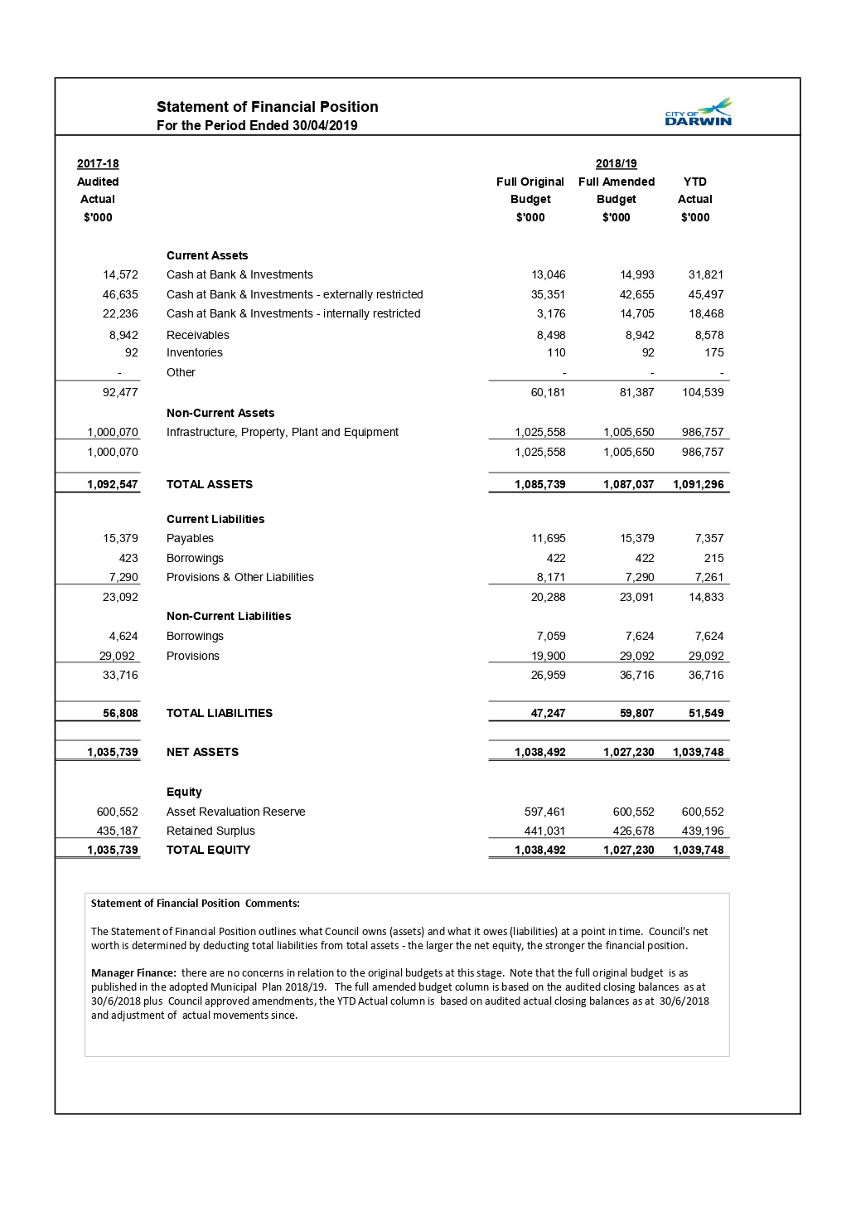

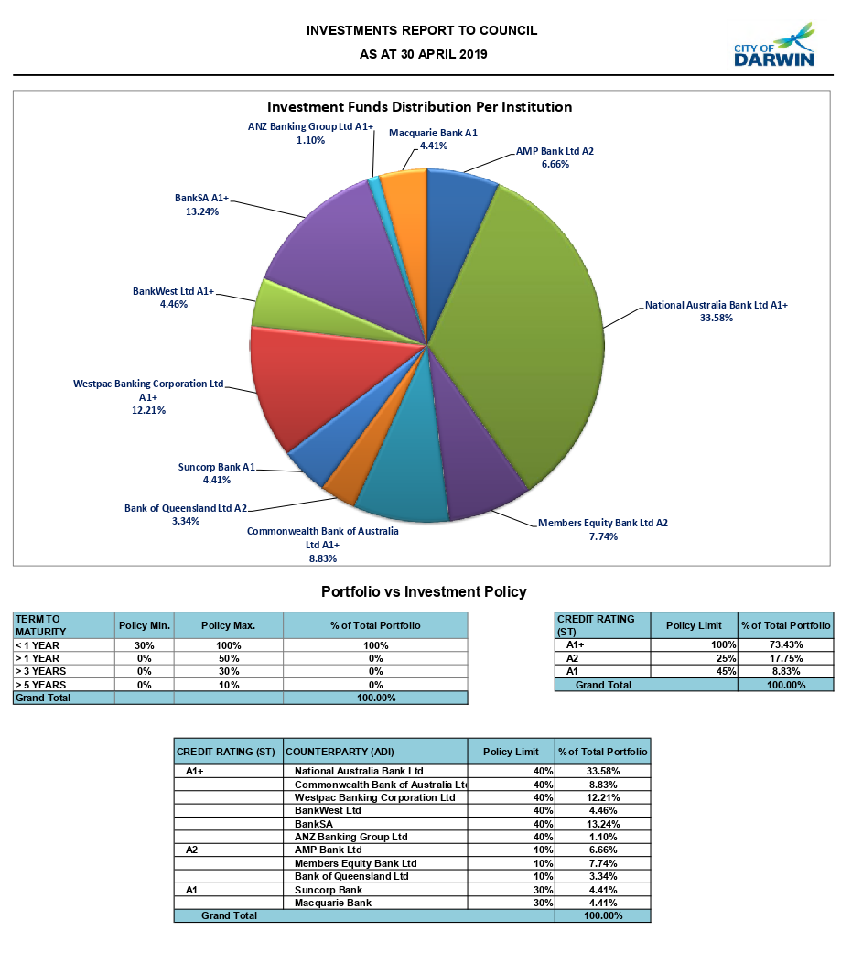

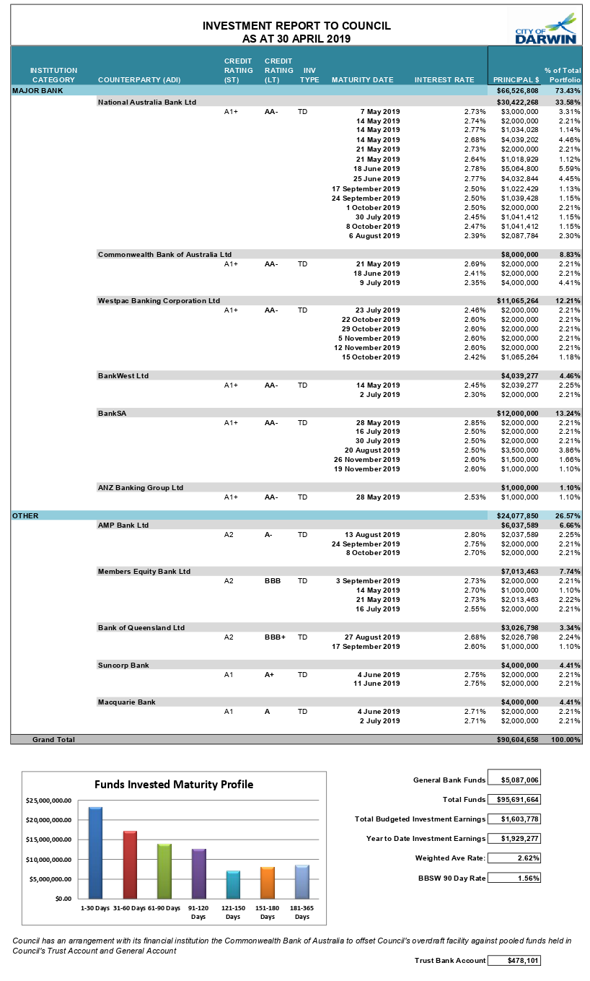
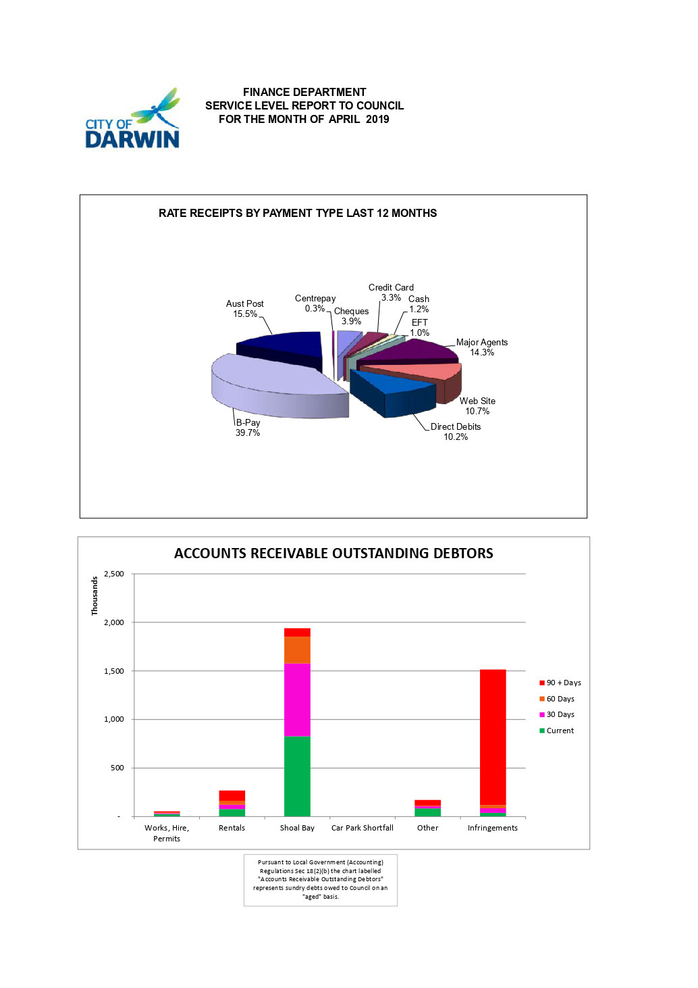

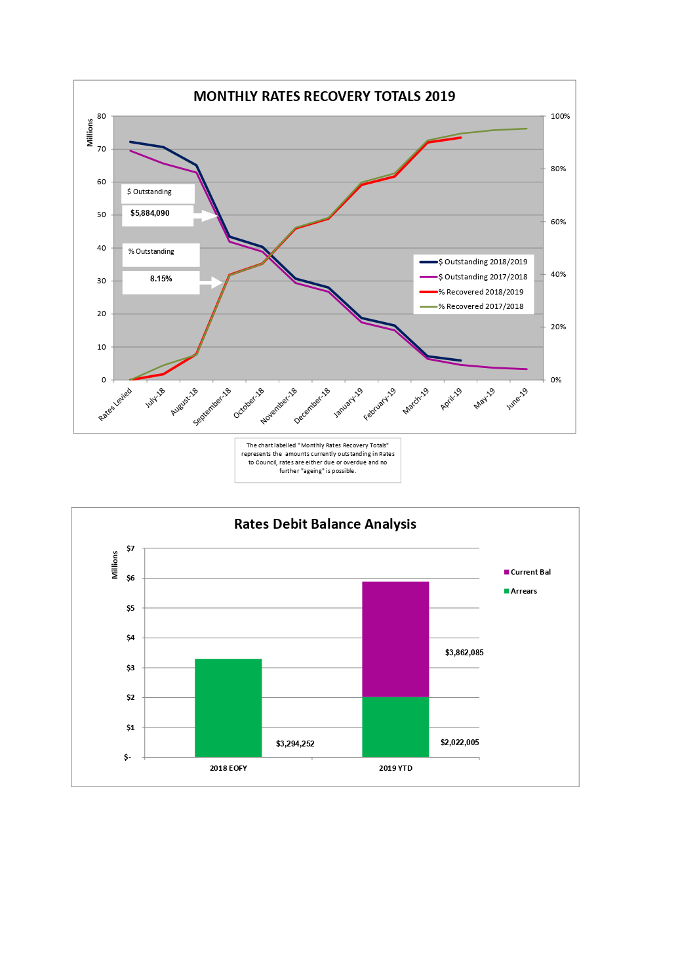

14.2 Update on the Implementation of the Dog and Cat Management Strategy 2018-2022
Common No.: 3035896
Author: Executive Manager Leisure and Regulatory Services
Authoriser: General Manager Community and Regulatory Services
Attachments: 1. Implementation Actions Summary 2018-2019
2. Detailed Implementation Plan and Actions 2018-2022

Summary
The purpose of this report is to provide an update on the progress of the implementation of the Dog and Cat Management Strategy 2018-2022.

Recommendations
THAT the report entitled Update on the Implementation of the Dog and Cat Management Strategy 2018-2022 be received and noted.

Key Issues
• Council adopted the Dog and Cat Management Strategy 2018-2022, in April 2018.
• The strategy includes an implementation plan detailing 48 actions to be undertaken.
• Twenty of the actions are ongoing throughout the strategy’s duration, 22 were scheduled to be delivered in the first year and 6 to be completed from 2019 to 2022.
• Sixteen of the 22 first year implementation actions have been completed.
• Four of the 6 implementation actions for delivery between 2019 and 2022 have also been completed.

Background

Previous Decisions

DECISION NO. 22\0671 (24/04/18)

Draft Dog And Cat Management Strategy

Report No. 18CL0039 AM:kl (24/04/18) Common No. 3035896

D. THAT a report on the implementation of the Dog and Cat Management Strategy be presented to Council after 12 months.

Discussion
Council endorsed the Animal Management Strategy 2018-2022 in April 2018. The strategy was developed following comprehensive consultation with stakeholders and the community, and a deliberative process that included consideration by the Animal Management Advisory Committee, an evidence-based review, and Elected Member workshops.

The strategy details an implementation plan with 48 actions across five key areas:
• Registration, Licencing and De-sexing 14 actions
• Nuisance Barking 8 actions
• Dog Attacks 6 actions
• Pets in Public Places 13 actions
• Pound Operations 7 actions

Implementation actions are further categorised into 5 key themes:

• Education and Communication
• Incentives
• Regulation and Enforcement
• Innovation and Technology
• Partnerships and Collaboration

Attachment 1 provides a summary of implementation actions for 2018-2019 which details completed, outstanding and ongoing actions. Twenty of the 48 actions are ongoing throughout the strategy’s duration, 22 were scheduled to be delivered in the first year and 6 to be completed from 2019 to 2022. Since the strategy was endorsed in April 2018, 16 of the 22 first year implementation actions have been completed. A further 4 actions have also been completed that were not due until years two, three or four of the strategy.

Attachment 2 provides the Dog and Cat Management Strategy 2018-2022 Implementation Plan in detail and identifies all actions undertaken together with current status for each key area and categorisation.

There are 6 outstanding actions from the first year implementation timeframe:

• Develop a ‘Welcome to Darwin’ information pack
• Update and develop education material on dog attacks
• Review procedures for animal attacks
• Develop a map for pets in public places
• Develop a strategy for the stray cat population
• Develop incentives for people who purchase animals from rehoming organisations

Work to complete these items is currently in progress; Attachment 2 details the actions that are being undertaken to complete these items.

The Dog and Cat Management Strategy 2018-2022 Implementation Plan identifies targets in key areas:
• Registration, Licencing and De-sexing
o Target - By 2022 there will be an increase in registrations by 20% or 5% each year.
• Nuisance Barking
o Target - Reduce Dog Barking Complaints by 20%
• Dog Attacks
o Target - Council aims to reduce dog attacks by 15% per year
• Pound Operations
o Target - Reduce the number of impounded animals by 20% by 2022
o Target - By 2022, increase the number of animals reunited with their owners or rehomed by 20% on 2016 figures

Registration, Licencing and De-sexing
The strategy targets an increase in registrations of 20% by 2022 or 5% each year. The table below provides dog and cat registration numbers from 2014 to 2019 year to date.

Year | Dogs | Cats
1/07/2018- 30/06/2019 YTD | 8007 | 1305
1/07/2017-30/06/2018 | 8975 | 1359
1/07/2016- 30/06/2017 | 9396 | 1274
1/07/2015- 30/06/2016 | 9139 | 1165
1/07/2014- 30/06/2015 | 8038 | 1063

The 2018-2019 year to date figures indicates a decrease in the number of registrations by 11% for dogs and 3% for cats from the previous year. There is a decline in dog registrations since 2017. A combined approach of education and compliance activity is required to reverse this trend. Council has allocated $150,000 in the 2019-2020 Draft Municipal Plan for the delivery of the Animal Management Community Education Program to address this issue. This includes the ‘Great Pets Start With You’ campaign and will provide an ongoing animal management campaign to achieve positive behaviour change for pet ownership within the Darwin municipality.

In addition, in August 2018 the Top End Regional Organisation of Councils (TOPROC) established the Animal Management Reference Group (AMRG) to improve animal management across the region and to provide recommendations to improve registration compliance. AMRG recommendations regarding common registration periods, reciprocal registration and standardisation of registration categories will be presented to Council in the 2019-2020 financial year.

Dog Attacks and Nuisance Barking
A comparison of the number of dog attacks and nuisance barking complaints for 2017-2018 and 2018-2019 indicates an 11% increase of the number of reported dog attacks and a 4% decrease in nuisance barking.

In April 2019, Council endorsed the revised Animal Management Policy 001. The policy was aligned to be consistent with the Dog and Cat Management Strategy 2018-2022 and included key amendments to achieve Council’s goals of amenity, safety, responsible pet ownership and compliance with the by-laws in relation to animal management. It is anticipated that key amendments that were adopted such as the reduction of the number of animals that may be kept at a property and definitions for nuisance barking will contribute to achieving Council’s goals for these areas.

Pound Operations
A comparison of the number of impounded animals and the number of animals reunited with their owners or rehomed based on 2016 figures (comparison target date established in the strategy) for the first year of implementation of the strategy details a 7.6% decrease in the number of impounded animals and a 17% increase in the number of animals reunited with their owners or rehomed.

Strategic Environment
The issues addressed in this Report are in accordance with the following Goals/Strategies as outlined in the ‘Evolving Darwin Towards 2020 Strategic Plan’:

Goal
5 Effective and Responsible Governance

Outcome
5.3 Good governance

Key Strategies
5.3.1 Demonstrate good corporate practice and ethical behaviour

Legislative/Policy
In April 2019, Council endorsed the revised Animal Management Policy 001. The policy was revised to provide a proactive, responsive, evolving approach to animal management that is consistent with Council’s Dog and Cat Management Strategy 2018-2022.

Consultation

Internal
In preparing this report, the following City of Darwin officers were consulted:
• Animal Education and Policy Officer
• Regulatory Pound Coordinator
• Animal Education Officer
• A/Regulatory Supervisor Animal Management

External
Nil

Budget/Resource Implications
The 2019-2020 Draft Municipal Plan details an operational new initiative of $150,000 for the delivery of the Animal Management Community Education Program.

Risk
Nil

Legal
Nil

Arts, Culture & Environment

Good animal management practices reduce the negative impact of domestic animals
on the natural environment and on community amenity.

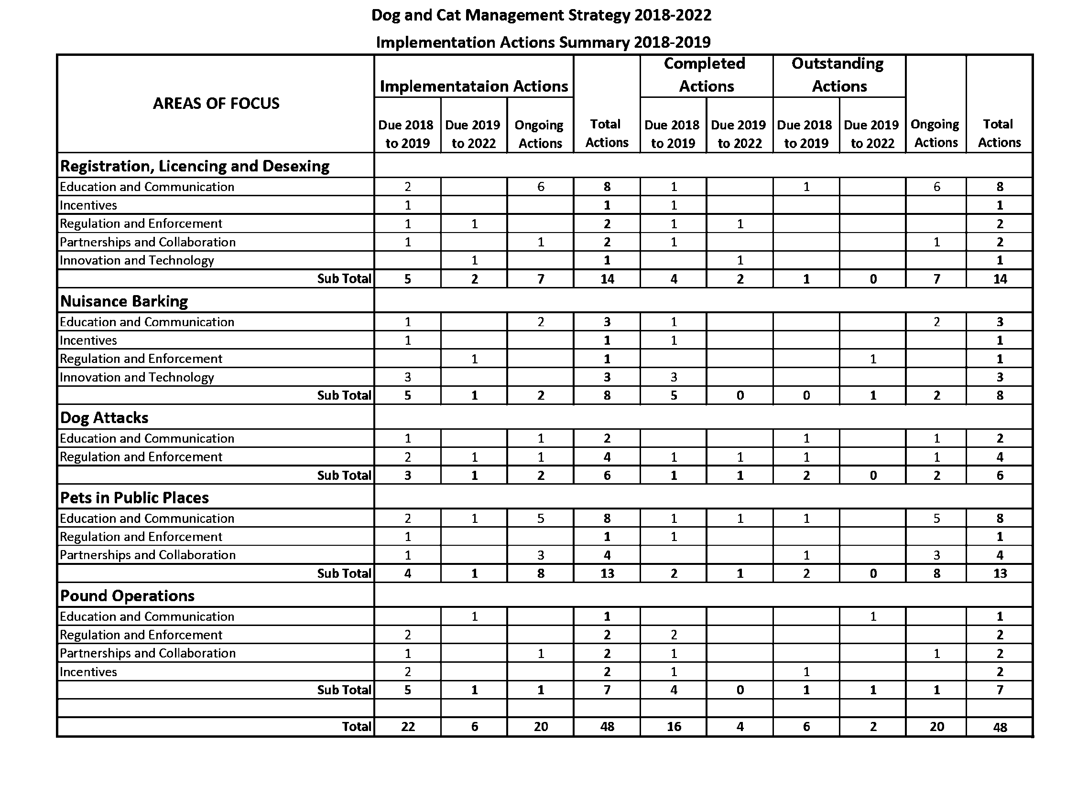
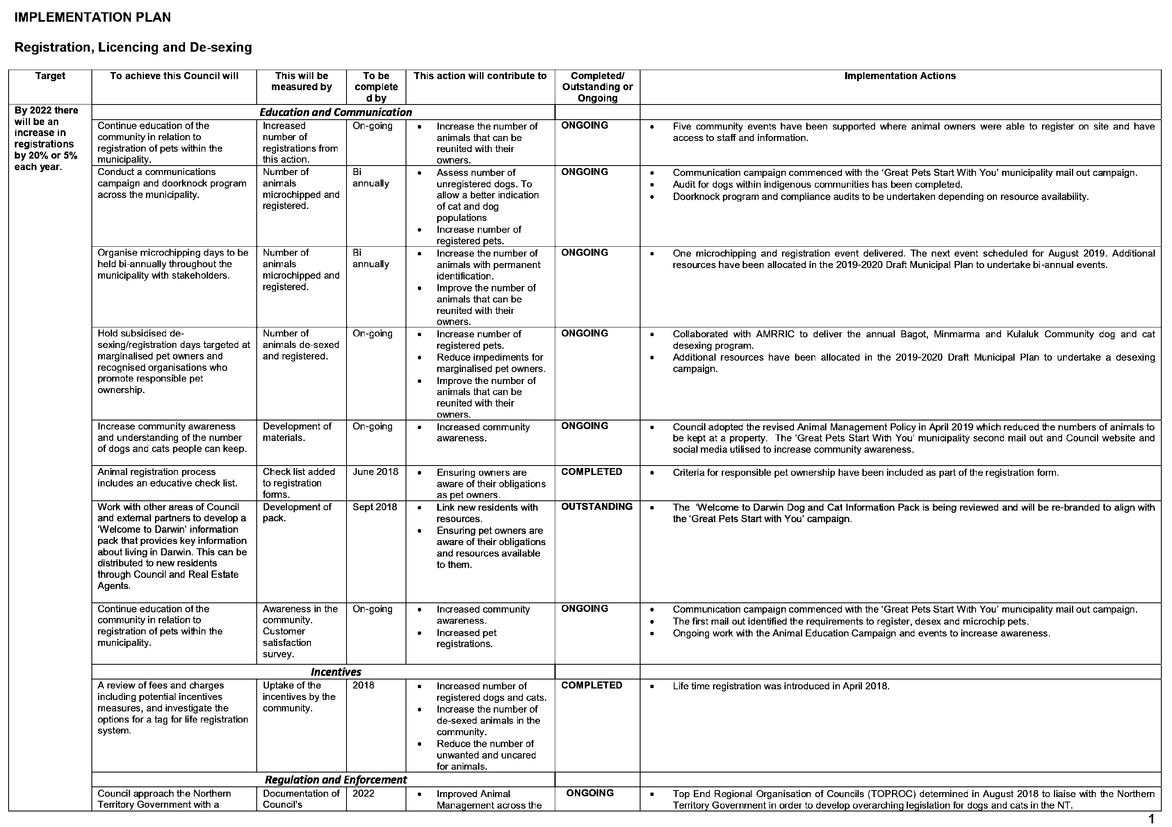

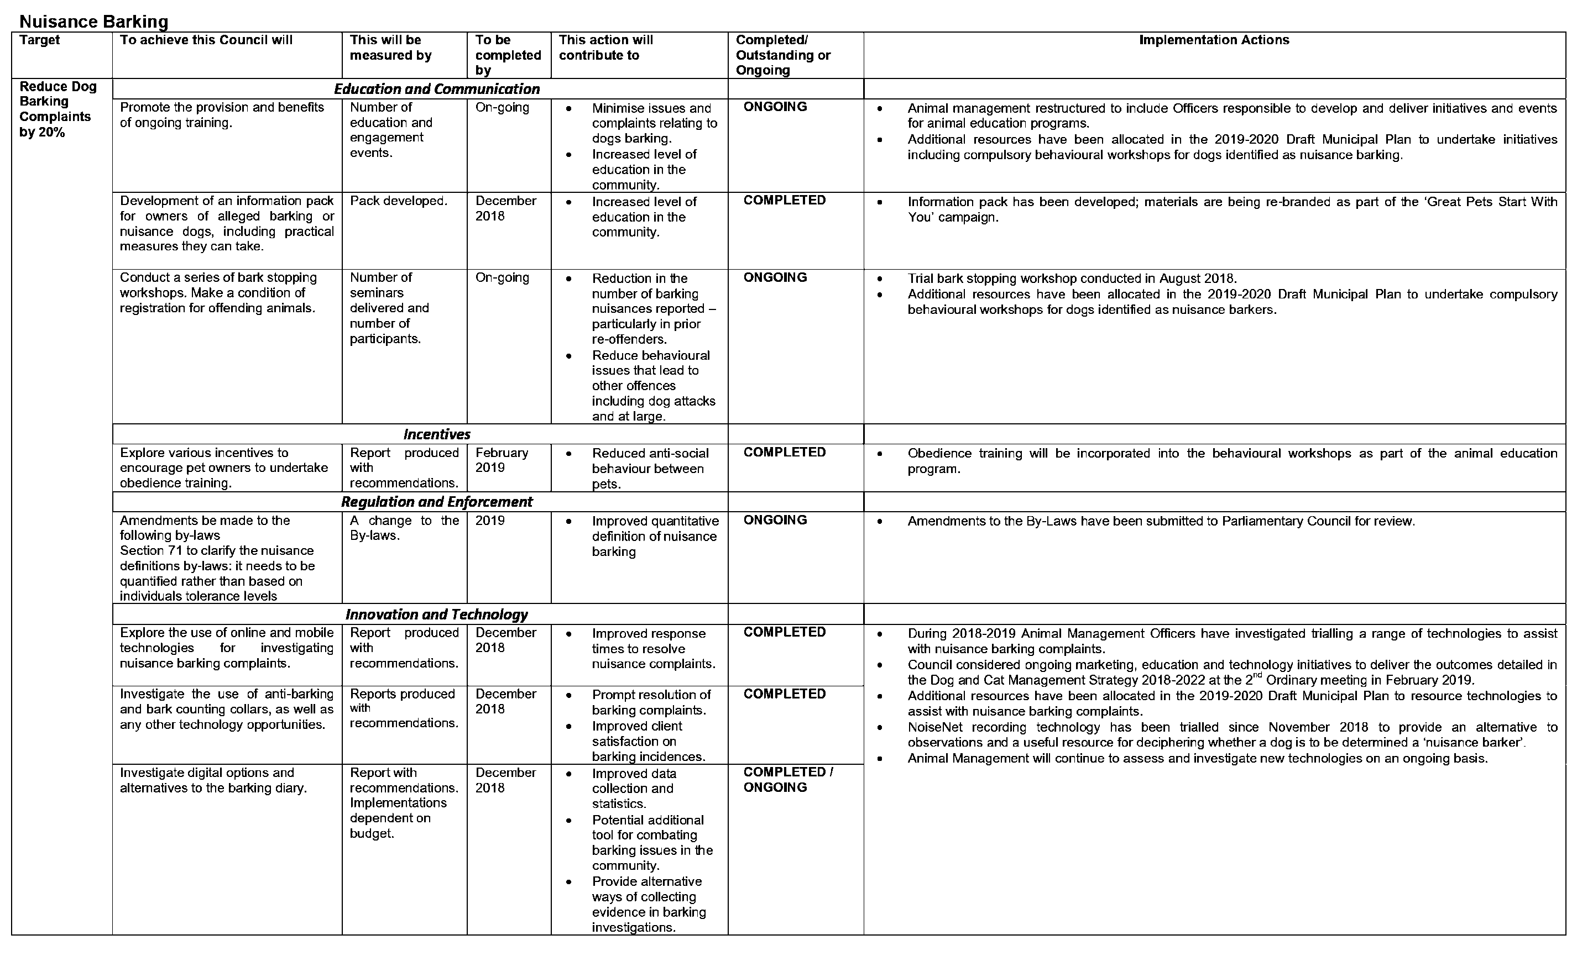

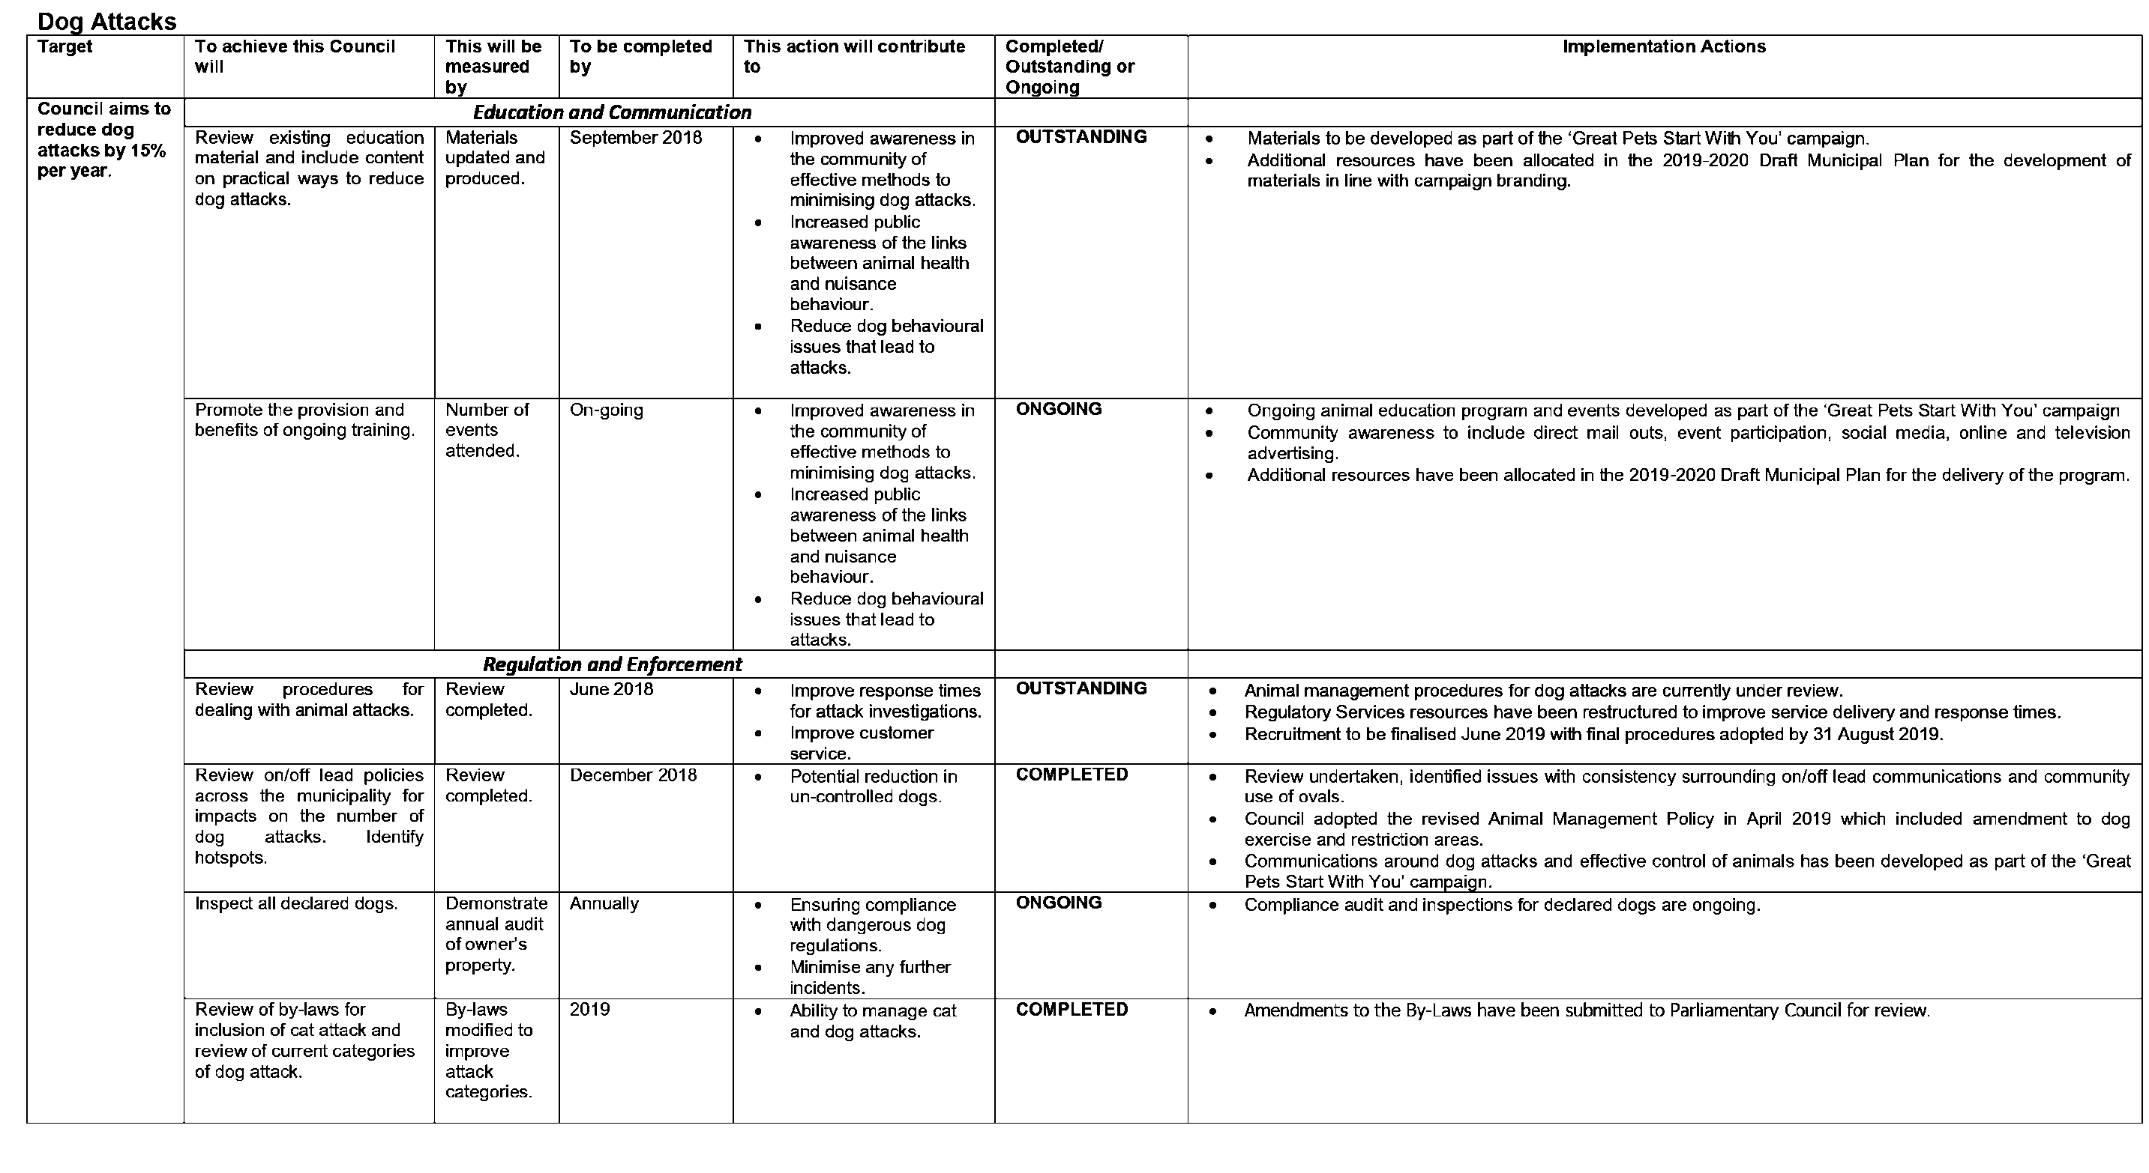

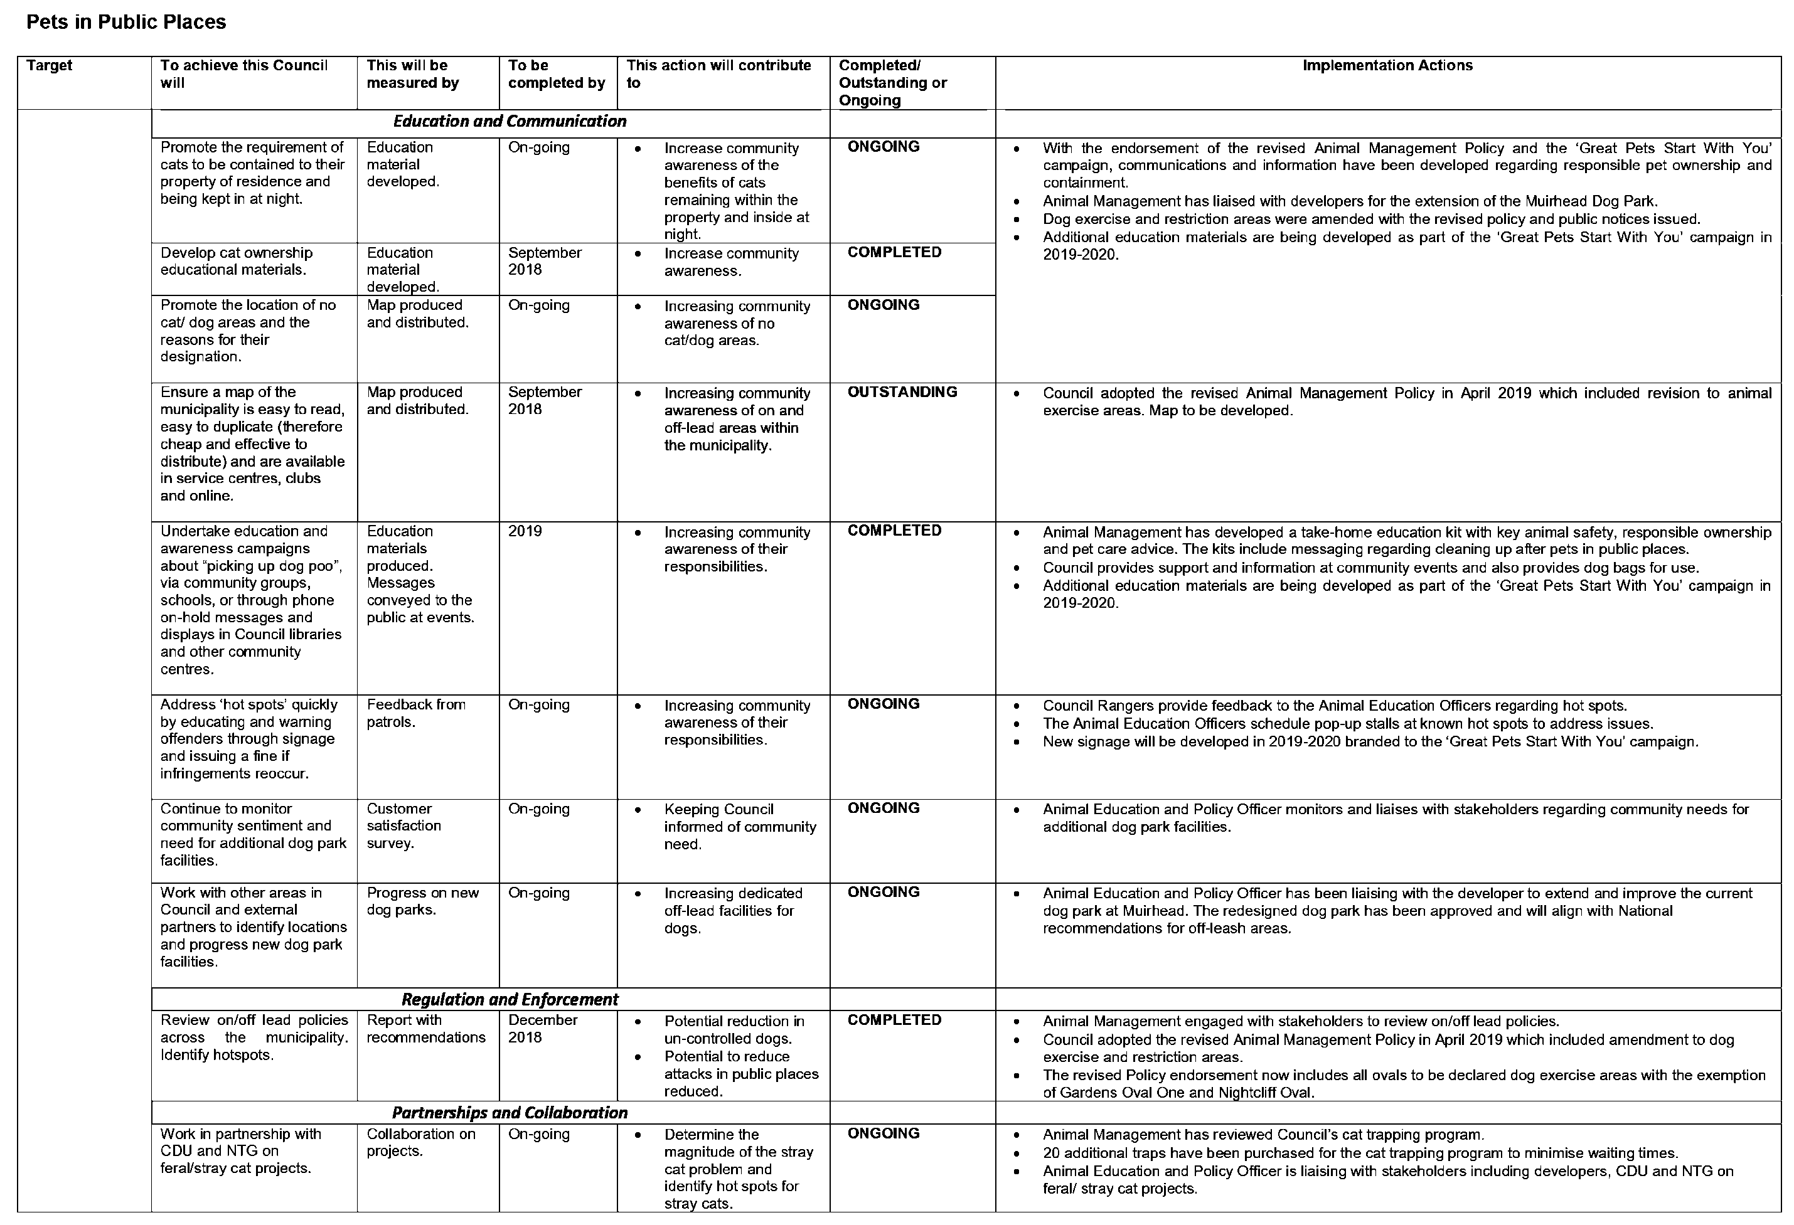

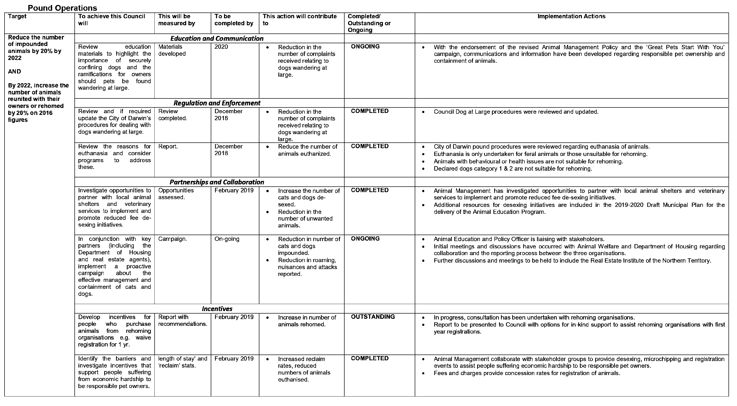

14.3 ICT Request for Tender and Future Investment Update - May 2019
Common No.:
Author: General Manager Corporate & Procurement Services
Authoriser: General Manager Corporate & Procurement Services
Attachments: Nil

Summary
The purpose of this report is to provide an update on the significant future investment being made in Information and Communications Technology (ICT) and in particular the current Request for Tender (RFT) process relating to printers, telephony and desk top computing.

Recommendations
- THAT the report entitled ICT Request for Tender and Future Investment Update - May 2019 be received and noted.
- THAT furthermore Council note the significant engagement with the local ICT industry in this process.

Key Issues
• The Draft Budget and Municipal Plan for 2019/20 includes provision for significant investment in ICT equipment and service transformation
• The first stage of this investment is being taken forward under a Request for Tender process for printers, telephony and desktop computing end user devices (PC’s and Laptops). The three tenders were released to market on Thursday 4 April 2019 and the submissions have been received and are currently being assessed by a cross organisational assessment panel.
• The General Manager of Corporate and Procurement Services is currently reviewing the organisation’s procurement processes to ensure best practice and legislative compliance and importantly to increase the amount of local procurement to support local business. To this end there has been a strong focus on encouraging the local Darwin ICT Industry to respond to the tenders.
• To facilitate this, ICT Industry Tender Briefings were conducted in early April 2019 for prospective applicants. The briefings provided a great opportunity to get to know local providers, explain to them the significant change management programme occurring in the City of Darwin and the importance of this investment and for them to seek clarification on the various aspects of the requirements.
• Following selection there will be a comprehensive implementation and training programme and the focus will then move to the key upgrade of the Councils key enterprise system Authority (provided by Civica) and a range of either upgraded or new modules e.g. procurement, asset management. A further report will be brought back to Council in due course.

Background
Following the appointment of the new Chief Executive Officer in June 2018 there were a number of external reviews carried out in the organisation. One of the significant pieces of work was a review of our ICT platform, systems, processes and procedures carried out by GWI.
In October/November 2018 GWI facilitated the development of the Productivity, Collaboration and Communication Request for Quote (RFQ). This was released through the Local Buy procurement system and targeted five specific vendors of which four made a submission. Through this process one single response was sought which at this stage covered end user devices, telephony, maintenance and software.
Based on the information received it became clear that there would be greater benefit in separating out some of the component parts to be tendered for and it was also timely to add in printers. It also became evident that the process ruled out some key local providers so the decision was taken to move to three separate tenders under a broader open tender arrangement. Each tender included relevant procurement requirements for maintenance and support.
Information from the RFQ’s was by no means wasted and was used to inform some changes to the process and highlighted the need for some further work in identifying and refining business requirements to better reflect the future operating model of the City of Darwin and to include future requirements such as call centre capability.
The new RFT’s were released on 4 April 2019 and specifically targeted the local ICT Industry and the submissions received are currently being assessed and will be the subject of a further update to Council

Discussion
As a key part of the tender process the City of Darwin were keen to support the local ICT Industry and conducted two RFT Industry Briefings encouraging local ICT businesses to respond. The briefing sessions provided a valuable opportunity for vendors to better understand the strategic issues and change management challenges facing the City of Darwin but also provided a valuable opportunity for vendors to ask specific questions and clarify requirements. Vendors were also encouraged to provide innovative solutions including ideas beyond the scope of the brief to ensure innovative opportunities could be considered.
Both of the briefing sessions were very well received by the local ICT Industry with five vendors attending the session on printers on Wednesday 10 April 2019 and nineteen attending the combined telephony and PC/Laptop briefing held on Wednesday 17 April 2019.
Through its review of Procurement practices the City of Darwin is committed to increasing the level of local procurement and in this case committed to supporting the local ICT economy by providing an encouraging and supportive environment for them to participate in the tender responses. Following submissions in May 2019 the assessment process has commenced and in line with the local focus a 30% weighting is being applied to local providers. As part of the assessment process, which is currently in train, providers shortlisted by the panel will be interviewed and further clarification sought on their submissions.
This is an exciting time for the City of Darwin and a great opportunity not only to transform and update the systems and equipment but also to provide an opportunity for a significant boost to the local economy.

Implications
This process represents the first step towards significant transformational change which will have a major organisational impact through updating and modernising the fleet of hardware, implementing up to date software, and upgrading the City of Darwin’s core operating platform which will also provide longer term benefits in respect of efficiency and effectiveness of operations.

15 Reports of Representatives

16 Questions by Members

17 General Business

17.1 Acting Deputy Lord Mayor - 7 to 17 June 2019
THAT in accordance with Part 4.3 of the Local Government Act, Alderman __ be appointed as Acting Deputy Lord Mayor for the period 7 to 17 June 2019.

18 Date, time and place of next Ordinary Council Meeting

THAT the next Ordinary Meeting of Council be held on Tuesday, 11 June 2019, at 5.30pm (Open Section followed by the Confidential Section), Council Chambers, Level 1, Civic Centre, Harry Chan Avenue, Darwin.

19 Closure of Meeting to the Public
THAT pursuant to Section 65 (2) of the Local Government Act and Regulation 8 of the Local Government (Administration) Regulations the meeting be closed to the public to consider the Confidential Items of the Agenda.

Recommendations
That Council considers the confidential report(s) listed below in a meeting closed to the public in accordance with Section 65(2) of the Local Government Act:
24.1 Shoal Bay Waste Management Facility Operations Contract Award
This matter is considered to be confidential under Section 65(2) - 8(c)(i) of the Local Government Act, and the Council is satisfied that discussion of this matter in an open meeting would, on balance, be contrary to the public interest as it deals with information that would, if publicly disclosed, be likely to cause commercial prejudice to, or confer an unfair commercial advantage on any person.
24.2 Access and Inclusion Advisory Committee Appointments - May 2019
This matter is considered to be confidential under Section 65(2) - 8(c)(iv) of the Local Government Act, and the Council is satisfied that discussion of this matter in an open meeting would, on balance, be contrary to the public interest as it deals with information that would, if publicly disclosed, be likely to prejudice the interests of council or some other person.
24.3 PAYMENT LISTING REPORT - APRIL 2019
This matter is considered to be confidential under Section 65(2) - 8(a), 8(b) and 8(c)(i) of the Local Government Act, and the Council is satisfied that discussion of this matter in an open meeting would, on balance, be contrary to the public interest as it deals with information about the employment of a particular individual as a member of the staff or possible member of the staff of the council that could, if publicly disclosed, cause prejudice to the individual, information about the personal circumstances of a resident or ratepayer and information that would, if publicly disclosed, be likely to cause commercial prejudice to, or confer an unfair commercial advantage on any person.

20 Adjournment of Meeting and Media Liaison

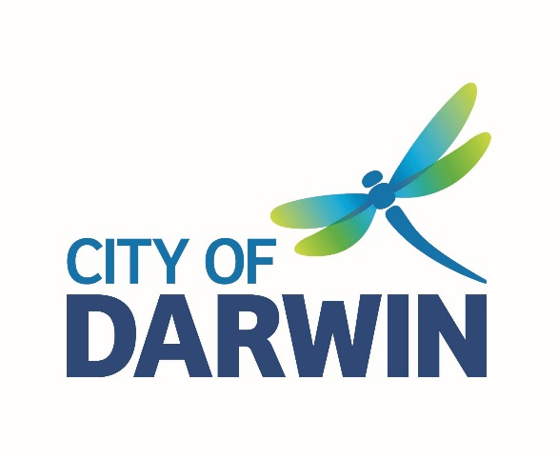
PREVIOUS MINUTES
Ordinary Council Meeting
Tuesday, 14 May 2019

Reports, recommendations and supporting documentation can be accessed via the City of Darwin Council Website at www.darwin.nt.gov.au, at Council Public Libraries or contact the Committee Administrator on (08) 8930 0670.

MINUTES OF City of Darwin
Ordinary Council Meeting
HELD AT THE Council Chambers, Level 1, Civic Centre, Harry Chan Avenue, Darwin
ON Tuesday, 14 May 2019 AT 5.30pm

PRESENT: Lord Mayor Kon Vatskalis, Alderman Andrew Arthur, Alderman Sherry Cullen, Alderman Justine Glover, Alderman Gary Haslett, Alderman Robin Knox, Alderman George Lambrinidis, Alderman Simon Niblock, Alderman Mick Palmer, Alderman Peter Pangquee, Alderman Rebecca Want de Rowe,
OFFICERS: Scott Waters (Chief Executive Officer), Maz Khosravi (Acting General Manager Innovation Growth & Development Services), Matt Grassmayr (Acting General Manager Community & Regulatory Services), Chris Potter (General Manager Corporate and Procurement Services), Melissa Reiter (General Manager Government Relations & External Affairs), Ron Grinsell (General Manager Engineering & City Services), Penny Hart (Coordinator Governance), Jane de Gault (Media & Communications Advisor), Irene Frazis (Management Accountant), Russell Holden (Executive Manager Finance), Vanessa Green (Manager Strategy & Outcomes), Robyn Higgins (Community & Cultural Development Coordinator), Trevor Clark (Project Officer Capital Works), Anthony Jones (Customer Service Officer), Julie Gordon (Executive Assistant), Sharon Barbagallo (Library Manager), Sheree Lewis (Administration Officer), Shenagh Gamble (Executive Manager Environment and Community).
APOLOGY: Alderman Jimmy Bouhoris, Alderman Emma Young.
MEDIA: NT News, Mr Will Zwar; Channel 9, Ms Zarisha Bradley; ABC News, Mr Mitchell Abram.
GUESTS: Mr Tony Burns was in attendance from Helping People Achieve.

WEBCASTING DISCLAIMER
The City of Darwin is live webcasting the Open Section of Ordinary Council Meetings. Audio-visual recording equipment has been configured to avoid coverage of the public gallery area and the City of Darwin will use its best endeavours to ensure images in this area are not webcast. However the City of Darwin expressly provides no assurances to this effect and in the event your image is webcast, you will by remaining in the public gallery area be taken to have given the City of Darwin a non-exclusive licence to copy and broadcast your image worldwide for no reward.

Order Of Business
1 Acknowledgement of Country 5
2 The Lord’s Prayer 5
3 Meeting Declared Open 5
4 Apologies and Leave of Absence 5
4.1 Apologies 5
4.3 Leave of Absence Requested 5
5 Electronic Meeting Attendance 5
6 Declaration of Interest of Members and Staff 6
7 Confirmation of Previous Minutes 6
8 Matters of Public Importance / Lord Mayoral Minute 6
Nil
9 Public Question Time 7
10 Petitions 7
11 Deputations and Briefings 7
11.1 Helping People Achieve 7
12 Notices of Motion 7
Nil
13 Officers Reports 8
13.1 Darwin 2030 - City for People. City of Colour. Strategic Plan 8
13.2 2019/2020 FEES AND CHARGES 8
13.3 Community and Environment Grant Programs (2019/2020) 8
13.4 Council Response to Liquor Licence Applications - April 2019 10
13.5 Election of Members of Committees 2019/20 12
13.6 Draft 2019/20 Municipal Plan 14
13.7 Operating Subsidies - Community and Regulatory Services 14
13.8 Operating Subsidy Tourism Top End and Darwin City & Waterfront Association 15
14 Receive & Note Reports 15
Nil
15 Reports of Representatives 16
16 Questions by Members 16
16.1 Anula Green Belt 16
16.2 Busking Program 17
16.3 Claymore Circuit Works 17
16.4 Dickward Drive Fire Break 17
16.5 Mindil Beach Events 18
17 General Business 18
17.1 Tree Planting 18
18 Date, time and place of next Ordinary Council Meeting 18
19 Closure of Meeting to the Public 18
20 Adjournment of Meeting and Media Liaison 19

1 Acknowledgement of Country

2 The Lord’s Prayer

3 Meeting Declared Open
The Chair declared the meeting open at 5.35 pm.

4 Apologies and Leave of Absence

4.1 Apologies
Resolution ORD069/19
Moved: Alderman Justine Glover
Seconded: Alderman Robin Knox
THAT the apology from Alderman Emma Young, be received.
THAT the apology from Alderman Jimmy Bourhois, be received.
Carried 8/0

4.2 Leave of Absence Granted

Nil

4.3 Leave of Absence Requested
Resolution ORD070/19
Moved: Alderman Justine Glover
Seconded: Alderman George Lambrinidis
THAT a Leave of Absence be granted for Alderman Robin Knox for the period 7 to 17 June 2019.
Carried 8/0

5 Electronic Meeting Attendance
5.1 Electronic Meeting Attendance Granted
Nil

5.2 Electronic Meeting Attendance Requested
Resolution ORD071/19
Moved: Alderman Robin Knox
Seconded: Alderman Justine Glover

THAT Council note that pursuant to Section 61 (4) of the Local Government Act and Decision No. 21\0009 – 15/04/12, the following member requests Electronic Meeting Attendance:
- Alderman Robin Knox to attend all Council and Committee Meetings for the period of 7 to 17 June 2019.
Carried 11/0

6 Declaration of Interest of Members and Staff
6.1 Declaration of Interest by Members
Resolution ORD072/19
Moved: Alderman Justine Glover
Seconded: Alderman George Lambrinidis
THAT Council note that pursuant to Section 73 & 74 of the Local Government Act, Member Niblock, declared a Conflict of Interest in Item 13.4.
Carried 11/0

6.2 Declaration of Interest by Staff
Nil

7 Confirmation of Previous Minutes
Resolution ORD073/19
Moved: Alderman Mick Palmer
Seconded: Alderman Peter Pangquee
That the minutes of the Ordinary Ordinary Council Meeting held on 30 April 2019 be confirmed.
Carried 8/0

8 Matters of Public Importance / Lord Mayoral Minute
Nil

9 Public Question Time
Nil

10 Petitions
Nil

Alderman Gary Haslett joined the meeting at 5.38pm.
Alderman Andrew Arthur joined the meeting at 5.39pm.
Alderman Sherry Cullen joined the meeting at 5.39pm.

11 Deputations and Briefings

11.1 Helping People Achieve
Representatives from Helping People Achieve were in attendance from 5.40pm to provide an update on operations and the partnership with Council.
Resolution ORD074/19
Moved: Alderman Rebecca Want de Rowe
Seconded: Alderman Justine Glover
THAT the presentation from Helping People Achieve be received and noted.
Carried 11/0

12 Notices of Motion
Nil

13 Officers Reports

13.1 Darwin 2030 - City for People. City of Colour. Strategic Plan

Summary
The purpose of this report is to endorse the Darwin 2030 – City for People. City of Colour. Strategic Plan, Attachment 1, for public consultation from 15 May 2019 to 7 June 2019 (23 days).
Resolution ORD075/19
Moved: Lord Mayor Kon Vatskalis
Seconded: Alderman Rebecca Want de Rowe
1. THAT the report be received and noted.
2. That Council adopt Attachment 1 the Darwin 2030 – City for People. City of Colour. Strategic Plan for the purpose of public consultation from 15 May 2019 to 7 June 2019 (23 days).

Carried 11/0

13.2 2019/2020 FEES AND CHARGES

Summary
Council is required to adopt fees and charges for the 2019/2020 year. The purpose of this report is to request that Council adopt the fees and charges as contained in Attachment 1 to this report, effective 1 July 2019.
Resolution ORD076/19
Moved: Alderman Robin Knox
Seconded: Alderman Sherry Cullen
1. THAT the report be received and noted.
2. THAT Council adopt the proposed fees and charges, as contained in Attachment 1 to Report Titled 2019/2020 Fees and Charges, effective from 1 July 2019.

Carried 11/0

13.3 Community and Environment Grant Programs (2019/2020)

Summary
The purpose of this report is to seek Council approval for the Community and Climate Change and Environment Grants Programs 2019/2020 applications
Resolution ORD077/19
Moved: Alderman Simon Niblock
Seconded: Alderman Andrew Arthur
1. THAT this report entitled Community and Environment Grant Programs (2019/2020) be received and noted.
2. THAT the following applications for round one of the Community Grant Program 2019/2020 be approved:

i. Growing and Using Local Produce (GULP NT) $3,600.00
ii. Darwin Men’s Shed (Men’s Shed – A Safe Place to Attend and Work) $7,775.00
iii. Mitchell Street Child Care Centre (Community Open Day) $3,500.00
iv. Darwin Visual Arts Association (Darwin CBD Walking Art Tour) $9,335.00
v. Free Space Studio (The Open House) $5,000.00
vi. Darwin Seventh Day Adventist Church (Youth Centre) $1,160.00
vii. Nature’s Flow (Disabilities Yoga) $2,340.00
viii. St John Ambulance Australia (NT) Inc. (Darwin City AED Project) $5,000.00
ix. Darwin Aboriginal Art Fair Foundation (2019 From Country to Couture
Mentoring Project) $5,000.00
x. Clubhouse Territory Inc. $1,400.00
xi. Open Gardens NT (The Art of Growing Communities) $4,500.00
Total $48,610.00

3. THAT The following applications for the Environment Grant Program 2019/2020 be approved:
i. COOLmob, a project of the Environment Centre NT (COOLmob Sustainable
Apartments Project) $7,895.00
ii. Larrakia Nation Aboriginal Corporation (Darwin Harbour Clean-Up 2019) $5,000.00
iii. Royal Australian Artillery Association (NT) Inc. (Landscaping of Gun
Embankment) $4,200.00
iv. Lakeside Drive Community Garden (Open Community Garden Day
(Site Preparation) $4,099.00
v. Carolyn Macdonald, Auspiced by Brown’s Mart
(High Tides at Casuarina Square) $6,000.00
vi. Greening Australia (Whose Rat is That?) $3,840.00
vii. Parap Primary School (Boomerang Bags) $645.00
viii. Girl Guides NT Inc (Tress, Vegetable and Herb Gardens) $1,900.00
ix. Parap Village Traders Associations (Bring your own, wash and reuse/ recycle) $2,664.10
x. Climate Action Darwin, Auspiced by Environment Centre NT
(Darwin, A Climate Awakening) $2,700.00
xi. Australian Association for Environmental Education NT (Sustaining
Urban & Peri-urban Endangered Reptiles – SUPER) $5,000.00

Total $43,943.10

Carried 11/0

Alderman Simon Niblock declared a conflict of interest in relation to item 13.4 and departed the meeting at 6.00pm.

13.4 Council Response to Liquor Licence Applications - April 2019

Summary
The purpose of this report is to present to Council for consideration responses to Liquor Licence Applications.
Resolution ORD078/19
Moved: Alderman Justine Glover
Seconded: Alderman Sherry Cullen
1. THAT the Report entitled Council Response to Liquor Licence Applications - April 2019, be received and noted.
2. THAT Council has not identified any grounds for objection under Section 47F (2) of the Liquor Act for the Application for a Permanent Variation to a Liquor Licence from One Mile Brewery, Unit 8/111 Coonawarra Road, Winnellie, NT.
3. THAT Council has not identified any grounds for objection under Section 47F (2) of the Liquor Act for the Application for a New Liquor Licence from James Ellis Pty Ltd t/a ‘Uncle Tony’s Bar’ for a yet to be built premises at Shop 7A and 7B, Voyager Arcade, 38 – 42 Smith Street, the Mall, Darwin City.
4. THAT Council has not identified any grounds for objection under Section 47F (2) of the Liquor Act for the Application for a New Liquor Licence from TNP Holdings Pty Ltd t/a ‘Charlies of Darwin’ for a yet to be built premises at 1st Floor, 56 Smith Street, Darwin
5. THAT Council has not identified any grounds for objection under Section 47F (2) of the Liquor Act for the Application for a New Liquor Licence from Platacon Management Pty Ltd t/a ‘Ichi Restaurant’, to be located at Shop 20-22, 48-50 Smith Street, Darwin.
6. THAT Council has not identified any grounds for objection under Section 47F (2) of the Liquor Act for the Application for a New Liquor Licence from Netball NT, to be located on their new premises at Sitzler Netball Centre, 235 Abala Road, Marrara.
Carried 10/0
Motion
Moved: Alderman Justine Glover
Seconded: Alderman Sherry Cullen
7. THAT Council does not support the application from Dominic Wundke t/a ‘Doms’ (proposed to be located at Aralia Supermarket, under Section 47F (2) on the grounds that the amenity of the neighbourhood where the premises is to be located will be adversely affected, as will the social conditions in the neighbourhood, but would not object should a restriction on trading hours be applied, as noted in Attachment 1 to the Report entitled Council Response to Liquor Licence Applications - April 2019.
TIED 5/5
There being an equality of votes for and against the motion, the Lord Mayor, having voted in the Negative with his deliberative vote, exercised his Casting Vote to Lose the Motion.
LOST

Resolution ORD079/19
Moved: Alderman Mick Palmer
Seconded: Alderman Andrew Arthur
FORESHADOW MOTION
7. THAT Council has not identified any grounds for objection under Section 47F (2) of the Liquor Act for the application from Dominic Wundke t/a ‘Doms’ (proposed to be located at Aralia Supermarket.
Carried 6/4
Motion
Moved: Alderman Justine Glover
Seconded: Alderman Sherry Cullen
8. THAT Council does not support the application from Hair Dude Pty Ltd under Section 47F (2) on the grounds that the amenity of the neighbourhood where the premises is located will be adversely affected, as will the social conditions in the neighbourhood as Attachment 2 to the Report entitled Council Response to Liquor Licence Applications - April 2019.
LOST 3/7
Resolution ORD080/19
Moved: Alderman Mick Palmer
Seconded: Alderman Rebecca Want de Rowe
FORESHADOW MOTION
8. THAT Council has not identified any grounds for objection under Section 47F (2) of the Liquor Act for the application from Hair Dude Pty Ltd.
Carried 7/3

Alderman Simon Niblock re-joined the meeting at 6.22pm.

13.5 Election of Members of Committees 2019/20

Summary
The purpose of this report is to appoint Elected Members to Executive and Advisory Committees and committees of external organisations for the 2019/20 financial year.
Resolution ORD081/19
Moved: Alderman Rebecca Want de Rowe
Seconded: Alderman Gary Haslett
Procedural Motion – Suspension of Meeting Procedures in Accordance with By-law 147 at 6.25pm for 30minutes
THAT in accordance with By-Law 147 the operation of procedures set out in Part 7 of the Darwin City Council By-Laws, that limits the duration and number of times a Member may speak, be suspended at 6.25pm for 30 minutes to allow for voting.
Carried 11/0

Resolution ORD082/19
Moved: Alderman Robin Knox
Seconded: Alderman Peter Pangquee

Resumption of Meeting
THAT the meeting be resumed at 6.46pm.
Carried 11/0
Resolution ORD083/19
Moved: Alderman Rebecca Want de Rowe
Seconded: Alderman Justine Glover
1. THAT the report be received and noted.
2. THAT Council make the following appointments for the period 1 July 2019 to 30 June 2020:

EXECUTIVE COMMITTEE

Administrative Review Committee
• Lord Mayor
• Alderman Emma Young
• Alderman Sherry Cullen
• Alderman Gary Haslett
• All other Aldermen appointed as Alternates

ADVISORY COMMITTEES

Access and Inclusion Advisory Committee
• Alderman Robin Knox
• Alderman Andrew Arthur (Alternate)

Arts & Cultural Development Advisory Committee (ACDAC)
• Alderman Mick Palmer
• Alderman Peter Pangquee (Alternate)

Bombing of Darwin & Military History Advisory Committee
• Lord Mayor (Chair)
• Alderman Mick Palmer
• Aldermen Andrew Arthur (Alternate)

International Relations Advisory Committee
• Lord Mayor (Chair)
• Alderman Peter Pangquee
• Alderman George Lambrinidis (Alternate)

Youth Advisory Committee (YAC)
• Alderman Andrew Arthur
• Alderman George Lambrinidis (Alternate)

SISTER CITY SUBCOMMITTEES

Ambon Sister City Subcommittee
• Alderman Gary Haslett
• Alderman Andrew Arthur

Anchorage Sister City Subcommittee
• Alderman Robin Knox

Dili Sister City Subcommittee
• Alderman Gary Haslett
• Alderman Andrew Arthur

Haikou Sister City Subcommittee
• Alderman Jimmy Bouhoris
• Alderman George Lambrinidis

Kalymnos Sister City Subcommittee
• Alderman George Lambrinidis
• Alderman Jimmy Bouhoris

EXTERNAL COMMITTEES

Council of the Ageing NT BOARD (COTA)
• Alderman Simon Niblock
• Alderman Jimmy Bouhoris (Alternate)

Tourism Top End
• Alderman Peter Pangquee
• Alderman Gary Haslett (Alternate)

Vibrant CBD Subcommittee
• Alderman Sherry Cullen

3. THAT Council make the following appointments for the period 1 July 2019 to 30 July 2021:

LEGISLATIVE COMMITTEE

Risk Management & Audit Committee
• Alderman Simon Niblock

Carried 11/0

13.6 Draft 2019/20 Municipal Plan

Summary
The purpose of this report is to endorse the City of Darwin Draft 2019/20 Municipal Plan (DMP), which incorporates the proposed 2019/20 Annual Budget, for public consultation.
With the consent of the Council, this item was moved from the Confidential Section into the Open Section on Wednesday, 125 May 2019 at 10.00am.
Resolution ORD084/19
Moved: Alderman Rebecca Want de Rowe
Seconded: Alderman Mick Palmer
1. THAT the report be received and noted.
2. THAT Council adopt the Draft 2019/20 Municipal Plan at Attachment 1 to this report, for the purpose of public consultation.
3. THAT pursuant to Section 103 of the Local Government Act, the staffing plan approved by Council for the 2019/20 financial year be based on a total budget for employee costs of $35.53M and an approved establishment full time equivalent (FTE) of 355.17 staff, noting that short-term projects may temporarily change the number of staff employed.
4. That pursuant to Section 65 (2) of the Local Government Act, and Regulation 8 of the Local Government (Administration) Regulations, the decision, report and attachments, be held in-confidence until 10.00am Wednesday 15 May 2019 at which time the decision, report and attachment will be made public on Council’s website.

Carried 11/0

13.7 Operating Subsidies - Community and Regulatory Services

Summary
The purpose of this report is to confirm Council’s decision on operating subsidies to be included in the 2019/20 budget.
Resolution ORD085/19
Moved: Alderman Robin Knox
Seconded: Alderman Gary Haslett
1. THAT the report be received and noted.
2. THAT Council note the current operating subsidies that were provided in 2018/19 and note the operating subsidies requested in 2019/20 in Attachment 1 to the report, entitled Operating Subsidies - Community and Regulatory Services.
3. That the following operating subsidies for 2019/20 be endorsed by Council for a period of one (1) year unless otherwise stated as detailed in Attachment 1 to the report entitled Operating Subsidies - Community and Regulatory Services.:
i. Darwin City Brass Band $30,000 (expires June 2021)
ii. PAWS Darwin $30,000 (expires June 2020)
iii. RSPCA $120,000 (expires June 2020
iv. Surf Life Saving NT $30,000 (expires June 2020)
v. Darwin Entertainment Centre $580,000 (expires June 2020)
4. That Council note that the final determination of the funding agreement for the Darwin Entertainment Centre and the funding agreement duration are subject to negotiations with the Northern Territory Government.
5. THAT this decision be moved into Open

Carried 11/0

13.8 Operating Subsidy Tourism Top End and Darwin City & Waterfront Association

Summary
This report recommends that Council continue to provide operating subsidies for both Tourism Top End and Darwin City & Waterfront Retailers Association in its 2019/20 budget process.
Resolution ORD086/19
Moved: Alderman Peter Pangquee
Seconded: Alderman Andrew Arthur
1. THAT the report be received and noted.
2. That Council provide an operating subsidy of $100,000 to Tourism Top End for the year ended 30 June 2020.
3. THAT Council provide an operating subsidy of $50,000 to Darwin City & Waterfront Retailers Association for year ended 30 June 2020 in addition to providing office accommodation at Westlane Arcade for that period.
4. THAT this decision be moved into OpenCarried 11/0

14 Receive & Note Reports
Nil

15 Reports of Representatives
Resolution ORD087/19
Moved: Alderman Justine Glover
Seconded: Alderman George Lambrinidis
THAT the following Reports of Representatives be received and noted.
Carried 11/0
15.1 Nightcliff Seabreeze Festival
Alderman Andrew Arthur reported on his attendance at the Nightcliff Seabreeze Festival, noting that it was a fabulous day that was well attended. He thanked Council for their support.
15.2 Investiture Ceremony
Alderman Justine Glover reported on her representation of the Lord Mayor at Government House for the Investiture Ceremony for 2018 Queen’s Birthday Honours and Awards and 2019 Australia Day Honours and Awards, noting that City of Darwin’s past Lord Mayor Katrina Fong Lim was honoured.
15.3 Italian Festival
The Lord Mayor resported on his attendamce at the Italian Festival, noting it was one of the best he had ever attended. He conveyed his thanks to the staff involved in arrangements for the day.
15.4 Sanderson Alliance Action Day
Alderman Robin Knox reported on her attendance at the Sanderson Alliance Action Day, commending them for the work they have done over the last 4 years and their contribution to the community.

16 Questions by Members

16.1 Anula Green Belt
Resolution ORD088/19
Moved: Alderman Robin Knox
Seconded: Alderman Mick Palmer
Alderman Justine Glover raised a question from as community member regarding the Anula greenbelt. Parts of the area are not currently being watered while the new reticulation is installed. Can stand up sprinklers be considered in the short term for these areas to ensure they remains green and do not revert to dust bowls?
The General Manager Engineering & City Services took the question on notice.
ACTION: GENERAL MANAGER ENGINEERING
Carried 11/0

16.2 Busking Program
Resolution ORD089/19
Moved: Alderman Robin Knox
Seconded: Alderman Mick Palmer
Alderman Andrew Arthur noted that Council recently initiated a busking program, with monetary incentive for buskers to go to different locations in the municipality to activate spaces. A question has been raised by a small boutique bar in town: can this program be extended to the CBD, focussing on The Mall and the laneways?
The CEO responded and advised that Council is committed to revitalising the CBD. There is a program in place already and there is some busking in The Mall during the day, but this can be looked at for expansion.
ACTION: GENERAL MANAGER COMMUNITY
Carried 11/0

16.3 Claymore Circuit Works
Resolution ORD090/19
Moved: Alderman Robin Knox
Seconded: Alderman Mick Palmer
Alderman George Lambrinidis asked for an update on Claymore Circuit, Brinkin. He noted that there is green space there that is not officially a park. Can it be updated with facilities and given a name? The area has recently been tidied a little but it is in need of further work. Can a plan be put in place for the area?
The General Manager Engineering responded and took the question on notice.
ACTION: GENERAL MANAGER ENGINEERING
Carried 11/0

16.4 Dickward Drive Fire Break
Resolution ORD091/19
Moved: Alderman Robin Knox
Seconded: Alderman Mick Palmer
Alderman Peter Pangquee note that on Dickward Drive and the adjoining land from Gwalwa Daraniki that the land and grass are green now, but unless a fire break is put in the trees planted by Council along the road will be burned again (as they did last year). Can Council contact the organisation about a fire break?
The Chief Executive Officer responded and advised that Council are working with them now and it will be raised this week in a meeting.
Alderman Pangquee further asked that it include an extended area in that vicinity.
ACTION: GENERAL MANAGER CORPORATE
Carried 11/0

16.5 Mindil Beach Events
Resolution ORD092/19
Moved: Alderman Robin Knox
Seconded: Alderman Mick Palmer
Alderman Justine Glover asked for an update on Mindil Beach and commerical events there. Is the Mindil Beach Market being impacted by Bass in the Grass this weekend, due to the infrastructure being placed for the event?
The General Manager Government Relations & External Affairs responded and advised that the organising committee were consulted in the lead up to the event. There will be some displacement of parking but the market is going ahead.
Carried 11/0

17 General Business

17.1 Tree Planting
Resolution ORD093/19
Moved: Alderman Rebecca Want de Rowe
Seconded: Alderman Justine Glover
The Lord Mayor noted the tremendous effort of the City of Darwin team and community members who participated in the tree planting event on Mother’s Day.
Carried 11/0

18 Date, time and place of next Ordinary Council Meeting
Resolution ORD094/19
Moved: Alderman Justine Glover
Seconded: Alderman Andrew Arthur
THAT the next Ordinary Meeting of Council be held on Tuesday, 28 May 2019, at 5.30pm (Open Section followed by the Confidential Section), Council Chambers, Level 1, Civic Centre, Harry Chan Avenue, Darwin
.Carried 11/0

19 Closure of Meeting to the Public
Resolution ORD095/19
Moved: Alderman Mick Palmer
Seconded: Alderman Gary Haslett
THAT pursuant to Section 65 (2) of the Local Government Act and Regulation 8 of the Local Government (Administration) Regulations the meeting be closed to the public to consider the Confidential Items of the Agenda.
Carried 11/0

Resolution ORD096/19
Moved: Alderman Mick Palmer
Seconded: Alderman Gary Haslett
That Council considers the confidential report(s) listed below in a meeting closed to the public in accordance with Section 65(2) of the Local Government Act:
24.1 Draft 2019/20 Municipal Plan
This matter is considered to be confidential under Section 65(2) - 8(c)(iv) of the Local Government Act, and the Council is satisfied that discussion of this matter in an open meeting would, on balance, be contrary to the public interest as it deals with information that would, if publicly disclosed, be likely to prejudice the interests of council or some other person.
24.2 Operating Subsidies - Community and Regulatory Services
This matter is considered to be confidential under Section 65(2) - 8(c)(iv) of the Local Government Act, and the Council is satisfied that discussion of this matter in an open meeting would, on balance, be contrary to the public interest as it deals with information that would, if publicly disclosed, be likely to prejudice the interests of council or some other person.
24.3 Operating Subsidy Tourism Top End and Darwin City & Waterfront Association
This matter is considered to be confidential under Section 65(2) - 8(c)(iv) of the Local Government Act, and the Council is satisfied that discussion of this matter in an open meeting would, on balance, be contrary to the public interest as it deals with information that would, if publicly disclosed, be likely to prejudice the interests of council or some other person.
24.4 Shoal Bay Waste Management Facility Stage 6 Contract Award
This matter is considered to be confidential under Section 65(2) - 8(c)(i) of the Local Government Act, and the Council is satisfied that discussion of this matter in an open meeting would, on balance, be contrary to the public interest as it deals with information that would, if publicly disclosed, be likely to cause commercial prejudice to, or confer an unfair commercial advantage on any person.
Carried 11/0

20 Adjournment of Meeting and Media Liaison
Adjournment of Meeting

Resolution ORD097/19
Moved: Alderman Mick Palmer
Seconded: Alderman Gary Haslett
That the meeting be adjourned at 7.05pm for 20 minutes to enable the Lord Mayor to liaise with the media.
Carried 11/0

The minutes of this meeting were confirmed at the Ordinary Council Meeting held on 28 May 2019.
...................................................
CHAIR

