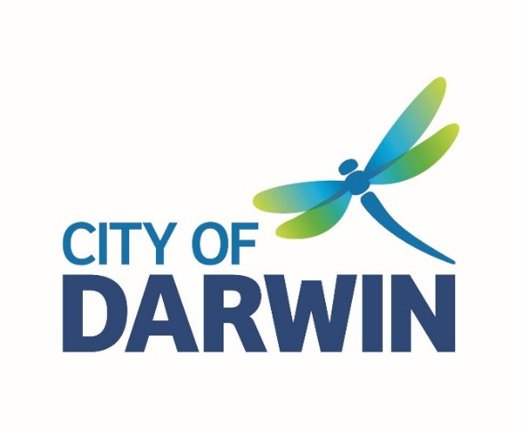
AGENDA

Access and Inclusion Advisory Committee Meeting
Thursday, 4 February 2021
I hereby give notice that an Access and Inclusion Advisory Committee Meeting will be held on:
Date: | Thursday, 4 February 2021
Time: | 1:30pm
Location: | Casuarina Library Meeting Room,  17 Bradshaw Terrace, Casuarina
Scott Waters
Chief Executive Officer

AGENDA
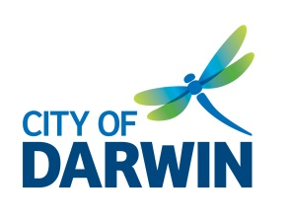
ACCESS & INCLUSION
ADVISORY COMMITTEE

Thursday 4 February 2021

1.30pm – 3.00pm

Casuarina Library Meeting Room & online via WebEx

MEMBERS
Alderman Robin Knox City of Darwin Alderman (Remote attendance)
Alderman Andrew Arthur City of Darwin Alderman (Alternate)

Martin Blakemore Community Representative (Chair)
Brett Peebles Community Representative (Deputy Chair)
Lynne Strathie Community Representative
Kyle Adams Community Representative
Sara Braines-Mead Community Representative

TBC Specialist Representative, Passenger Transport
Cecilia Chiolero Specialist Representative, Council on the Ageing Northern Territory (COTA NT)
Nicholas McGrath Specialist Representative, Building Advisory Services
Daniel Noone Specialist Representative, National Disability Services Northern Territory (NDS)

City of Darwin Officers
Lynn Allan Community Development Officer
Mathew Vituci Senior Capital Works Coordinator

GUESTS/ OBSERVERS

Nil

WELCOME

APOLOGIES
Liz Reid Community Representative

ACKNOWLEDGEMENT OF COUNTRY & PEOPLE IN ATTENDANCE WITH A DISABILITY

- DECLARATION OF CONFLICT OF INTEREST IN ANY AGENDA ITEMS

5. ACCEPTANCE OF PREVIOUS MEETING NOTES – 10 November, 2020

7. BUSINESS ARISING FROM PREVIOUS MINUTES
7.1 Review action list

8. GENERAL BUSINESS
8.1 Review Access and Equity Fund request – input sought from Committee

8.2 Focus areas for remainder of financial year – input sought from Committee
- Public Toilet audit/ accessible toilet map
- General municipal-wide access and mobility map
- Accessibility advocacy with businesses
- Employment, volunteering, and student placements; staff learning and development

9. MEMBERS UPDATE

10. ANY OTHER BUSINESS

11. NEXT MEETING
Thursday 4 March, 2021, from 1.30pm to 3.00pm at Casuarina Library Meeting Room

Summary of Actions
Meeting | Item | Notes | Status
02/06/2019 | Event Accessibility | - Members to send outline of event accessibility concerns to CoD to be raised with event organisers. | Ongoing
02/06/2019 | Sector Support | - Members to support events and activities as much as possible. | Ongoing
25/09/2019 | MLAK Key System | - CDO to review documentation on PDA’s campaign and MLAK system and seek further guidance on any possible action. | Ongoing
03/03/2020 | Project Grants | - Committee investigate and advise Council of any grants that could be applied for to assist in funding recommended projects. | Ongoing
10/11/2020 | Building Services | - CDO to investigate with Building Services Council’s role in the application and development process of new buildings relating to disability access standards.  Any input from Building Advisory Services? | By next meeting
10/11/2020 | Access and Equity Fund | - CDO to investigate viability of establishing a City of Darwin “Access and Equity Fund”.  Desktop research complete. Seek further guidance from AIAC on direction/ intent. | By next meeting
10/11/2020 | CBD Accessible Parking Upgrade | - CDO to email CBD accessible parking upgrade design document for the Committee to feedback on. | Done
10/11/2020 | Adult Change Space | - CDO to approach NT’s Anti-Discrimination Commissioner, Sally Seivers around MLAK Key approach for adult change space and develop an engagement and education plan for users of adult change space.  See notes from email sent to committee on 21/12/20 | Done
10/11/2020 | Ceiling Fans for Council’s public facilities | - CDO to investigate a project request for installing ceiling fans above BBQs in addition to fans in Exeloos. | Done
10/11/2020 | Access and Inclusion Plan Implementation Update | - CDO to email copy of Access and Inclusion Plan implementation update report to Committee.  Attached with agenda. | Done
10/11/2020 | Mobi-Mat matting Update | - CDO to follow-up on Committee’s request for an out-of-session meeting for further information on the timeframe and delivery of the Mobi-Mat matting project.  See notes from email sent to committee on 21/12/20 | Done
10/11/2020 | Dangerous Road | - CDO to follow up with Kyle Adams on the dangerous exit out of The Patch in Leanyer. | By next meeting

