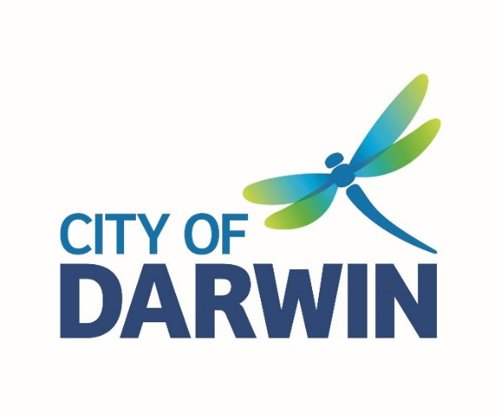
AGENDA

Access and Inclusion Advisory Committee Meeting
Thursday, 6 May 2021
I hereby give notice that an Access and Inclusion Advisory Committee Meeting will be held on:
Date: | Thursday, 6 May 2021
Time: | 1:30pm
Location: | Casuarina Library Meeting Room,  17 Bradshaw Terrace, Casuarina
Scott Waters
Chief Executive Officer

AGENDA
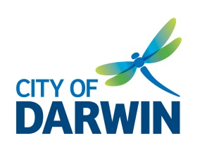
ACCESS & INCLUSION
ADVISORY COMMITTEE

Thursday 6 May 2021

1.30pm – 3.00pm

Casuarina Library Meeting Room & online via WebEx

MEMBERS
Alderman Robin Knox City of Darwin Alderman (Remote attendance)
Alderman Andrew Arthur City of Darwin Alderman (Alternate)

Martin Blakemore Community Representative (Chair)
Brett Peebles Community Representative (Deputy Chair)
Lynne Strathie Community Representative
Kyle Adams Community Representative
Sara Braines-Mead Community Representative
Liz Reid Community Representative
Callum Hooley Community Representative

Bernie Ingram Specialist Representative, Passenger Transport
Cecilia Chiolero Specialist Representative, Council on the Ageing Northern Territory (COTA NT)
Nicholas McGrath Specialist Representative, Building Advisory Services
Susan Burns Specialist Representative, National Disability Services Northern Territory (NDS)

City of Darwin Officers
Lynn Allan Community Development Officer
Mathew Vitucci Senior Capital Works Coordinator
Anneke Barnes Manager Community and Cultural Development

GUESTS/ OBSERVERS

WELCOME

APOLOGIES

ACKNOWLEDGEMENT OF COUNTRY & PEOPLE IN ATTENDANCE WITH A DISABILITY

- DECLARATION OF CONFLICT OF INTEREST IN ANY AGENDA ITEMS

5. ACCEPTANCE OF PREVIOUS MEETING NOTES – 4 March, 2021

7. BUSINESS ARISING FROM PREVIOUS MINUTES
7.1 Review action list

8. GENERAL BUSINESS
8.1 For information
- Report - use of equipment/ projects supported by the Committee
- NTcommunity Directory
- Committee community member appointments expire 30 June 2021:
- Lynn Strathie
- Liz Reid
- Kyle Adams
- Brett Peebles
- Martin Blakemore
- Sara Braines-Mead and
- Callum Hooley

8.2 For input:
- Request from community member on accessible parking bay near the Cool Spot at Fannie Bay
- Accessible toilet signage at DEC

9. MEMBERS UPDATE

10. ANY OTHER BUSINESS

11. NEXT MEETING
Thursday 1 July, 2021, from 1.30pm to 3.00pm at Casuarina Library Meeting Room

Summary of Actions
Meeting Date | Item | Notes | Status
02/06/2019 | Event Accessibility | - Members to send outline of event accessibility concerns to CoD to be raised with event organisers. | Ongoing
02/06/2019 | Sector Support | - Members to support events and activities as much as possible. | Ongoing
25/09/2019 | MLAK Key System | - CDO to review documentation on PDA’s campaign and MLAK system and seek further guidance on any possible action. | Ongoing
03/03/2020 | Project Grants | - Committee investigate and advise Council of any grants that could be applied for to assist in funding recommended projects. | Ongoing
10/11/2020/  06/03/2021 | The Patch Facilities | - CDO to follow-up with Building and Facilities team to assess and fix broken shower facilities at The Patch.  The land is leased to Charles Darwin University (CDU); therefore any maintenance requests will need to go through CDU. | By next meeting
10/11/2020/ 04/02/2021/  06/03/2021 | Dangerous Road | - Kyle Adams to email the CDO the location and details of identified dangerous roads to forward on to Passenger Transport. | By next meeting
06/03/2021 | CPV Review | - CDO to share Larrakia Nation contact with CPV Review Consultant; Committee to contact Consultant to provide input into the CPV review. | Completed
06/03/2021 | Committee supported projects | - CDO to provide a summary for Committee on use of equipment/ projects supported by the Committee, e.g. accessible swings, fishing platform by next meeting. | By next meeting

