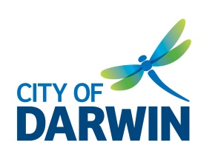**MINUTES**

**ACCESS & INCLUSION**

**ADVISORY COMMITTEE**

**Tuesday 12 November 2019**

**1.30pm – 3.00pm**

Casuarina Library Meeting Room, Bradshaw Terrace

**MEMBERS**

Brett Peebles Community Representative

Martin Blakemore Community Representative

Sara Braines-Mead Community Representative

Lynne Strathie Community Representative

Susan Burns Specialist Representative, National Disability Services Northern Territory (NDS)

Ian George Specialist Representative, Passenger Transport

Catherine Fairlie Community Representative

Cecilia Chiolero Specialist Representative, Council on the Ageing Northern Territory (COTA NT)

Liz Reid Community Representative

Kyle Adams Community Representative

**City of Darwin (CoD) Officers**

Lynn Allan Community Development Officer (CDO)

Mathew Vitucci Senior Capital Works Coordinator

Rosanna De Santis Community and Cultural Development Coordinator

**Observer**

Sade Waugh Community Services Student

Mitch Down Syndrome Association Support Worker

# WELCOME

# APOLOGIES

Alderman Robyn Knox City of Darwin

Alderman Andrew Arthur City of Darwin

Sheree Scott Specialist Representative, Building Advisory Services

Ashley Robinson Community Representative

**ABSENT**

Ramya Ramamoorthi Community Representative

# NOMINATION OF CHAIR

Three members were nominated for Chair: Susan Burns, Ashley Robinson, and Martin Blakemore. Martin Blakemore received the majority of votes, and be recommended to Council for appointment as Chair for the current term ending 30 June 2021.

# DECLARATION OF CONFLICT OF INTEREST IN ANY AGENDA ITEMS

Nil

# ACCEPTANCE OF PREVIOUS MEETING NOTES- 25 September, 2019

Moved by Sara Braines-Mead

Seconded by Martin Blakemore

# BUSINESS ARISING FROM PREVIOUS MINUTES

**6.1 General business**

• *CoD to liaise with Bryan Harty at Botanic Gardens to advocate for parking and connecting pathways as part of upgrade*

Bryan Harty advised an access pavement to the new Visitor and Event Centre (VEC) that links to the street pavement has been constructed (3m wide at correct gradient), to deliver pedestrians and others to the ramp leading into the VEC. CoD installed a raised walkway from Gardens Rd into the Botanic Gardens that connects with existing internal pathways (2m wide); this walkway eliminates a historical hazard whereby pathway users were delivered to a dead end and forced onto the road. There are five accessible parking bays within the internal parking areas accessible from Gardens Road. He is advocating for a bus drop off zone to deliver visitors closer to the new entrance pavement. NTG Passenger Transport advised there is currently no route nor any future plans to commence one on Gardens Road. The nearest bus stop is in front of Gardens Oval.

• *Members to send outline of event accessibility concerns to CoD to be raised with event organisers.*

There are still ongoing concerns about access to the Amphitheatre; in particular that people with access needs don’t necessarily want to be corralled into a particular area. A longer-term solution needs to be investigated.

|  |  |
| --- | --- |
| **ACTION** | CoD’s CDO to follow-up with appropriate department on long-term solution to improving accessibility of Amphitheatre. |

Concerns on the accessibility of the NT Rugby Union grounds for the upcoming Rugby 7s tournament; CoD to advocate for improved infrastructure to this facility.

|  |  |
| --- | --- |
| **ACTION** | CoD’s CDO to follow-up with CoD’s Sport and Recreation Facilities team on NT Rugby Union grounds accessibility. |

*• Members to support events and activities as much as possible.*

Ongoing

Brett Peebles provided advice on the accessible pathway and parking design proposed for East Point Reserve’s new accessible fitness equipment; feedback was also provided on other missing elements to improve the space, including lighting, accessible picnic tables, and a shade structure, as the equipment that’s been painted black gets too hot to use.

*• CoD to email Integrated disability Action (IdA) the details of Marrara Rugby League grounds accessibility issue for actioning.*

IdA have emailed Marrara Rugby League; awaiting response.

• *CoD to determine level of remedial works required and priorities for CBD accessible parking.*

CoD’s Engineering and City Services department undertook a review into the 11 CBD sites identified by Brett Peebles, determining that none are compliant. A handful of sites could be brought up to compliance at a low-cost, fairly quickly; however most sites would require significant upgrades; a concept layout to treat the parallel accessible bays is outlined below with an estimated cost of $33,000 per site.

|  |  |
| --- | --- |
| **ACTION** | CDO to meet with Senior Design Officer to discuss a plan for progressing works. |

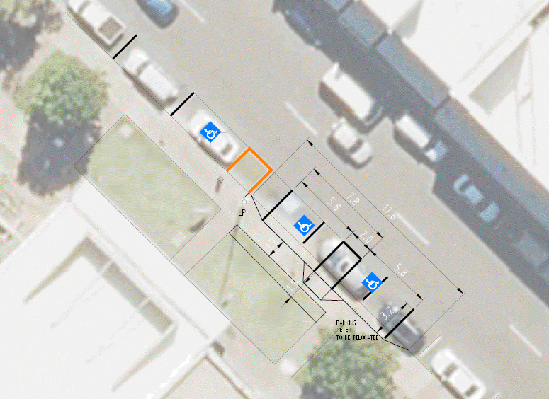

Committee recommends that accessible bays continue to be spread throughout the CBD, and not limited to one area only.

|  |  |
| --- | --- |
| **ACTION** | CDO to provide information to committee on Council policies and procedures around signage for accessible parking and reporting of infringements etc. |

• *CDO to discuss MLAK key system with CoD’s Executive Manager Operations.*

Physical Disability Australia’s (PDA) ‘No Key to Pee” campaign had some great background information on this: <http://www.pda.org.au/projects-campaigns/>.

|  |  |
| --- | --- |
| **ACTION** | CDO to review documentation on PDA’s campaign and MLAK system and seek further guidance on any possible action. |

**6.2 Budget expenditure requests**

***Spent***

1. Consultant fees for beach access workshop and beach access audits: $4,400.00 (GST incl).

The Push Mobility workshop is scheduled for Monday 2 Dec, venue TBC, Committee welcome to attend. Shane Hryhorec from Push Mobility will conduct access auditing of two other beaches, in addition to Mindil Beach. The Waterfront has been identified as an area that requires auditing; however preference is for beaches located within the Darwin municipality, such as Casuarina Beach; NDS advised that they could pay any additional fees for the Waterfront to be audited.

The accessibility of Darwin Surf Life Saving Club (DSLS) was raised as an issue. The land is leased from NTG; ongoing advocacy is required to encourage NTG to invest in accessible tourism; the Mindil Beach Accessibility project is a key step in developing this strategy.

|  |  |
| --- | --- |
| **ACTION** | Members to contact Susan Burns if interested in attending Push Mobility workshop. |
| **ACTION** | CoD with NDS to confirm locations for beach access audits. |

2. Accessible parking bay at East Point Reserve for access to new inclusive outdoor fitness equipment: $5,241.72 (GST incl).

Works completed in time for opening this weekend, with in principle support received from the committee at the previous meeting (quorum wasn’t reached therefore a decision couldn’t be formally made) and via email, receiving support from the majority of members.

**Under consideration**

1. Pavonia Place accessible parking bay to be brought up to current standard; requested by a member of the Nightcliff community: $10,500.00 (GST incl.).

2. Extended accessible parking bay for the new accessible play space at Jingili Water Gardens for bigger mobility vehicles:

Option 1: Marking and signage amendments to existing space at SE carpark: $1,500.00 (GST incl.)

Option 2: Marking and signage amendments to existing space at NW carpark: $11,500.00 (GST incl.)

Option 3: Construction of new car park pavement into embankment at SE carpark: $46,500.00 (GST incl.).

3. A co-contribution towards cost of Mobi-matting at Mindil Beach: $20,000.00.

4. Liz Reid proposed remaining funds to be expended on remedial works to footpath and curb outside the NDS office on Dashwood Place. Senior Capital Works Coordinator advised that this could come out of a different budget.

|  |  |
| --- | --- |
| **ACTION** | Liz Reid to send details to CoD to process to determine action. |

Recommendation is for the following budget expenditure items to be approved:

1. East Point Reserve accessible parking and pathway: $5,241.72 (GST incl).

2. Pavonia Place remedial work on accessible parking bay: $10,500.00 (GST incl.)

3. Option 1 for Jingili Watergardens accessible parking bay: $1,500.00 (GST incl.)

4. Co-contribution towards the cost of Mobi-matting at Mindil Beach: $20,000.00 (GST incl.)

Total cost is approx. $37,241.72.

Moved: Sara Braines-Mead

Seconded: Liz Reid

Carried

With $4,400.00 already spent, this will bring expenditure of the 2019/20 Access and Inclusion budget ($55,600.00) to $41,641.72, with $13,958.28 remaining.

1. **GENERAL BUSINESS**
   1. Proposal: Event Producers Forum

CDO presented concept plan to CoD’s Community Events team. Proposal is for CoD to co-deliver a Darwin Event Producers Forum in 2020 to develop the capacity of local event producers. Participants would learn from each other and sector specialists and develop a shared understanding of best practice principles and guidelines in the areas of: Access and Inclusion, Safety (Risk Assessment), and Sustainability.

Committee supportive of proposal, with a recommendation to focus on learning over regulating; recommendation to ensure the access and inclusion component is delivered by someone with lived experience of disability; a further suggestion to involve the Local Government Association of the Northern Territory (LGANT) for a broader reach.

|  |  |
| --- | --- |
| **ACTION** | CDO to send concept plan for Event Producers Forum to committee for feedback. |

* 1. Update on International Day of People with Disability Carnival of Fun event and Lord Mayoral Awards

Preparation for the collaborative event is ongoing, with a schedule of events including formal and informal activities developed. The Administrator of the NT and a representative for the Minister for Disabilities will be in attendance, and the Lord Mayor will present the inaugural Lord Mayoral Awards on the day. Nominations for the awards close Wednesday 13 November; members encouraged to submit a nomination.

# MEMBERS UPDATE

* **Lynne Strathie**

Carers NT’s Wulagi House offers day respite to maintain independence (a respite home has also recently opened in Nhulunbuy); they also offer mental health support groups in Casuarina Library weekly on a Tuesday for registered carers. Further information on services here: <https://www.carersnt.asn.au/services/aged-care-services>.

* **Susan Burns**

NDS will be hosting a Behaviour Support Practitioners group on 4 December and a second workshop by Professor David Gilchrist on financial sustainability for not-for-profits.

* **Ian George**

NTG’s Public Transport team collaborated with APM to run several ‘Try Before you Ride’ sessions at Casuarina Square and Palmerston to encourage people with disabilities to use public transport (they are looking to expand this into Alice Springs and other remote areas in the NT). The Department of Transport spends millions of dollars each year on upgrading infrastructure, for example bus shelters to meet standards.

* **Cecilia Chiolero**

COTA NT’s Aged Care Navigator service provides assistance and guidance to older Territorians and their families to make informed choices about their aged care needs.

* **Liz Reid**

Recently attended a PDA directors planning meeting; they are currently recruiting for an engagement officer, seeking someone with lived experience of physical disability. PDA is developing a website, ‘Crip Advisor’ as an accessible tourism site. YouthWorx NT is providing input into the Royal Commission into Violence, Abuse, Neglect and Exploitation of People with Disability; and reviewing the 2020 National Disability Standards – consultations will take place soon. A communique will soon be available from the National Disability Insurance Agency Advisory Council with updates on the NDIS.

* **Rosanna De Santis**

City of Darwin is developing its first Reconciliation Action Plan (RAP) – an Innovate RAP to focus on developing and strengthening relationships between Aboriginal and Torres Strait Islander peoples and the wider community, and engaging staff and stakeholders in reconciliation across the three key areas of relationships, respect and opportunities. Expressions of interest for the RAP working group are currently open and close Thursday 14 November.

# ANY OTHER BUSINESS

Nil

# NEXT MEETING

# Proposed calendar for 2020 meetings to be circulated for comments and approval:

|  |  |  |
| --- | --- | --- |
| **Month** | **Date and Time** | **Meeting/ Event Details** |
| **January** | **Tuesday**  **07/01/20**  1.30pm to 3.00pm | **AIAC Meeting**  Casuarina Library Meeting Room  Bradshaw Terrace, Casuarina |
| **March** | **Tuesday**  **03/03/20**  1.30pm to 3.00pm | **AIAC Meeting**  Casuarina Library Meeting Room  Bradshaw Terrace, Casuarina |
| **May** | **Tuesday**  **05/05/20**  1.30pm to 3.00pm | **AIAC Meeting**  Casuarina Library Meeting Room  Bradshaw Terrace, Casuarina |
| **July** | **Tuesday**  **21/07/20**  1.30pm to 3.00pm | **AIAC Meeting**  Casuarina Library Meeting Room  Bradshaw Terrace, Casuarina |
| **September** | **Tuesday**  **01/09/20**  1.30pm to 3.00pm | **AIAC Meeting**  Casuarina Library Meeting Room  Bradshaw Terrace, Casuarina |
| **November** | **Tuesday**  **10/11/20**  1.30pm to 3.00pm | **AIAC Meeting**  Casuarina Library Meeting Room  Bradshaw Terrace, Casuarina |
| **December** | **Thursday**  **03/12/19**  **(no meeting)** | **International Day of People with Disability**  TBC |

|  |  |
| --- | --- |
| **ACTION** | Committee to provide feedback/ approve meeting dates for 2020 and CDO to send out meeting requests for 2020. |

Meeting closed at 3.00pm.

**Summary of Actions**

|  |  |  |  |
| --- | --- | --- | --- |
| **Meeting Date** | **Item** | **Notes** | **Status** |
| 02/06/2019 | Event Accessibility | * Members to send outline of event accessibility concerns to CoD to be raised with event organisers. | Ongoing |
| 02/06/2019 | Sector Support | * Members to support events and activities as much as possible. | Ongoing |
| 25/09/2019 | Marrara Rugby League Grounds | * CoD to email IdA the details of Marrara Rugby League Grounds accessibility issue for actioning. | Underway |
| 25/09/2019 | MLAK Key System | * CDO to review documentation on PDA’s campaign and MLAK system and seek further guidance on any possible action. | By next meeting |
| 25/09/2019 | Accessible Parking 2 | * CDO to meet with Senior Design Officer to discuss a plan for progressing works around accessible parking in the CBD. | Underway |
| 12/11/2019 | Amphitheatre Access | * CoD’s CDO to follow-up with appropriate department on long-term solution to improving accessibility of Amphitheatre. | By next meeting |
| 12/11/2019 | NT Rugby Union Grounds Access | * CoD’s CDO to follow-up with CoD’s Sport and Recreation Facilities team on NT Rugby Union grounds accessibility. | By next meeting |
| 12/11/2019 | Accessible Parking Policies and Procedures | * CDO to provide information to committee on Council policies and procedures around signage for accessible parking and reporting of infringements etc. | By next meeting |
| 12/11/2019 | Beach Accessibility | * Members to contact Susan Burns if interested in attending Push Mobility workshop and CoD and NDS to confirm locations for beach access audits. | By next meeting |
| 12/11/2019 | Budget Expenditure Request | * Liz Reid to submit budget expenditure request form to CoD to process. | By next meeting |
| 12/11/2019 | Event Producers Forum | * CDO to send concept plan for Event Producers Forum to committee for feedback. | By next meeting |
| 12/11/2019 | 2020 Meeting Dates | * Committee to provide feedback/ approve meeting dates for 2020 and CDO to send out meeting requests for 2020. | By next meeting |