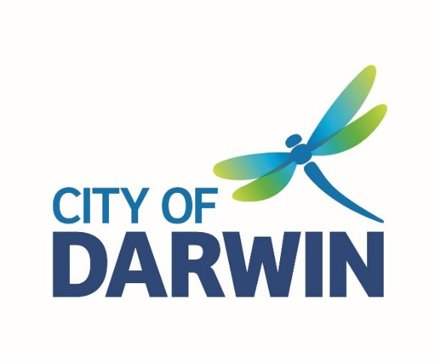
AGENDA
Reconciliation Action Plan
Steering Committee Meeting
Tuesday, 20 April 2021
I hereby give notice that a Reconciliation Action Plan Steering Committee Meeting will be held on:
Date: | Tuesday, 20 April 2021
Time: | 12:00pm
Location: | City of Darwin Operations Centre
Scott Waters
Chief Executive Officer

MEETING OPENS WITH ACKNOWLEDGEMENT OF COUNTRY

1. WELCOME
City of Darwin Alderman
Alderman Peter Pangquee
City of Darwin Staff
Lynn Allan Secretariat
Anneke Barnes Chair
Amy Greisbach
Tristan Cook
Mark Pocock
Tony Vincent
Sade Waugh
Community Members
David Parfitt
Helena Wright
Lynette Fejo

2. APOLOGIES

3. DECLARATION OF INTEREST IN ANY ITEMS ON THE AGENDA

- SUMMARY OF PREVIOUS MEETING MINUTES – INCLUDING ACTIONS

- AGENDA ITEMS
Play Larrakia video used in RAP Staff Roadshows – What is one thing people should know about Larrakia people, Country and Culture, and What makes you proud to be Larrakia?

5.1 RAP Implementation update
- Council decision on RAP resourcing - Anneke
- Terms of Reference - Anneke

5.2 National Reconciliation Week and NAIDOC Week programming – Sade

5.3 RAP Cultural Leave – Amy (see attached discussion paper)

5.4 Feedback from Local Government RAP Network webinar and conversation with RA about RAP reporting and next steps – Lynn and Anneke

- ANY OTHER BUSINESS

- NEXT MEETING
Tuesday 15 June, 2021 - 12.00pm to 1.30pm at the Casuarina Library Meeting Room

