Lord Mayors Climate Emergency Roundtable 4 December 2019.
Initial outcomes from the Lord Mayor’s Climate Emergency Roundtable. This summary is collated from Mentimeter online polling on the day. Further outcomes and collation of information will be analysed and reported on in coming days/weeks.
Overview Priorities and concerns regarding the climate were asked of attendees at strategic points across the day. Similar questions were designed to identify changes in attitudes after hearing speakers and other perspectives on climate issues.

First question after initial introduction started the polling to see attendees concerns in their own words. From the word cloud we can identify a concern about government action, this clearly supports the Councils move to declare a Climate Emergency as one in line with community expectations.
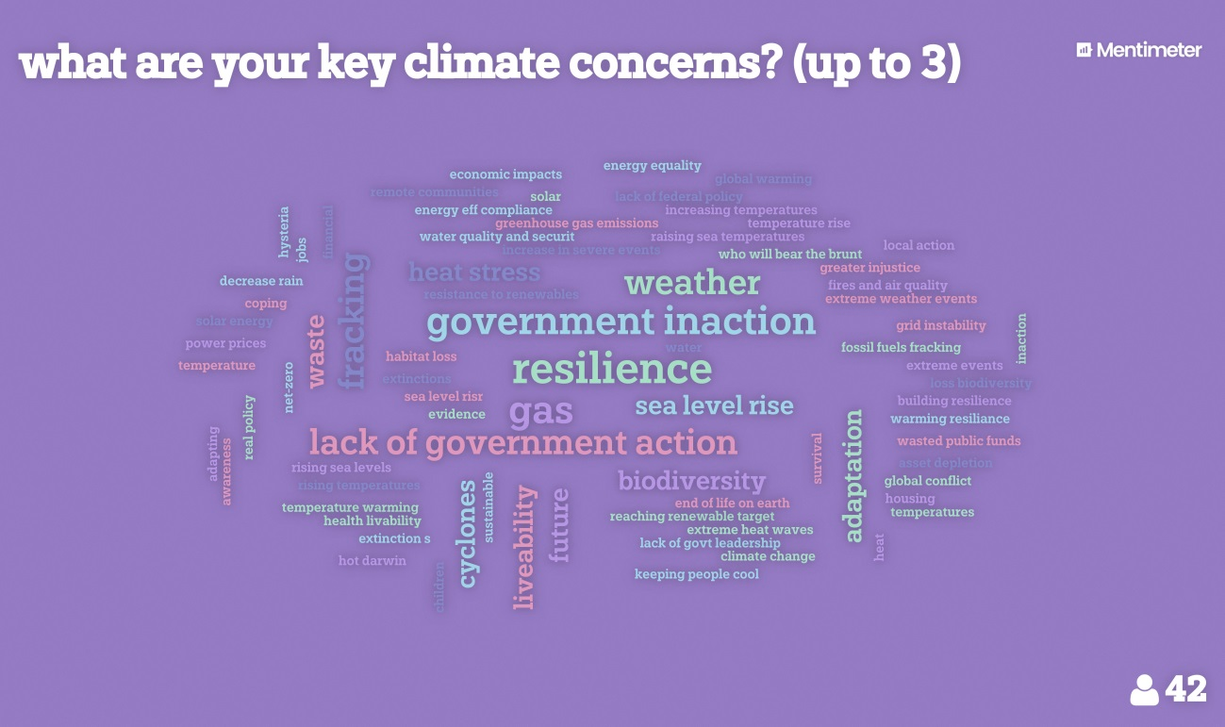

Part way through the event, after hearing several speakers and having an outline of City of Darwin’s Climate Emergency project plan audience members were asked to rate which of the four key priorities, Council has identified, should be of highest priority. Clearly decarbonisation is a significant concern amongst the community.
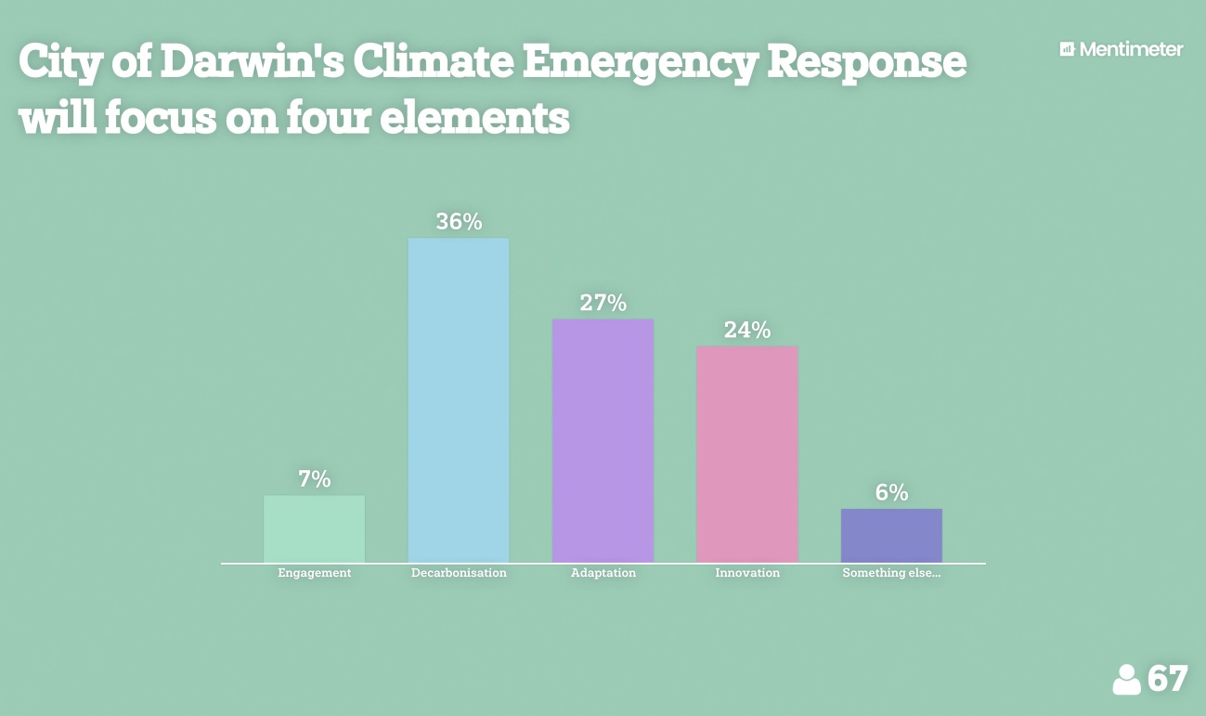
Towards the end of the day the community were once again invited to prioritise what they see as critical actions for council. Reducing carbon emissions (decarbonisation) again ranked highly.
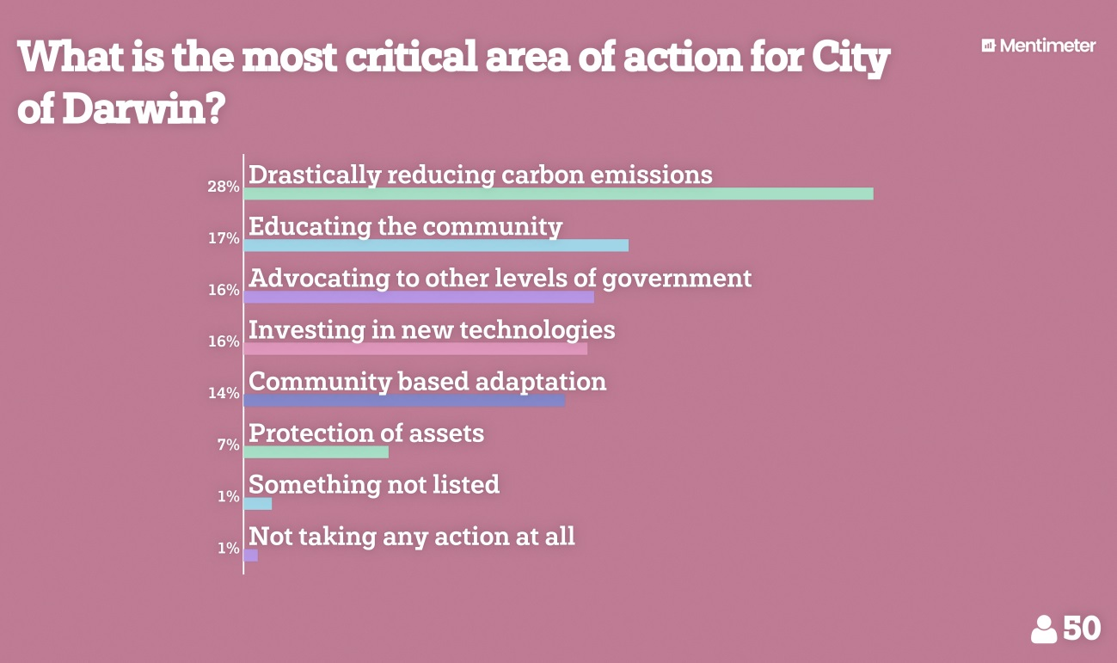

To finish the day a question was asked regarding personal actions and commitments to change after hearing the day’s proceedings. Great to see attendees eager to share in the advocacy and efforts to decarbonise the economy, as well as significant interest in electric vehicles and eating less meat.
