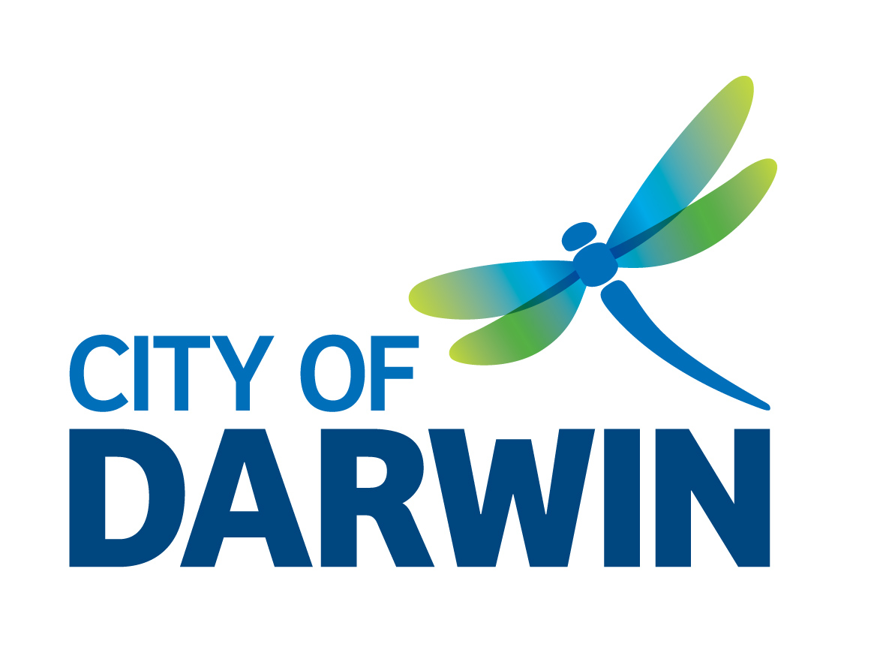
Trap ID: __________
Supply Date: __________
Return Date: _________
Northern Territory of Australia
Local Government Act
Darwin City Council By-Laws
(By-Law 67(1))

CAT TRAP LOAN
REGULATORY SERVICES

Applicant name:____________________________________________________________

Postal Address:____________________________________________________________

Contact phone: (bh)______________(ah)________________mobile__________________

Email: _____________________________ fax: __________________________________

Trap to be used only at (address): ___________________________________________
Please note that in times of high demand there may be a waiting list for customers requiring traps. For this reason traps must be returned on or before the return date determined.

Declaration: I agree to comply with the following conditions.

I undertake to:
- Advise my neighbours that I am trapping and removing cats from my property before I begin trapping.
- Use the trap only to humanely capture cats within my property, as above.
- Promptly release any native animals that are accidentally trapped.
(Wildlife Conservation Information Line 89955008).
- Deliver trapped cat(s) to the City of Darwin Pound or if unable to deliver a trapped cat contact Councils Animal Management Section on 89300600 to organise for the trapped cat to be collected.
- Collect and return the trap on the agreed dates or organise for the trap to be collected by a Council Ranger by contacting 89300600.
- Accept full responsibility for any actions taken by me during the loan of the trap and indemnify the City of Darwin against any actions whatsoever arising from the failure at any time by the borrower to observe the aforementioned conditions.
Signature:____________________________________Date : _______________________
Print name: _______________________________________________________________

City of Darwin Pound opening hours: Mon-Fri 9.00am-6pm, Saturday 9.00am-1.00pm, Closed Sundays and Public Holidays.

Privacy Statement
The information requested in this form is being collected by the City of Darwin for the purpose of updating our administrative systems to be able to carry out the City of Darwin functions. The City of Darwin may disclose the information provided by you on this form to a third party, as required or authorised by the City of Darwin By-Laws and the Local Government Act or in accordance with the Information Act or our Privacy Policy which is available on our website www.darwin.nt.gov.au or on request from the City of Darwin’s office. You may obtain access to your personal information held by the City of Darwin by submitting a request for information form that is available on our website or from the “Information Officer” (08) 89300300.

City of Darwin, Civic Centre, Harry Chan Ave, Darwin NT
(GPO Box 84 Darwin NT 0801)
Telephone 89300600 (Regulatory Services Communications)
www.darwin.nt.gov.au
Email: darwin@darwin.nt.gov.au

