10 November 2021 Please quote: 453033JS:nt

Dear Resident
Proposal to install a smart bench on Rapid Creek Foreshore
As part of our City of Colour, City for People 2030 Strategy, the City of Darwin is proposing to install a ‘Smart Bench’ near the Chapman Street Carpark, Chapman Road, Rapid Creek. This will form part of a six-month trial to better inform future initiatives and actions towards achieving a smart and prosperous city.
The Smart Bench, which is approximately 2.3 metres high by 2.8 metres wide, is best described as shaded urban furniture that provides comfort, connectivity, and convenience to the community. Not to mention also being quite Instagram-able.
It includes solar powered LED lighting and is equipped with USB and Wireless charging stations with Wi-Fi connectivity. This is all available under timed management and can be controlled and changed throughout the trial period. The seat hosts a Wi-Fi hotspot and no personal information is obtained while logged in as per our current Wi-Fi offerings throughout Darwin.
The Smart Bench is compliant to CPTED (Crime Prevention Through Environmental Design) standards and similar installations have been popular in Victoria, South Australia and the Australian Capital Territory.
Installation involves the laying of a 1.5 metre by 3 metre concrete slab. The smart bench is prefabricated and takes less than a week to install, and no trees or vegetation will be removed.
City of Darwin is planning to install the smart bench before Christmas 2021. The success of the smart bench will be considered following the trial period and a photo of the smart bench and a map of the proposed location is provided overleaf.

If you have any queries or concerns regarding the Smart Bench, please contact the Manager Digital Innovation on (08) 8930 0810 or email to darwin@darwin.nt.gov.au.
Yours sincerely

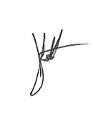

JOSHUA SATTLER

GENERAL MANAGER – INNOVATION
Encl. Smart Bench Images & Location Map

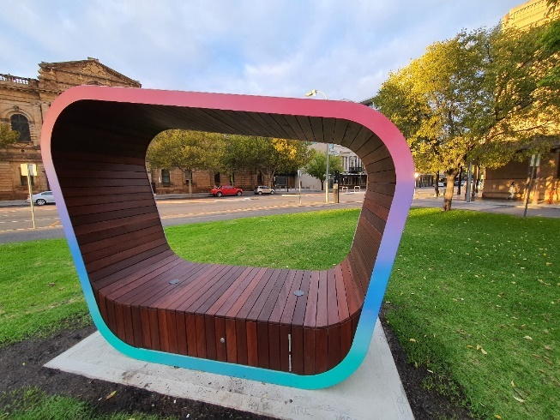

Photo of Smart Bench

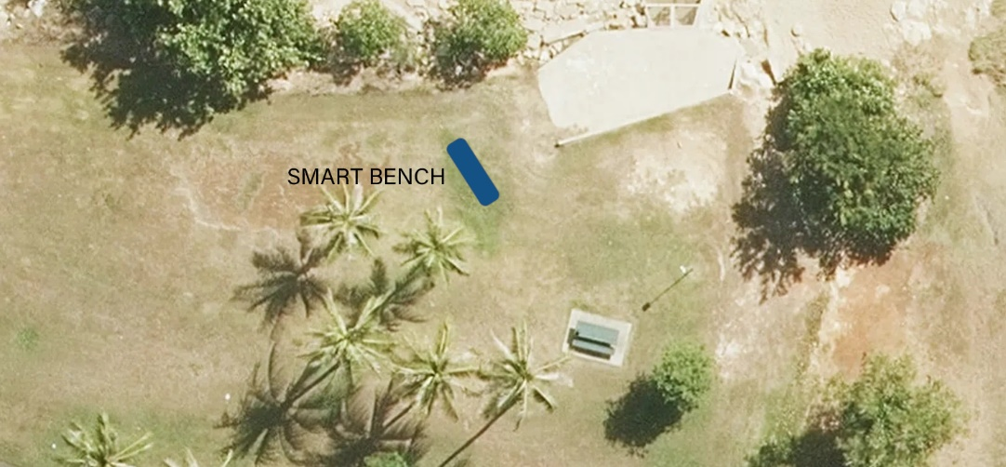
Map of location

